**The C-ADAPT Technical Report**

The University of Auckland

Ashton Eaves a

Professor Paul Kench b

Dr Garry McDonald c

Associate Professor Mark Dickson d

a PhD Candidate, University of Auckland, New Zealand.

b Dean of Science, Simon Frazer University, Canada.

c Market Economics, Auckland, New Zealand.

d School of Environment, University of Auckland, Auckland, New Zealand.

The following document covers the development, method and functional relationships for an integrated assessment model (IAM) applicable to coastal managed retreat called C-ADAPT using the Agile Development Methodology. First, it describes the Scenario Planning involved to discover a plausible view of the region of interest now and into the future. Second, this knowledge and information are incorporated into System Dynamics modules that integrate with MERIT, a quasi Computational General Equilibrium model for economic impact. MERIT derives regional economic impacts from baseline scenarios and policy interventions. Finally, model outputs are assessed using Robust Decision Making in Python (PYRDM) to discover dynamic adaptation planning pathways (DAPP) of least regret for coastal communities.

This research was funded by the Ministry of Business, Innovation and Employment through the Living at the Edge (Coastal) project and the Economics Toolbox project within the Resilience to Nature’s Challenges National Science Challenge.

Table of Contents

**1.** **Integrated Assessment Model development** 4

1.1 Scenario development 7

1.1.1 The Baseline Scenario 11

1.1.2 Environment and climate 12

1.1.3 Economy 13

1.1.4 Land-use 16

1.1.5 Population and households 20

1.1.6 Insurance 21

1.1.7 The Defence Scenario 23

1.1.8 The Climate Bonds Scenario 27

1.1.9 The Property Rates Scenario 29

1.1.10 Land-use Planning Scenario 31

1.2 Develop modules for direct impacts and interventions 32

1.3 Calibration and module structure tests 43

1.4 Integrate modules into MERIT for indirect impacts to the regional economy 45

1.5 Calibrate and test C-ADAPT and apply model feedback 46

1.6 Define key aggregates for scenario comparison 47

1.7 Develop adaptation pathways 48

1.7.1 The robust scenario of least regret 51

1.7.2 A trade-off timeframe 52

1.9 All functionalities complete 53

1.10 Limitations and assumptions 53

**2.** **Model set up, equations and source material** 56

2.1 The Risk Assessment Module 56

2.2 The Socio-Economic Module 64

2.3 The Interdependencies Module 71

2.4 The Defence Module 78

2.5 The Climate Bonds Module 80

2.6 The Property Rates Module 83

2.7 The Land-use Zoning Module 87

2.8 Miscellaneous operators 92

2.9 MERIT linkages 100

2.10 PYRDM Script 104

**3.** **Appendices** 112

Appendix 1 Table of multi-variate regression analysis for hedonic pricing 112

Appendix 2 Kernel Density Estimate maps from Infrastructure outages 113

Appendix 3 Testing 122

3A Table of testing undertaken for C-ADAPT. 122

3A Reality Check testing for the Risk Assessment Module and the Socio-Economic Module. 124

Appendix 4 Model assessment results from the SDM-doc Tool 125

Appendix 5 Sensitivity analysis 126

5A Sensitivity results for the Risk Assessment Module and the Socio-Economic Module 126

5B Sensitivity results for MERIT integration 133

Appendix 6 PYRDM output 142

**4. References** 144

Table of Figures

**Figure 1** The Agile Development Methodology 7

**Figure 2**  Causal loop diagram for C-ADAPT 8

**Figure 3** C-ADAPT workflow from modules into MERIT and then out to the PYRDM pathway matrix 8

**Figure 4** Indicative timing of scenarios (A) and the implementation of intervention funding (B) 12

**Figure 5** Decision tree of the scenario pathways over time in C-ADAPT. 13

**Figure 6** HPUDS future zoning for growth, territorial boundaries and the CHZ. 19

**Figure 7** The population of Hawke’s Bay and the national population. 22

**Figure 8** Lorenz curves prepared from StatsNZ census data. 23

**Figure 9** An indicative Total Defence Cost (annual cost) and Cumulative Defence Cost (total project cost) 29

**Figure 10** The indicative outputs for allocating central government climate bonds 31

**Figure 11** Indicative Property Rates generated for capital investment by Local Government 32

**Figure 12** Possible sites for a managed retreat based on ESRI ArcGIS raster analysis map algebra. 34

**Figure 13** The stock-flow diagram of the Risk Assessment Module 36

**Figure 14** The stock-flow diagram of the Socio-Economic Module 37

**Figure 15** Vensim® Stock-flow diagram for the Infrastructure Interdependency Module 39

**Figure 16** Vensim® Stock-flow diagram for the Defence Module operating at the CHZ scale. 40

**Figure 17** The stock-flow diagram for the Climate Bonds Module 41

**Figure 18** The stock-flow diagram for the Property Rates Module 42

**Figure 19** The stock-flow diagram for the Land-use Module 43

**Figure 20** Modified operability function in MERIT for coastal hazards. 44

**Figure 21** Modified aggregate investment function and the mobility of investment 44

**Figure 22** The modified Industry Income (Industryinc) and Industry Expenditure (indexpendu) 45

**Figure 23** Modified Multifactor Production to enhance the Economies of Scale 45

**Figure 24** Indicative simulation results for the Regional TVA. 50

**Figure 22** Workflow from MERIT to the matrix in Python 3.6 (PYRDM) 51

**Figure 26** Boxplot of minimum regret for scenarios across all timesteps 54

**Figure 27** All DAPP scenarios by timestep. 55

# **Integrated Assessment Model development**

The following IAM is a novel approach to explore coastal managed retreat. It simulates the implementation of economic, regulatory and planning instruments alongside coastal hazards associated with climate change to discover adaptation pathways that minimise risk. It adopts the theoretical elements of planning with elements of the economy (Haasnoot et al., 2014) and the environment in a multi-disciplinary and interdependent way. It combines and communicates knowledge from economic impact analysis to address environmental issues by analysing the entire system's cause and effect relationships. Integrated assessment analyses interacting systems to define states, impacts, and feedback resulting from policy intervention (Haasnoot et al., 2014). It is key to planning futures as it minimises uncertainty and assimilates diverse knowledge into the decision-making process to tackle environmental problems (Bosello, 2014; Haasnoot et al., 2014). The IAM should inform decision-making that leads to future risk reduction as planning is more effective when the long-term costs and residual risk are known (Longworth, 2017).

The evaluation of impacts given climate pressures, socio-economic developments or policy options determines the usefulness of an IAM (Haasnoot et al., 2014). As suggested by Frame and Reisinger (2016), a range of climate-specific and non-climate specific policies and scenarios must be examined to provide essential coverage of climate change risk. It should allow for the analysis of trade-offs, rank actions to achieve objectives, support the improvement of adaptation pathways, be quick enough to simulate long periods and provide an output of relevance to the decision-making process (Haasnoot et al., 2014). The model provides a means to infer relationships of consequence by analysing key performance indicators (KPI) or useful model outputs.

The method outlined here combines System Dynamics, Scenario Planning, Dynamic Adaptive Policy Pathways (DAPP) and Robust Decision Making (RDM) into an IAM called C-ADAPT. C-ADAPT uses Ventana Systems’ Vensim® DSS to simulate the influence of coastal flooding and inundation on the local and regional economy and implement adaptation strategies. The approach aligns with Exploratory Modelling Analysis methods by Kwakkel, Haasnoot and Walker (2015) for analysing complex and uncertain systems through computational experiments. It also aligns with the RDM methods of Lempert et al. (2013) for comparing the performance of alternative combinations of policies that are evaluated by prescribed metrics over a wide range of uncertain futures. Finally, the IAM compares pathways through robust optimisation and preference functions under the assessment of key aggregates (model outputs) described by Callaway (2014). Therefore, the concepts and methods used in the IAM are similar to those of Smith et al. (2016) and Brown et al. (2015) for coupling SD modules with MERIT; Hamarat et al. (2013) for Adaptive Robust Design, and Callaway (2014), Kwakkel et al. (2015) and Lempert et al. (2013) for pathway evaluation.

The method for building and testing C-ADAPT involves the Agile Development Methodology (Matrix Software, 2014), which is adapted in Figure 1. The Agile Development Methodology is a structured process for technological development that computer programmers use to provide transparency to their automation and provide an audit trail of activity, testing and consultation (Matrix Software, 2014). The C-ADAPT Vensim® model, its equations and the source data are accessible from Gitlab at <https://gitlab.com/aceaves/c_adapt>.

**Figure 1** The Agile Development Methodology adapted from Matrix Software (2014). It illustrates the steps taken to develop the IAM called C-ADAPT.

C-ADAPT is based on the CLD’s outlined in Figure 2, which define crucial cause and effect relationships through balancing (-) and reinforcing (+) feedback loops within the environment-economy systems. Similar to Smith et al. (2016), first the modelling exercise develops a conceptual causal loop model, or influence diagram, to define stand-out variables and their relationships and feedback in the system based on previous studies and literature. Second, CLDs incorporate more detailed information once logic, influential relationships and interventions are derived. Information is obtained from scenario planning with expert workshops, questionnaires and interviews with experts and stakeholders, alongside digital media, databases and statistics. Finally, quantitative stock-flow diagrams (modules) are built from the CLD, then iterated for robustness and analysed for sensitivity. Macmillan (2012) defines this process as the preparation phase, which then flows into the modelling phase and concludes with a follow-up phase which reviews the model outputs. Next, MERIT and the modules integrate and operate baseline and intervention scenarios. Key aggregates of MERIT and the modules (KPI’s) are assessed using RDM in the Python-generated least-regret matrix - PYRDM. Figure 3 illustrates the module integration of C-ADAPT.

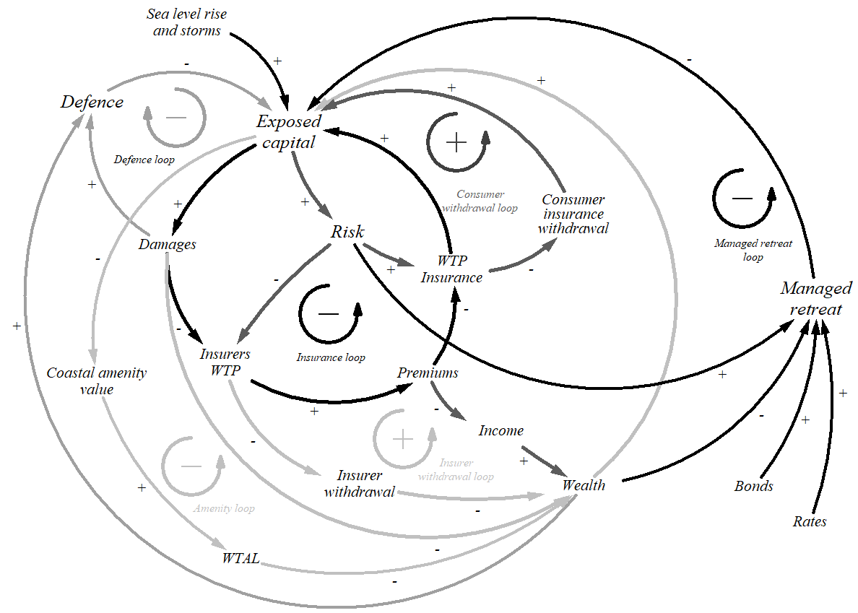

**Figure 2** Causal loop diagram for C-ADAPT. Central to the diagram is the baseline insurance mechanisms that maintain the status quo. On the top left is the mitigating coastal defence balancing loop, the bottom left is the coastal amenity value balancing loop, and on the right, the managed retreat balancing loop.

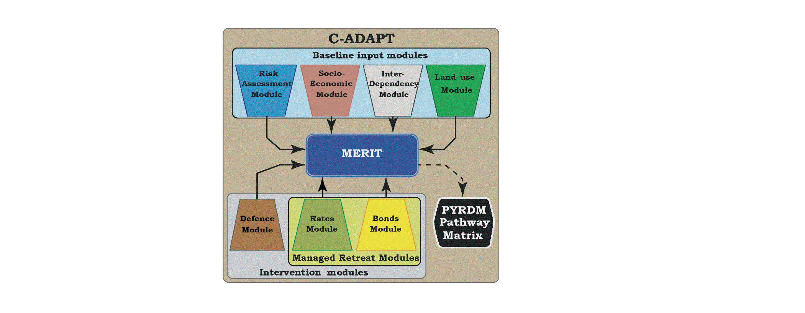

**Figure 3** C-ADAPT workflow from modules into MERIT and then out to the PYRDM pathway matrix for pathway analysis.

## 1.1 Scenario development

The following section illustrates the baseline scenario and the intervention scenarios (experiments) to enable a managed retreat. Scenarios allow modellers to account for different perspectives on specific issues and opportunities (Frame et al., 2005). They cover situations that explore the unfolding of futures given various drivers under baseline conditions (problem exploration) and scenarios that examine how various interventions might eventuate (solution exploration) (IPCC, 2014b). Methodically, the baseline scenario, once established, is compared with alternative future scenarios (interventions). Where possible, it is useful to employ hindcast validation with available time-series data (Turner, 2000). By design, they should look more than a decade ahead and address changes across many aspects of society (Frame et al., 2005). Scenarios should have technical credibility and adequacy through scientific evidence and arguments; relevance to the assessment process required by decision-makers; and legitimacy through objective information (Cash & Moser, 2000).

Adaptation scenarios require modellers to integrate, where appropriate, interacting factors such as human behaviour, policy choices, land-use changes, population trends, economic conditions, technological advances, and international competition and cooperation (Moss et al., 2010; Turner, 2000). Models are populated with a wide range of data to develop meaningful scenarios architecture, ideally with consistent assumptions (Frame & Reisinger, 2016). Data may include: a) inferences from global datasets; b) extensions of current shorter-term datasets; or c) inferred extensions of datasets based on declared suppositions (Frame & Reisinger, 2016). The data development process and the underlying assumptions need to be recorded and accessible so that as new information comes to light, the data can be challenged (Frame & Reisinger, 2016).

Modelling future options for a coastal managed retreat for sub-regional Hawke’s Bay draws on Scenario Planning developed using census information, expert workshops, expert conversations, questionnaires, government planning documents and datasets, utility datasets, reports, industry practice, model feedback and finally, knowledge obtained through the National Science Challenge: Living at the Edge project (see Kench et al., 2018). Expert workshops were held with the Hawke’s Bay Technical Advisory Group and the Reserve Bank of New Zealand (ethics approval reference 021706) to provide a range of plausible scenarios. External expert input was conducted with Market Economics, EQC governance, Climate Sigma, NIWA coastal engineers, consulting engineers and district planners. Smith, Orchiston et al. (2016) applied a similar approach to developing system variables exogenous to the MERIT model that reflected stakeholders' narratives. The audience for the Scenario Planning was considered to be government decision-makers, coastal managers and stakeholders in Hawke’s Bay. These workshops were participatory rather than collaborative, an approach outlined by Allison (2020). Iteration, sensitivity analysis and model feedback also design the plausibility of the scenarios through model refinement. Thus, a hybrid approach was developed that tested predetermined scenarios developed with experts as described by Scenario Planning and the use of model refinement in System Dynamics. A brief overview of the scenarios is as follows:

1. The Baseline Scenario (status quo, counter-factual or reference mode):
   1. IPCC (2019b) climate change scenarios and Ministry for the Environment guidance (Ministry for the Environment, 2017) derive exposure to flooding and inundation for occupants.
   2. Capital asset databases and infrastructure network analysis define the direct impacts on the built and natural capital of households and firms;
   3. Business disruption and network operability define the indirect impacts on industry and infrastructure that propagate into higher-order impacts on the regional economy;
   4. Insurers increase risk-based premiums and excesses with eventual market withdrawal (either provider or consumer-initiated);
   5. Coastal amenity values and socio-economic state of CHZ occupants declines with exposure;
   6. Occupants remain in the CHZ until Ahoc or forced retreat is inevitable. Eventual Adhoc and forced retreat supported by public insurance (EQC);
   7. Intensification of existing land-uses that constrains supply;
2. The Climate Bonds Scenario:
   1. The Central Government releases climate bonds to fund managers nationally and internationally to generate capital for climate change relief with a proportion allocated to Hawke’s Bay.
   2. The Central Government acts as a ‘Development Partner’ (Hall & Lindsay, 2017) by purchasing affected properties and increasing land-use zoning capacity to accommodate a managed retreat.
   3. Where possible, the Central Government leases exposed properties back to vendors to enable occupation until the risk becomes intolerable.
3. The Property Rates Scenario:
   1. The Local Government collects a property tax or rate from households and firms in the region. Hawke’s Bay Local Government apply both targeted and general rates.
   2. The Local Government acts as a ‘Direct Investor’ by purchasing new land and managing the relocation of households and firms to accommodate managed retreat.

C-ADAPT is set up with the scenarios shown in Table 1. Three baseline scenarios (Table 1, 1 - 3) illustrate a world where we do nothing and continue to live with communities at risk from coastal hazards: storms impact the coast, inundating assets and eroding foundations. Eventually, depending on the two RCP driver conditions, risk-averse insurers withdraw from exposed markets and communities are forced to retreat from the coast as their savings evaporate and the land yields to erosion and flooding. Scenarios 4 and 5 represent a view where insurers remain in the market indefinitely to discover when consumers are no longer WTP for insurance as premiums rise. Two engineering intervention scenarios (Table 1, 6 & 7) examine the effects of installing coastal defence structures (see HBRC, 2019, 2020), and four financial intervention scenarios (Table 1, 8-11) examine the plausibility of financial planning mechanisms that could enable managed retreat. One set of financial intervention scenarios (Table 1, 8 & 9) involves the central government acting as a ‘Development Partner’ (Hall & Lindsay, 2017) by purchasing at-risk properties through climate bonds. In contrast, the second set of scenarios (Table 1, 10 & 11) considers the possibility of no central government contribution. Instead, the local government comes to the aid of exposed communities as a ‘Direct Investor’ (Hall & Lindsay, 2017) by financing and managing relocation through a property rating tax.

All scenarios integrate current global and national climate change science alongside operative regional planning documents. The IPCC (2019a) RCP projections define future physical exposure to SLR and storm impacts that reflect projections by the Ministry for the Environment (2017) under RCP4.5. Conversely, under RCP8.5, the IPCC defined SLR, whereas storm impacts reflect a greater magnitude than reported by the IPCC to reflect New Zealand’s exposure to extreme storms in the South Pacific.

Table 1 Main scenario details

|  |  |  |  |  |  |
| --- | --- | --- | --- | --- | --- |
| Scenario | RCP driver | SLR (mm a-1) | Increase in Storm Intensity (% a-1) | Increase  in Storm  Frequency  (% a-1) | Interventions / Comments |
|  | RCP0 | 0 | 0 | 0 | **No SLR**  Properties are exposed to infrequent storms without climate change |
|  | RCP4.5 | 6 | 0.23 | 1.86 | **Baseline**  Baseline scenario in which property owners remain in situ until insurers withdraw from the market or three significant storms force an *ad hoc* relocation financed by public insurance. |
|  | RCP8.5 | 8 | 0.98 | 2.75 | **Worst-case baseline**  Property owners follow the same behaviour as (1) but are subject to higher SLR and more intense storms earlier in the model period. |
|  | RCP4.5  Insure | 6 | 0.23 | 1.86 | **Insure**  Baseline scenario (2) modified so that insurers remain in the coastal property market in order to define when property owners themselves retreat. |
|  | RCP8.5 Insure | 8 | 0.98 | 2.75 | **Worst-case insure**  Identical to (4) but subject to higher SLR and more intense storms. |
|  | RCP4.5 Defence | 6 | 0.23 | 1.86 | **Defend**  Baseline scenario (1) modified with defence structures installed along the coastline (see Figure __).  Pandora cell cost is NZ$200739M (inundation trigger level).  Northern cell cost is NZ$20076M (erosion trigger level).  Southern cell cost is NZ$200755M (erosion trigger level). |
|  | RCP8.5 Defence | 8 | 0.98 | 2.75 | **Worst-case defend**  Identical to (3) but subject to higher SLR and more intense storms. |
|  | RCP4.5 bonds | 6 | 0.23 | 1.86 | **Managed retreat (bonds)**  NZD2007$35Bn national bond issued by the central government to finance a managed retreat.  NZ$20072.4Bn allocated to Hawke’s Bay. |
|  | RCP4.5 rates | 6 | 0.98 | 1.86 | **Managed retreat (rates)**  Targeted, general and household property rates generated by the local government to finance a managed retreat.  NZ$20072.4Bn generated for Hawke’s Bay. |
|  | RCP8.5 bonds | 8 | 0.23 | 2.75 | **Worst-case managed retreat (bonds)**  Identical to (5) but subject to higher SLR and more intense storms. |
|  | RCP8.5 rates | 8 | 0.98 | 2.75 | **Worst-case managed retreat (rates)**  Identical to (6) but subject to higher SLR and more intense storms. |

The timing of adaptation scenarios through changes to the number of structures affected and finance installations are illustrated in Figure 4 to provide context around CHZ occupation. It shows the occupation through property count to illustrate when any *ad hoc* or managed retreat occurs under the different scenarios (A) and the associated government expenditure on intervention scenarios (B), as explained in Table 2. As flooding forces an *ad hoc* retreat, the number of properties in the CHZ reduces after 2040 under baseline scenarios (2 & 3). Still, the percentage loss is more significant under RCP8.5 owing to higher SLR and more intense storms (Figure 4A). Properties in the CHZ reduce to zero under the RCP8.5 managed retreat scenarios (10 & 11) and RCP8.5 (3) but not under the RCP4.5 scenario (2). In contrast, defence scenarios and the No SLR scenario result in all properties remaining (1, 6 & 7). A delay in the baseline scenarios occurs where insurers remain in the market (4 & 5). Figure 4B illustrates the timing and cost of interventions. All managed retreat scenarios cost significantly more than defence scenarios, as outlined earlier, as the cost of community relocation far outweighs that of defensive structures.

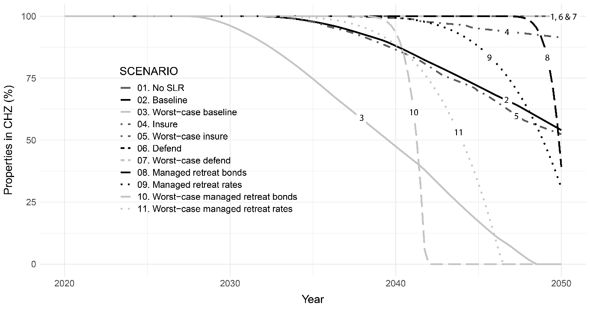

**A**

**B**

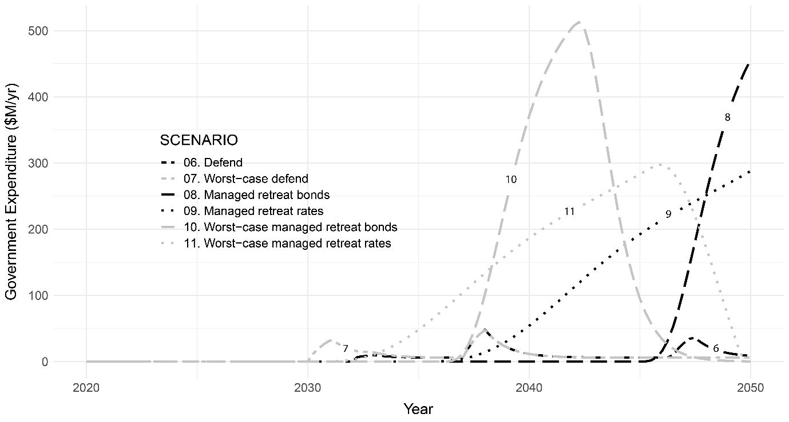

**Figure 4** Indicative timing of scenarios (A) and the implementation of intervention funding (B) based on the median of 100 simulations. Note that baseline scenarios are missing in (B) as they do not require government expenditure.

The model’s decision tree is outlined in Figure 5 for the various scenario pathways. Whereas Table 5 describes the associated distributional impacts implicit in the modelling on households, industries and governments.

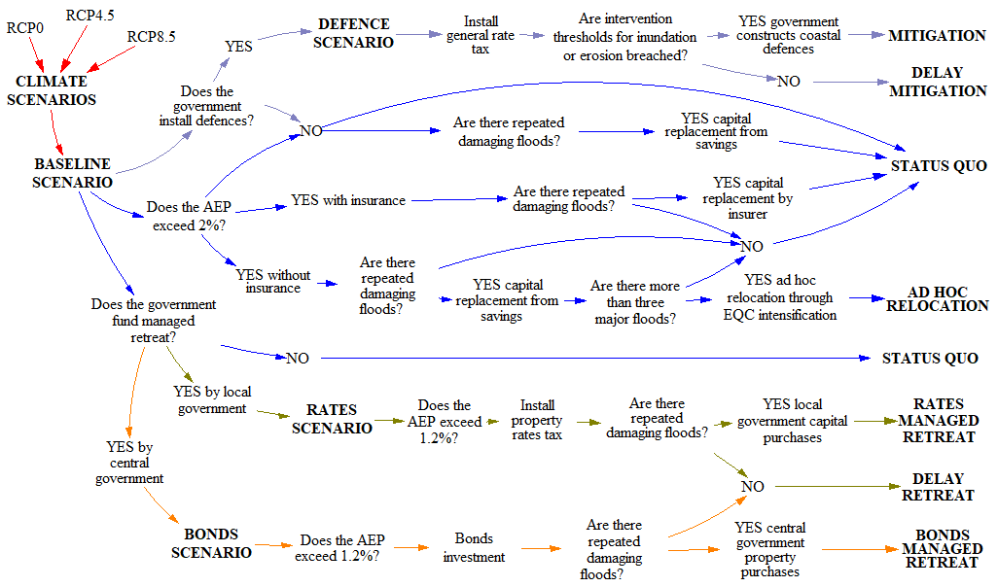

**Figure 5** Decision tree of the scenario pathways over time in C-ADAPT.

Table 2 Distributional impacts of scenarios for managed retreat (NB: HHLD = Households, IND = Industries, GOVT = Government)

|  |  |  |  |  |
| --- | --- | --- | --- | --- |
| Scenario | Distribution on HHLD | Distribution on IND | Distribution on GOVT | Other |
| Baseline | * High impacts on a few individuals. | * More long-term impacts than managed retreat. | * Significant impact on public insurance. | * Minimal moral hazard. |
| Defence | * Households gain at the expense of the region. | * Industry gains at the expense of the region. | * Medium impact on local government. | * Long-term hazard remains. * Intergenerational and spatial risk transfer. |
| Rates | * Performs poorly for households. * Affects low-income earners more than higher earners. | * More spread of impacts onto businesses than Baseline. * Invigorates manufacturing | * Local GOVT consumption significantly outweighs revenue. | * Large moral hazard. |
| Bonds | * Performs well for households. * Reduces unemployment. | * Diverts investment expenditure lowering capital growth regionally & nationally. * Exchange rate impacts. | * Minimal impact on Central GOVT. * Requires a favourable bond market. | * Large moral hazard. * Equity issues. |

### 1.1.1 The Baseline Scenario

The baseline scenario is what we expect if the status quo is maintained. It broadly follows the expectation outlined by Maven Consulting Limited (2017, p. 9) for the Hawke’s Bay Cape Coast area where:

“Property owners take individual responsibility for the protection of their properties and assets. Councils do not construct any defensive works along the coastline. Essential services (power and water supply, etc.) will continue to coastal properties in the erosion and inundation hazard zone for as long as it is viable to do so”.

Firms and households remain in the CHZ through repeated inundation events of varying magnitude. However, once the total water level exceeds 1.23 m above MHWS thrice (12 m NZVD2016), households and firms abandon the CHZ through Adhoc or forced relocation. In this instance, relocation is supported by the public insurance provider EQC, who underwrite lost land with the replacement of a modest section away from hazards. Households and firms internalise direct impacts or transfer risk through public and private insurance schemes. Although insurance providers stop covering exposed households once the AEP exceeds 2%, if capital is not insured, then households and firms cover damage and clean-up costs after floods from savings.

Capital values in the CHZ start to decline from 2030 onwards with no new development in the area. Again, Maven Consulting LImitied (2017, p. 45) under their status quo scenario contest that “discounts on a property in an area that is subject to natural hazards will remain for as long as the hazards exist (and may increase if the perceived risk becomes higher)”. However, Filippova et al. (2020) illustrated that property prices in hazard zones are not so simple as people are willing to tolerate coastal risk in the short-term for the added amenity value. Simultaneously, a coastal squeeze of the intertidal zone reduces the CHZ amenity value, reduces ecosystem services and the socio-economic wellbeing declines.

Outside the CHZ projections look good for Hawke’s Bay, with growth in primary production and manufacturing sectors. Population growth is greater than the national trend as people seek the amenable lifestyle of Hawke’s Bay. However, the increasing demand for quality land from many competing interests forces land prices higher. This section will now investigate the baseline scenario states for the following factors: 1) environment and climate, 2) Economy, 3) land-use, 4) population and households, and 5) insurance.

### 1.1.2 Environment and climate

The baseline scenario for the environment and climate draws on information from the global and national scale. The baseline scenario reflects three climate states based on RCP of atmospheric CO2 for the globe; RCP0, RCP4.5 and RCP8.5. RCP0 represents no warming and is used to isolate the effects of sea-level rise and increasing storminess. RCP4.5 represents warming of 1.7 – 3.2°C by 2100, with emissions peaking around 2050 before declining (Ministry for the Environment, 2017). RCP8.5 is modelled due to a lack of urgent global mitigation to reduce atmospheric CO2. The RCP8.5 is also useful to assess greenfield developments, adaptability of infrastructure, test adaptation pathways and the timing of trigger points (Ministry for the Environment, 2017).

The IPCC (IPCC, 2014b, 2019b) provides projections for global sea-level change according to the RCP’s, which is in turn adapted by the Ministry for the Environment (2017) for national use. Sea-level rise projections are modelled with a positive regional departure (offset) (New Zealand Government, 2017) as shown in Table 3. Storm surge (Komar & Harris, 2014), waves (Komar & Harris, 2014), river flooding (HBRC, 2018), tide (LINZ, 2012) and vertical land movement (Beavan & Litchfield, 2012) were also incorporated to identify significant total water levels during storms. The vertical land movement, or geodetic change, is significant at approximately -2 mma-1 and is based on Beavan and Lichfield (2012). HBRC and Napier Port supplied water level time-series datasets. HBRC (2017) by way of Civil Defence and Emergency Management (CDEM) provided spatial flooding extents validated against topographical datasets.

Table 3 Modelled sea-level rise and extreme water level components.

|  |  |  |  |  |  |  |  |  |
| --- | --- | --- | --- | --- | --- | --- | --- | --- |
| Scenario | Global projection (2050, m) | New Zealand offset (m) | Sea-level rise ( 2050, m) | Geodetic change (2050, m) | Peak storm surge (m) | Peak wave run-up (m) | Highest astronomical tide (m) | River flooding (m) |
| RCP 0 | 0 | 0.00 | 0 | -0.088 | 0.25 | 0.52 | 1.99 | 1.22 |
| RCP 4.5 | 0.27 | 0.015 | 0.285 | -0.088 | 0.25 | 0.53 | 1.99 | 1.22 |
| RCP 8.5 | 0.32 | 0.025 | 0.345 | -0.088 | 0.27 | 0.61 | 1.99 | 1.38 |

### 1.1.3 Economy

Hawke’s Bay has seen Real Regional Domestic Product (RDP) growth at around 10% since 2009, which currently exceeds the population and household growth rates for the Heretaunga Plains (HBRC et al., 2017); a sub-region of Hawke’s Bay that includes the study area. Historic statistical data illustrates RDP for Hawke’s Bay, increasing at a decreasing rate (StatsNZ, 2020).

Since 1972, the national trend in GDP composition has seen a reduction in the primary and secondary sectors and an enhancement in the tertiary sector (StatsNZ, 2019b). Currently, primary production and manufacturing sectors are the key drivers for the overall performance of the Hawke’s Bay economy, sharing 30 - 40% of total RDP (HBRC et al., 2017). The baseline scenario assumes the dominant primary production and manufacturing trend in Hawke’s Bay through to 2050. However, the region requires enhanced exploration and expansion of water storage opportunities to increase regional productivity (HBRC, 2016). Substantial regional employment of the local workforce in public capital projects is also future aspiration of the region to increase the population's resiliency (HBRC, 2016).

#### 1.1.3.1 Direct impacts

Direct impacts are calculated from the assets valuations of 2007 exposed to the CDEM 2120 1% AEP CHZ. The aerial extent of inundation is modelled through step changes in inundation levels aligned with the 1% AEP exceedance probabilities at 2065 and 2120 (see HBRC, 2017). The estimated capital damage, which accounts for replacement costs, stock, plant, and contingent values, was calculated from Riskscape (see NIWA, 2017b; NIWA, 2017c). Similarly, exposed infrastructure assets were calculated from Local Government and utility company asset inventories and adjusted to 2007 values. Natural capital losses are set at 1% of government land valuations for each storm event. The model assumes that subsequent storms incrementally remove a share of the land area and value. The 1% is the assumed inundation of the CHZ over 100 years, and therefore each storm event incrementally costs a share of the land value. There are approximately 40 significant storm events (total WL>11.5m NZVD2016) over the 44 years, and therefore, they account for 40% of the land value. Tonkin and Taylor’s (2016) land inundation mapping is more conservative and estimated approximately a 30% reduction in the area over 100 years. See Table 4 for the industry breakdown of assets at risk for the a) CDEM 2065 1% AEP coastal inundation, b) CDEM 2120 1% AEP coastal inundation and c) the regional asset value expressed in MERIT for 2007.

Table 4 Direct impacts of coastal hazards

|  |  |  |  |  |  |  |  |
| --- | --- | --- | --- | --- | --- | --- | --- |
| 1. **Exposed assets (NZ$2007) within the 1% AEP coastal inundation by 2065 (CDEM)** | | | | | | | |
| **Industry** | **Land** | **Capital** | **Improvements** | **Infrastructure** | **Total** | **Area (Ha)** | **Land-use share (%)** |
| Accommodation, restaurant & retail services | 8,914,200 | 15,628,900 | 0 | 0 | 24,543,100 | 0.93 | 0.22 |
| Construction | 3,398,850 | 8,820,410 | 5,013,200 | 0 | 17,232,460 | 9.21 | 2.16 |
| Government, education & healthcare | 51,943,890 | 165,873,840 | 2,784,650 | 24,992,097 | 245,594,477 | 230.61 | 54.02 |
| Horticulture & fruit growing | 0 | 0 | 0 | 0 | 0 | 0.00 | 0.00 |
| Food product manufacturing | 672,300 | 1,859,200 | 0 | 0 | 2,531,500 | 0.37 | 0.09 |
| Other manufacturing | 9,260,310 | 56,184,360 | 0 | 0 | 65,444,670 | 4.59 | 1.08 |
| Other primary production | 3,063,450 | 5,954,420 | 0 | 0 | 9,017,870 | 101.75 | 23.84 |
| Other services & trades | 40,372,860 | 58,680,170 | 0 | 9,775,162 | 108,828,192 | 47.17 | 11.05 |
| Residential & real estate services | 4,062,850 | 207,163,020 | 7,216,850 | 0 | 218,442,720 | 32.23 | 7.55 |
| Wood & paper manufacturing | 0 | 0 | 0 | 0 | 0 | 0.00 | 0.00 |
| **TOTAL** | **121,688,710** | **520,164,320** | **15,014,700** |  | **691,634,990** | **427** | **100.00** |
| 1. **Exposed assets (NZ$2007) within the 1% AEP coastal inundation by 2120 (CDEM)** | | | | | | | |
| **Industry** | **Land** | **Capital** | **Improvements** | **Infrastructure** | **Total** | **Area (Ha)** | **Land-use sHare (%)** |
| Accommodation, restaurant & retail services | 23,909,000 | 71,770,000 | 0 | 0 | 95,679,000 | 3.57 | 0.33 |
| Construction | 17,260,000 | 50,802,000 | 6,040,000 | 0 | 74,102,000 | 20.22 | 1.85 |
| Government, education & healthcare | 85,657,000 | 326,837,000 | 3,695,000 | 53,972,213 | 470,161,213 | 246.88 | 22.58 |
| Horticulture & fruit growing | 3,360,000 | 45,940,000 | 0 | 0 | 49,300,000 | 157.83 | 14.43 |
| Food product manufacturing | 18,001,000 | 41,290,000 | 0 | 0 | 59,291,000 | 11.98 | 1.10 |
| Other manufacturing | 47,867,000 | 232,612,000 | 0 | 0 | 280,479,000 | 28.64 | 2.62 |
| Other primary production | 6,157,984 | 59,470,000 | 0 | 0 | 65,627,984 | 357.62 | 32.70 |
| Other services & trades | 84,762,000 | 165,325,000 | 0 | 23,224,648 | 273,311,648 | 87.64 | 8.01 |
| Residential & real estate services | 101,962,500 | 886,816,000 | 18,991,000 | 0 | 1,007,769,500 | 171.51 | 15.68 |
| Wood & paper manufacturing | 8,260,000 | 14,090,000 | 0 | 0 | 22,350,000 | 7.63 | 0.70 |
| **TOTAL** | **397,196,484** | **1,894,952,000** | **28,726,000** | **77,196,860** | **2,398,071,344** | **1,094** | **100.00** |
| 1. **Regional asset value and areas from MERIT (NZ$2007)** | | | | | | |  |
| **Industry** | **Built capital** | **CHZ capital share (%)** | | **Area (Ha)** | **CHZ area share (%)** | |  |
| Accommodation, restaurant & retail services | 2,571,340,000 | 3.72 | | 235 | 1.52 | |
| Construction | 15,313,500,000 | 0.48 | | 647 | 3.13 | |
| Government, education & healthcare | 7,912,390,000 | 5.94 | | 678 | 36.41 | |
| Horticulture & fruit growing | 200,694,000 | 24.56 | | 38,510 | 0.41 | |
| Food product manufacturing | 479,408,000 | 12.37 | | 499 | 2.40 | |
| Other manufacturing | 3,870,290,000 | 7.25 | | 247 | 11.59 | |
| Other primary production | 2,482,530,000 | 2.64 | | 930,100 | 0.04 | |
| Other services & trades | 14,043,600,000 | 1.95 | | 1,606 | 5.46 | |
| Residential & real estate services | 26,277,800,000 | 3.84 | | 4,570 | 3.75 | |
| Wood & paper manufacturing | 210,488,000 | 10.62 | | 183 | 4.17 | |
| **TOTAL** | **73,362,040,000** |  | | **977,275** | **0.11** | |

1. **Infrastructure exposed to coastal hazards leading to indirect impacts (NZ$2007)**

|  |  |  |  |  |  |  |  |  |
| --- | --- | --- | --- | --- | --- | --- | --- | --- |
| **ROADS** | **Cost per km ($)** | **Sum of length (km)** | **Total value ($)** |  | **COMMS** | **Quantity** | **Value** | **Total value ($)** |
| **Estimated replacement cost with a 1% AEP present inundation** | | | |  | **Estimated replacement cost with a 1% AEP present inundation** | | | |
| Local roads NCC | 900,826 | 0.08 | 73,128 |  | Chorus exchange cabinet | 1 | 40,000.00 | 40,000 |
| Local roads HDC | 735,168 | 3.59 | 2,639,253 |  | Underground fibre | 2,135 | 61.00 | 130,235 |
| State highways | 3,000,000 | 0.29 | 855,838 |  | Aerial fibre | 33 | 61.00 | 2,013 |
| **Total** |  |  | **3,568,219** |  | **TOTAL** |  |  | **172,248** |
| **Estimated replacement cost with a 1% AEP 2065 inundation** | | | |  | **Estimated replacement cost with a 1% AEP 2065 inundation** | | | |
| Local roads NCC | 900,826 | 4.97 | 4,479,835 |  | Cell tower | 1 | 250,000.00 | 250,000 |
| Local roads HDC | 735,168 | 6.11 | 4,491,876 |  | Chorus exchange cabinet | 2 | 40,000.00 | 80,000 |
| State highways | 3,000,000 | 4.59 | 13,779,361 |  | Underground fibre | 3,023 | 61.00 | 184,403 |
| **Total** |  |  | **22,751,072** |  | Aerial fibre | 1,120 | 61.00 | 68,320 |
| **Estimated replacement cost with a 1% AEP 2120 inundation** | | | |  | **TOTAL** |  |  | **582,723** |
| Local roads NCC | 900,826 | 7.12 | 6,409,464 |  | **Estimated replacement cost with a 1% AEP 2120 inundation** | | | |
| Local roads HDC | 735,168 | 26.93 | 19,795,026 |  | Cell tower | 3 | 250,000.00 | 750,000 |
| State highways | 3,000,000 | 5.76 | 17,280,494 |  | Chorus exchange cabinet | 8 | 40,000.00 | 320,000 |
| **Total** |  |  | **37,075,520** |  | Underground fibre | 4,584 | 61.00 | 279,624 |
|  |  |  |  |  | Aerial fibre | 3,725 | 61.00 | 227,225 |
| **RAIL** | **Cost per km ($)** | **Sum of length (km)** | **Total value ($)** |  | **TOTAL** |  |  | **1,576,849** |
| **Estimated replacement cost with a 1% AEP present inundation** | | | |  |  |  |  |  |
| Total | 2,711,628 | 0.34 | **923,906** |  | **ELECTRICITY** | **Quantity** | **Value/m** | **Total value ($)** |
| **Estimated replacement cost with a 1% AEP 2065 inundation** | | | |  | **Estimated replacement cost with a 1% AEP present inundation** | | | |
| Total | 2,711,628 | 3.31 | **8,977,441** |  | HV Cable | 1,202 | 180.00 | 216,360 |
| **Estimated replacement cost with a 1% AEP 2120 inundation** | | | |  | HV Line | 2,907 | 180.00 | 523,260 |
| Total | 2,711,628 | 5.82 | **15,790,358** |  | **TOTAL** |  |  | **739,620** |
|  |  |  |  |  | **Estimated replacement cost with a 1% AEP 2065 inundation** | | | |
| **WATER** | **Quantity** | **Value/m** | **Total value ($)** |  | HV Cable | 5,032 | 180.00 | 905,760 |
| **Estimated replacement cost with a 1% AEP present inundation** | | | |  | HV Line | 8,591 | 180.00 | 1,546,380 |
| Water pipes all types | 64 | 26.08 | 1,669 |  | **TOTAL** |  |  | **2,452,140** |
| **TOTAL** |  |  | **1,669** |  | **Estimated replacement cost with a 1% AEP 2120 inundation** | | | |
| **Estimated replacement cost with a 1% AEP 2065 inundation** | | | |  | HV Cable | 11,575 | 180.00 | 2,083,500 |
| Water pipes all types | 13,852 | 26.08 | 361,260 |  | HV Line | 24,883 | 180.00 | 4,478,940 |
| HDC water mains | 9,045 | 298.61 | 2,700,927 |  | **TOTAL** |  |  | **6,562,440** |
| **TOTAL** |  |  | **3,062,188** |  |  |  |  |  |
| **Estimated replacement cost with a 1% AEP 2120 inundation** | | | |  |  |  |  |  |
| Water pipes all types | 29,103 | 26.08 | 28,192 |  | **TOTAL FOR ALL INFRASTRUCTURE** | |  |  |
| HDC water mains | 19,175 | 298.61 | 5,725,847 |  |  | **Quantity** | **Value/m** | **Total value ($)** |
| **TOTAL** |  |  | **5,754,039** |  | **Total infrastructure costs 2065** | |  | **39,973,860** |
|  |  |  |  |  | **Utility services land cost 2065** | **3** | **232,077** | **696,231** |
| **SEWER** | **Quantity** | **Value/m** | **Total value ($)** |  |  |  |  |  |
| **Estimated replacement cost with a 1% AEP present inundation** | | | |  | **Total infrastructure costs 2120** | |  | **83,668,672** |
| Sewer pipes all types | 494 | 49.98 | 24,690 |  | **Utility services land cost 2120** | **3** | **232,077** | **696,231** |
| HDC Sewer main | 0 | 1,054.53 | 0 |  |  |  |  |  |
| **TOTAL** |  |  | **24,690** |  | **Combined infrastructure costs 2065** | | | **73,737,589** |
| **Estimated replacement cost with a 1% AEP 2065 inundation** | | | |  | **Combined utility land costs 2065** | |  | **6,910,670** |
| Sewer pipes all types | 9,672 | 49.98 | 483,407 |  | **TOTAL** |  |  | **80,648,259** |
| HDC Sewer main | 711 | 1,054.53 | 749,771 |  |  |  |  |  |
| **TOTAL** |  |  | **1,233,177** |  | **Combined infrastructure costs 2120** | | | **161,823,198** |
| **Estimated replacement cost with a 1% AEP 2120 inundation** | | | |  | **Combined utility land costs 2120** | |  | **7,644,051** |
| Sewer pipes all types | 24,959 | 49.98 | 1,247,451 |  | **TOTAL** |  |  | **169,467,249** |
| HDC Sewer main | 7,882 | 1,054.53 | 8,311,805 |  |  |  |  |  |
| **TOTAL** |  |  | **9,559,256** |  | **Totals for industries:** |  | **2065** | **2120** |
|  |  |  |  |  | Accommodation, restaurant & retail services | | |  |
| **STORMWATER** | **Quantity** | **Value/m** | **Total value ($)** |  | Construction |  |  |  |
| **Estimated replacement cost with a 1% AEP present inundation** | | | |  | Government, education & healthcare | | **27,961,556** | **59,739,026** |
| NCC drainage pipes | 3,700 | 115.56 | 427,572 |  | Horticulture & fruit growing | |  |  |
| HDC drainage pipes | 1,124 | 777.06 | 873,415 |  | Food product manufacturing | |  |  |
| **TOTAL** |  |  | **427,572** |  | Other manufacturing |  |  |  |
| **Estimated replacement cost with a 1% AEP 2065 inundation** | | | |  | Other primary production | |  |  |
| NCC drainage pipes | 7,919 | 115.56 | 915,120 |  | Other services & trades |  | **12,012,304** | **23,929,647** |
| HDC drainage pipes | 3,070 | 777.06 | 2,385,574 |  | Residential & real estate services | |  |  |
| **TOTAL** |  |  | **915,120** |  | Wood & paper manufacturing | |  |  |
| **Estimated replacement cost with a 1% AEP 2120 inundation** | | | |  |  |  |  |  |
| NCC drainage pipes | 16,291 | 115.56 | 1,882,588 |  |  |  |  |  |
| HDC drainage pipes | 9,459 | 777.06 | 7,350,211 |  |  |  |  |  |
| **TOTAL** |  |  | **7,350,211** |  |  |  |  |  |

#### 1.1.3.2 Indirect impacts

Under the baseline scenario, disruption to business operability and interdependent infrastructure is an ongoing occurrence. These disruptions for flood events are between one and five days, with logarithmic decay after that up to a month. Business inoperability also flows onto household or firm income, expenditure and productivity. Infrastructure disruption is more far-reaching as nodes within the CHZ extent propagate to users beyond the CHZ. The significant disruptions are closure to highways at the Ahuriri Estuary, closure to the rail line at the Ahuriri Estuary Bridge, reduction in service at the Napier Airport (30%), the sewage treatment plant reduction in service (15%), and gas supply outage (15%).

### Land-use

The Heretaunga Plains Urban Development Strategy (HPUDS) (HBRC et al., 2017), and the Matariki Hawke’s Bay Regional Economic Development Strategy and Action Plan 2016 (Matariki Plan) (HBRC, 2016) provide for local land-use planning. The HPUDS is a collaborative approach to plan for urban growth on the plains for the period 2015-2045 by the Hastings District Council (HDC), Napier City Council (NCC) and Hawke’s Bay Regional Council (HBRC) (HBRC et al., 2017). The area extends beyond the CHZ but encompasses it (Figure 6). HPUDS takes a long-term view of infrastructure and land-use with regular review to ensure relevance and consistency with Long Term Plans (HBRC et al., 2017). Similarly, the MatarikiPlanseeks to ensure the provision of adequate commercial, industrial and residential land for future generations and resilient network infrastructure (HBRC, 2016). However, these plans do not allocate land for managed retreat, which will lead to increased competition for the finite land resource given the supply shortfall as communities relocate.

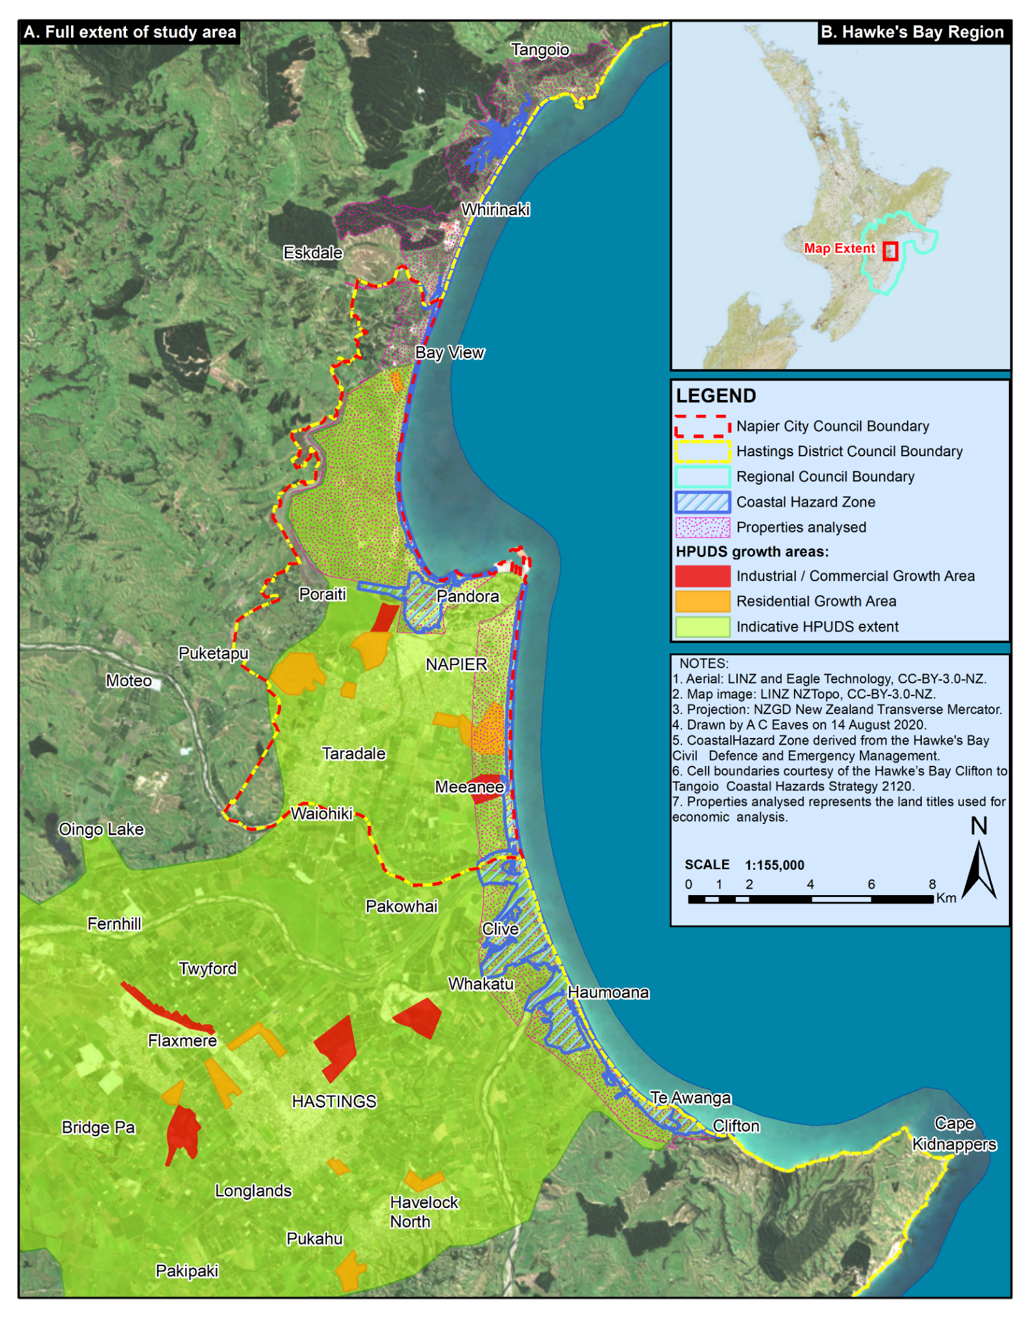

**Figure 6** HPUDS future zoning for growth, territorial boundaries and the CHZ.

The HPUDS ensures that development is centred away from coastal hazards and recognises the potential effects of climate change (HBRC et al., 2017). Settlements are to avoid sensitive natural environments such as streams, wetlands, lakes, rivers and estuaries, and protect productive soils and land (HBRC et al., 2017). Avoidance of these sensitive environments should reduce the risk of coastal inundation for new developments. Table 5 illustrates the vulnerable land in the CHZ by land-use.

Table 5 The vulnerable land in the CHZ by sector.

|  |  |  |  |  |
| --- | --- | --- | --- | --- |
| Vulnerable land-use within the CHZ | 2065 1% AEP | 2065 1% AEP | 2120 1% AEP | 2120 1% AEP |
| Land-use category | **Area (Ha)** | **Share (%)** | **Area (Ha)** | **Share (%)** |
| Commercial (Includes government land parcels) | 288 | 26.4 | 358 | 20 |
| Industrial | 5 | 0.5 | 48 | 2.7 |
| Residential | 32 | 3 | 172 | 9.6 |
| Rural | 102 | 9.3 | 515 | 28.7 |
| Unclassified (Includes roads, landscapes, ecosystems) | 664 | 60.9 | 701 | 39.1 |
| TOTAL | **1091** | **100** | **1795** | **100** |

HPUDS aims to intensify new development around the existing urban centres through increasing density (HBRC et al., 2017). Increased density will minimise the loss of versatile land for productive purposes and gain efficiencies in infrastructure and servicing costs (HBRC et al., 2017). A move toward a more compact urban form by 2045 will see: a) 60% intensification (10 – 20% intensification of brownfields); b) 35% intensification of green fields; and c) 5% in rural areas (HBRC et al., 2017). The desired compact form is due to the significant expansion of greenfield developments since 2000, transforming productive land to residential and infrastructure (HBRC et al., 2017).

The minimum net densities to be achieved for residential are a) average yield of 15 lots per hectare in each greenfield growth area developed; and b) average yield of 20 lots per hectare within each intensification development area (HBRC et al., 2017). Table 6 illustrates the allocation for residential growth for both the number of households and the calculated area required.

Table 6 The HPUDS residential land allocation 2015-2045. Table adapted from HBRC et al. (2017, p. 14)

|  |  |  |  |  |  |
| --- | --- | --- | --- | --- | --- |
| Development Type | Current (2015) Development [%] | Proposed Additional Households [No.] | | | |
| **2015-2025** | **2025-2035** | **2035-2045** | **2015-2045** |
| Intensification | [35] | 40% [2140] | 51% [1705] | 60% [1150] | 47% [4995] |
| Greenfields | [40] | 50% [2670] | 42% [1405] | 35% [670] | 45% [4745] |
| Rural Residential | [25] | 10% [535] | 7% [235] | 5% [100] | 8% [870] |
| TOTAL | **[100]** | **5345** | **3345** | **1920** | **10610** |
|  |  | **Proposed Additional Households (Ha)** | | | |
| Development Type | | **2015-2025** | **2025-2035** | **2035-2045** | **2015-2045** |
| Intensification (20 lots per Ha) | | 107 | 85 | 58 | 250 |
| Greenfields (15 lots per Ha) | | 178 | 94 | 45 | 316 |
| Rural - residential (0.3 lots per Ha*) | | 161 | 71 | 30 | 261 |
| TOTAL | | **446** | **249** | **132** | **827** |
| *Calculated using https://www.surveyingthebay.co.nz/project-posts/the-terraces-kent-terrace-taradale | | | | | |

HPUDS has determined a sufficient short to medium-term supply of industrial land (HBRC et al., 2017). The future supply of Industrial land is through the redevelopment of existing zones and extending zones in the Hastings industrial areas by providing an additional 225 Ha by 2045 (HBRC et al., 2017). The 10-year actual industrial land consumption to 2014 was 66.94 Ha in Hastings District, and 23 Ha in Napier City, with a peak in uptake in Napier of 9 Ha in 2014 due to development in Pandora (HBRC et al., 2017). Projections for industrial land consumption within the Hastings District and Napier City are expected to be 64 Ha by 2026, with a projected average annual uptake of 1.6 Ha and 5.2 Ha for Napier and Hastings, respectively (HBRC et al., 2017). The total land required for commercial growth is approximately 110 Ha; which assumes that this land requirement is absorbed through intensification and redevelopment of existing zones (HBRC et al., 2017). The allocation is “approximately 56.5 Ha more than projected demand for the 30 years, and four times the projected demand over the next ten years. At the average projected uptake rate, this represents around 40-45 years supply” (HBRC et al., 2017, p. 23) Therefore HPUDS accounts for future land allocation and growth without managed retreat under the baseline scenario. Table 7 highlights the business land staging projected by HPUDS.

Table 7 The HPUDS business land staging 2015-2045. Table adapted from (HBRC et al., 2017, p. 23).

|  |  |  |  |
| --- | --- | --- | --- |
| Location | Capacity (Ha) | Timing (Year) | Potential Activities |
| Napier Business Park | 30 | 2009- | Technology |
| Napier and Awatoto redevelopment of existing sites | 36 | 2009- | Service Industry |
| Irongate | 99.5 | 2015- | Dry Industry |
| Omahu Road | 56 | 2015- | Service Industry |
| Tomoana / Whakatu | 60 | After Whakatu full | Wet Industry |
| TOTAL | **281.50** |  |  |

The previous land-use planning tables outlined by in HPUDS, are adapted into MERIT in Table 8. However, it would appear that there is ample future allocation for residential and industrial land-uses. Still, the concern is the under-supply for commercial, infrastructure (roads and services) and amenity. The Land-use Module accounts for this by converting development contributions to approximately 647 Ha of land for infrastructure, amenity and ecosystem services (by way of the Government, Education and Healthcare Industry) by 2050 under the baseline scenario. Although compensation for the lost infrastructure and amenity is approximately 264 Ha allocated from development contributions to Local Government.

Table 8 HPUDS adapted baseline land-use zoning for MERIT.

|  |  |  |  |  |  |  |  |
| --- | --- | --- | --- | --- | --- | --- | --- |
| FUTURE ZONING (Ha) | 2007 | 2016 | 2026 | 2036 | 2046 | 2050 | TOTAL |
| Accommodation, restaurant & retail services | 0 | 0 | 7 | 7 | 7 | 0 | **21** |
| Construction | 0 | 0 | 7 | 7 | 7 | 0 | **21** |
| Government, education & healthcare | 0 | 0 | 7 | 7 | 7 | 0 | **21** |
| Horticulture & fruit growing* | 0 | 0 | 0 | 0 | 0 | 0 | **0** |
| Food product manufacturing | 0 | 0 | 18 | 18 | 18 | 0 | **54** |
| Other manufacturing | 0 | 0 | 18 | 18 | 18 | 0 | **54** |
| Other primary production* | 0 | 0 | 0 | 0 | 0 | 0 | **0** |
| Other services & trades | 0 | 0 | 7 | 7 | 7 | 0 | **21** |
| Residential & real estate services | 0 | 0 | 339 | 164 | 75 | 0 | **577** |
| Wood & paper manufacturing | 0 | 0 | 18 | 18 | 18 | 0 | **54** |
| TOTAL |  |  | **420** | **246** | **157** | **0** | **823** |
| ZONE INTENSIFICATION (Ha) |  | | | | | | |
| Accommodation, restaurant & retail services | 0 | 0 | 9 | 0 | 0 | 0 | **9** |
| Construction | 0 | 0 | 9 | 0 | 0 | 0 | **9** |
| Government, education and healthcare | 0 | 0 | 9 | 0 | 0 | 0 | **9** |
| Horticulture and fruit growing* | 0 | 0 | 0 | 0 | 0 | 0 | **0** |
| Food product manufacturing | 0 | 0 | 0 | 0 | 0 | 0 | **0** |
| Other manufacturing | 0 | 0 | 0 | 0 | 0 | 0 | **0** |
| Other primary production* | 0 | 0 | 0 | 0 | 0 | 0 | **0** |
| Other services and trades | 0 | 0 | 9 | 0 | 0 | 0 | **9** |
| Residential & real estate services | 0 | 0 | 107 | 85 | 58 | 0 | **250** |
| Wood & paper manufacturing | 0 | 0 | 0 | 0 | 0 | 0 | **0** |
| TOTAL | **0** | **0** | **143** | **85** | **58** | **0** | **286** |

### 1.1.5 Population and households

The Hawke’s Bay population slightly deviates from the national population trend forecasted by StatsNZ (2019a). There is a more substantial increase in the regional population than the national population over the latter half of the modelled period (Figure 7). MERIT projections conform with technical reports produced for HPUDS where current population data and projections illustrate a significant population increase over the next 30 years and a 30% increase in the number of dwellings (HBRC et al., 2017). The population increase will provide a reasonable labour force to achieve future growth targets in productivity and achieve the Matariki Plan's aim “to increase the median household income above the national median, for equitable growth” (HBRC, 2016, p. 7). History shows regional employment has increased by 1 – 1.5% over the 2000 – 2015 period (HBRC et al., 2017).

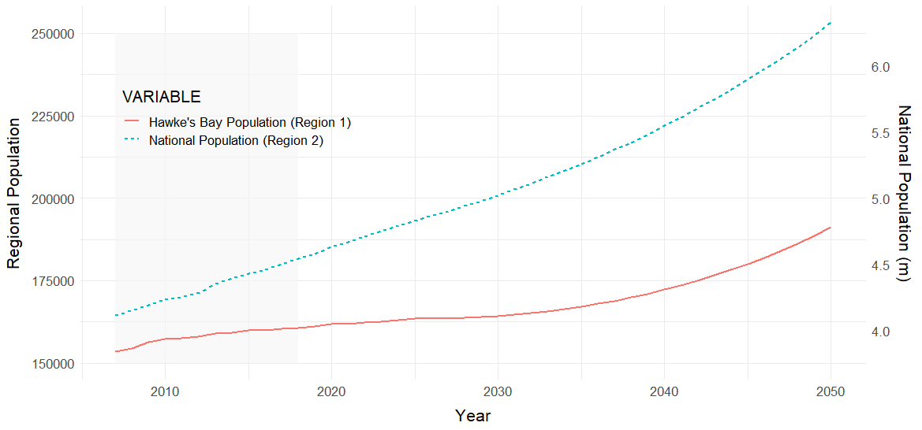

**Figure 7**  The population of Hawke’s Bay and the national population.

As of 2007, there are 1508 households and 943 businesses in the CHZ, totalling 2451 properties. The total number of ‘households’ in the HPUDS area increased by 6.3% between 2009 and 2015 and exceeded the projections (HBRC et al., 2017). Future households will need to be provided for within a smaller land footprint through increased densities in new residential developments and intensive redevelopment of existing residential areas while providing amenity values (HBRC et al., 2017). Thus, Ad hoc and forced retreat infill existing land-use zoning under the baseline scenario.

The household income distribution for both the New Zealand population and Hawke’s Bay is represented in Figure 8 using Lorenz curves. It would appear that between 2013 and 2018 that inequality is on the rise for both the New Zealand population and the Hawke’s Bay population. The Gini coefficients (area under the curve) for 2018 are a) 33.1 for New Zealand (with StatsNZ (2020) defining the same period as 33.2) and b) 20.5 for Hawke’s Bay.

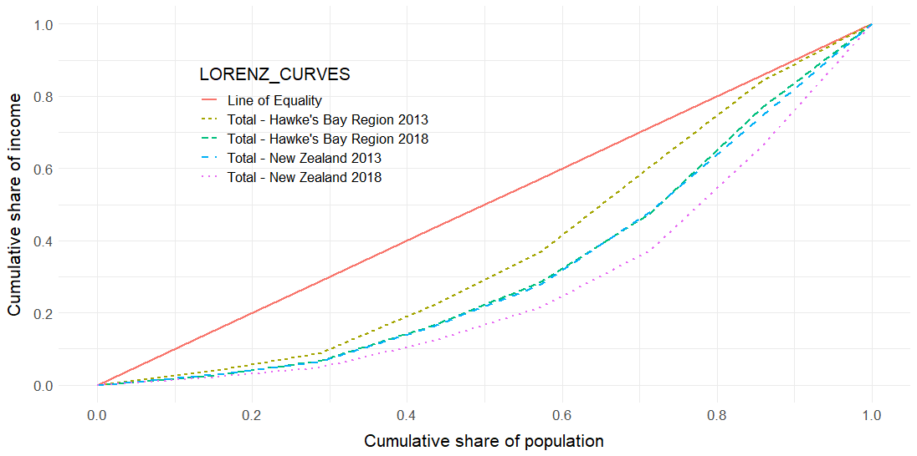

**Figure 8** Lorenz curves prepared from StatsNZ census data for 2013 and 2018 (StatsNZ, 2020) to derive the Gini coefficient.

Under the baseline scenario banks no longer grant mortgages on properties in the CHZ when the AEP > 2%. Banks are regulated to only carry a certain percentage of financial debt from loss of equity in coastal markets (RBNZ communication, 5 December 2018). Regulation forces lending institutions to adjust company policies that de-incentivise remaining in-situ and encourage relocation/reinvestment of an asset repositioned elsewhere (RBNZ communication, 5 December 2018).

#### 1.1.5.1 Decreasing amenity value from coastal hazards

Firms and households pay for local amenities through higher land prices and wages given the attractive local characteristics; with some households willing to accept lower wages to locate to places with valuable features (Bram et al., 2002). The behaviour of households in the CHZ is their tolerance of risk for the perceived benefits of coastal living (Bin et al., 2008), whether they be accessibility, coastal views, ecosystem services or recreation. Taking on risk is understandable when coastal hazard risk is low, and the reward of having proximity to the coastal environment is high. However, the scenario here illustrates that coastal hazards remove land, increase flood damage costs and adjust property markets. Coastal erosion and inundation physically impact structures and erode property values, followed by reducing residents’ quality of life and peace of mind (Geis, 2000; Tonkin & Taylor, 2019). The model set up includes these impacts through hedonic pricing and therefore, links amenity value to property value and wealth (see Appendix 1). The rationale is that as wealth declines, so too in time will amenity value as households generate a negative perception of their economic situation, which is linked to place.

However, environmental satisfaction can outweigh the risk and reduced property value long-term (Bin et al., 2008), as was the case in Haumoana, Hawke’s Bay, where vulnerable residents were offered buyouts in the 1970s and most refused (Tonkin & Taylor, 2019). Similarly, Filippova et al. (2020) countered the argument for declining property values by analysing at-risk house prices to determine that buyers do not factor in long term future risks given the average turnover of a property is a mere six years. Thus the modelled scenario pushes out the trigger level for the effect of coastal hazards on property values to when the exposure is critical (AEP > 2%).

### 1.1.6 Insurance

Property insurance brakes down into two parts; 1) private insurance that covers built capital and contents, and 2) public insurance that covers land through the Earthquake Commission (EQC). Expert workshops held with Insurance managers at the Reserve Bank of New Zealand (RBNZ) and the Clifton to Tangoio Coastal Hazards Strategy 2120 Technical Advisory Group (TAG) informed insurance futures. Industry reports and expert conversations also filled knowledge gaps.

The key concepts are that premiums and excesses reflect risk-based pricing and that the viability of insurers’ in exposed coastal markets is determined by company profitability. Eventually, Adhoc and forced retreat occur for some property owners as insurers withdraw from the market, and the replacement of assets following damages is not justifiable after repeated events. However, EQC has the mandate to provide modest sections to socio-economically vulnerable households.

#### 1.1.6.1 Private insurance

The insurance industry has long been in risk management, primarily employing a short-term reactionary approach to disastrous events through premium prices and claims excesses. In NZ, more than 90% of households purchase private residential property insurance (Fleming et al., 2018b). Insurer’s reliance on historical environmental and economic information shows an ex-post approach from an aggregated claims history, which focuses on post hoc signals and thresholds from extreme years or events (RBNZ communication, 5 December 2018). The onus of insurers is on profitability and viable capital management, rather than civic responsibility (RBNZ communication, 5 December 2018). Therefore to date, there has not been a direct translation between flood risk, section elevation, floor height and insurability.

The trend is toward risk-based pricing, price modelling and forecasting for private insurance. Increased risk-based pricing requires more granular data to rate properties more precisely and locally. More granular data and modelling can alleviate market uncertainty for insurers where environmental effects are ambiguous (RBNZ communication, 5 December 2018). However, this undermines the objective of insurance to pool risk (risk transfer), rather than only back low-risk properties. Risk-based pricing means that insurers will inevitably withdraw from high-risk consumers as it becomes more certain that sea-level rise will affect their assets.

The AEP (risk) defines the insurability of coastal assets, with contracts renewed annually. Insurers are only willing to cover properties where the AEP < 2%, above this amount, insurers withdraw from the market. Conversely, households are only willing to pay up to 5% of household income toward insurance; otherwise, consumers withdraw from the market. Similarly, they are only willing to lose 5% of their built capital wealth. The model initially calculates the household insurance premium at NZ$20071,000 and calibrates to NZ$20071,500 by 2018 to conform with Corelogic Inc (2018). During the 2016 financial year, New Zealand households on average spent 17.6% of their income on housing costs (mortgage or rent expenses, property rates and building-related insurance) (StatsNZ, 2016). Given that the median household income was NZ$201353,200 (StatsNZ, 2020) in 2013, 5% represents a tolerable percentage.

#### 1.1.6.2 Public insurance (EQC)

The EQC provides natural disaster insurance for homes and land (Earthquake Commission NZ, 2019) and is controlled by the Earthquake Commission Act 1993. Technically, it is a social policy instrument that incentivises insurance to limit the Government’s vulnerability to a natural disaster (Hugh Cowan, former EQC Research Manager, personal communication, 4 June 2020). Therefore, EQC is part of any discussion on community resilience such as adaptation, risk control or risk avoidance (Hugh Cowan, personal communication, 4 June 2020). By default, EQC is viewed as the insurer of last resort, given its social vulnerability mandate. Between 1980 and 2018, the EQC has paid out close to NZ$2018 300M in claims classified as “landslip/storm/flood” (Fleming et al., 2018b). For the Hawke’s Bay, EQC has paid out NZ$2018 10.1M for weather-related claims over 2000-2017 (Fleming et al., 2018b).

The EQC only insures the land against flooding within 8 m of homes and outbuildings and driveways within 60 m of the dwelling (Earthquake Commission NZ, 2019) for homeowners with existing insurance. Land claims cover the cost to repair land that has been damaged or lost, and they may also cover the reduction in the value of the land (Earthquake Commission NZ, 2019). Where the land is no longer fit for purpose, the EQC reimburses homeowners with the smallest of: the area of damaged land, or 4,000 m2 of land at the site of the damage, or the minimum sized residential building site allowed in the area in which you live (Earthquake Commission NZ, 2019). Insurance excesses are set at 10% (min - $500, max - $5,000) for land (Earthquake Commission NZ, 2019). However, EQC may limit cover where a property is in imminent danger from landslip, storm or flood damage and that further damage could reasonably be, or have been, avoided by the owner (Earthquake Commission NZ, 2019). EQC’s recent claims history has included an increasing proportion of payouts to compensate for the land loss (Tombs & France-Hudson, 2018). Historically, EQC was a reactive government entity facilitating recovery post unforeseen and catastrophic events (Tombs & France-Hudson, 2018). Now it invests heavily in research and policy development toward resiliency (Hugh Cowan, personal communication, 4 June 2020).

Where homeowners do not have existing insurance and therefore, have not contributed to EQC, the Government may have set a precedent after the Christchurch earthquakes by paying out uninsured and underinsured homeowners (Stepanova, 2018). 103 ex-gratia payments were made to residents in the ‘residential red-zone’ (Stepanova, 2018), an area deemed highly exposed to further earthquake damage or flooding. The Government ruling was determined on the premise that an area-wide response was required to support recovery, and the ruling did not differentiate households based on insurance status (Stepanova, 2018).

### 1.1.7 The Defence Scenario

The defence scenario is the ‘historical practice scenario’ where communities choose to defend the shoreline against coastal hazards. Technically, it illustrates a baseline scenario where communities decide to defend their properties against the ravages of the sea with the aid of the Local Government. Local Government mitigates against hazard through defence structures along the coast. There are two pertinent issues for coastal defence; cost and timing. The costs have been calculated by HBRC (2019, 2020) and the trigger levels for the timing of any implementation is defined by scenarios put forward by coastal engineers.

The Clifton to Tangoio Coastal Hazards Strategy 2120 (HBcoast, 2017) outlines a series of preferred options for each community to manage coastal hazards through to 2120. The options include (Infometrics Consulting Limited, 2017):

1. Renourishment of the beach;

2. Control structures such as groynes and breakwaters, with renourishment;

3. Sea wall;

4. Stopbanks;

5. Flood gate;

6. Retreat the line;

7. Managed retreat.

The options predominantly favour short to medium term coastal defence through control structures, followed by a managed retreat long term (HBcoast, 2017). However, this scenario only focusses on the short-term pathways for coastal defence outlined by the Strategy. The cost of defence and pathways were derived from HBRC’s (2019, 2020) design and cost estimates to implement short-term strategies (Table 9). It is assumed that defence structures last 20 – 30 years (Infometrics Consulting Limited, 2017) with an ongoing maintenance program outlined by HBRC (2019, 2020) once installed.

Trigger levels determine the implementation of defence strategies before significant exposure is imminent and were designed with coastal engineers' knowledge. Given the diversity in spatial extent, each management cell requires a different implementation timeframe given different environmental factors affecting each community. Therefore Pandora requires a trigger level based on water level due to its estuarine environment. In contrast, all other cells are open coast and therefore trigger levels are derived from the rate of erosion. Inundation levels and erosion rates are determined by HBRC (2019, 2020) after consultation with Jose Beya (HBRC coastal engineer, personal communication, 15 October 2020).

The inundation trigger level for Pandora was suggested by Mike Allis (NIWA coastal engineer, personal communication, 29 October 2020) when 1-2 10% AEP events affect property foundations over ten years. The trigger level should not be based on episodic extremes, which may only reflect natural climate variability (Mike Allis, personal communication, 29 October 2020). They should reflect the slower onset or trend of the natural system responding to climate change, such as multiple inundation events over time, salinisation or chronic erosion (Mike Allis, personal communication, 29 October 2020).

The erosion trigger level required establishing distances between structures and the sea and the current rate of change for the coastline. The approach is similar to that used by NIWA (2017a) at Carters Beach, West Coast. GIS analysis averaged the distance from MHWS to close exposed dwellings for each cell. Although isolated buildings (surf clubs, campgrounds, boat sheds, etc.) and utility infrastructure were exempt from the calculation. A building buffer or offset also provides time for planning, community inertia and implementation; an approach outline by Mike Allis (personal communication, 29 October 2020) and the Ministry for the Environment (2017). A buffer of 7 m was suggested by Tom Shand (Tonkin and Taylor coastal engineer, personal communication, 28 October 2020) which is based on a subdivision ruling by the Environment Court at Mahanga Beach, Mahia (see NZEnvC 83 "Mahanga E Tu Inc v Hawkes Bay Regional Council," 2014).

Table 9 Pathways and community coastal defence costs, as described by Infometrics Consulting Limited (2017) and HBRC (2019, 2020).

|  |  |  |  |  |  |  |  |  |
| --- | --- | --- | --- | --- | --- | --- | --- | --- |
| DEFENCE COSTS FROM HBRC (2019, 2020): | | | | | | | | |
| Area | **Maintenance** | **Invest Cost** | **Invest Cost** | **Timeframe** | **Defence of** | **Linear** | **Comments** |
| **($M a-1)** | **($M-2019)** | **($M-2007)** | **shoreline* (m)** | **Cost ($ m-1)** |
| Te Awanga & Haumoana | 2.20 | 69.1 | 55.28 | Short term | 3,700 | 18,676 | Groynes. |
| Northern Cell | 2.88 | 7.05 | 5.64 | Short term | 1,950 | 3,615 | Gravel and sand nourishment. |
| Clifton Unit | 0.15 | 3.47 | 2.78 | Short term | 1,300 | 2,669 | Revetment & nourishment. Installed 2018. |
| Pandora | 0.05 | 49.04 | 39.23 | Short term | 2,144 | 22,873 | Stop banks, sheet pile, revetments, sailing club upgrade, road raising & stormwater. |
| TOTAL | **5.28** | **128.66** | **102.93** | **TOTAL** | **9,094** |  |  |
| 2007 inflation adjust | 0.8 |  | 0.8 | **Average cost ($/m)** | | **14,148** |  |
| TOTAL VALUE 2007 | **4.23** |  |  |  |  |  | * HBRC values |
| ESTIMATED MODEL TIMEFRAME FOR THE IMPLEMENTATION OF COASTAL DEFENCE: | | | | | | | | |
| Timeframe | **Trigger level** | **Erosion rate\*** | **Building buffer** | **Buffer offset** | **Implementation** | **Invest Cost** | **Comments** |
| **(m a-1)** | **to MHWS (m)** | **(m)** | **(Year)** | **($M-2007)** |
| Clifton Unit | Installed | - |  |  | 2018 | **2.78** |  |
| Short-term Pandora Unit | Inundation | - |  |  | 2030-2050 | **39.23** | Triggers when TWL > 12 m RL (MSL > 3.183 m) on two occasions. |
| Short-term northern cell | Erosion rate | 3 | 54 | 7 | 2033 | **5.64** | Westshore (benchmark HB13) erosion rate. |
| Short-term southern cell | Erosion rate | 0.65 | 21 | 7 | 2038 | **55.28** | Haumoana & Te Awanga average (benchmark HB2, HB3, HB4) erosion rate. |
| TOTAL |  |  |  |  |  | **100.15** | * HBRC values |
| DEFENCE COSTS FROM HBRC (2019, 2020): | | | | | | | | |
| Area | **Maintenance** | **Invest Cost** | **Invest Cost** | **Timeframe** | **Defence of** | **Linear** | **Comments** |
| **($M/yr)** | **($M-2019)** | **($M-2007)** | **shoreline* (m)** | **Cost ($/m)** |
| Te Awanga & Haumoana | 2.20 | 69.1 | 55.28 | Short term | 3,700 | 18,676 | Groynes. |
| Northern Cell | 2.88 | 7.05 | 5.64 | Short term | 1,950 | 3,615 | Gravel and sand nourishment. |
| Clifton Unit | 0.15 | 3.47 | 2.78 | Short term | 1,300 | 2,669 | Revetment & nourishment. Installed 2018. |
| Pandora | 0.05 | 49.04 | 39.23 | Short term | 2,144 | 22,873 | Stopbanks, sheetpile, revetments, sailing club upgrade, road raising & stormwater. |
| TOTAL | **5.28** | **128.66** | **102.93** | **TOTAL** | **9,094** |  |  |
| 2007 inflation adjust | 0.8 |  | 0.8 | **Average cost ($/m)** | | **14,148** |  |
| TOTAL VALUE 2007 | **4.23** |  |  |  |  |  | * HBRC values |
| ESTIMATED MODEL TIMEFRAME FOR THE IMPLEMENTATION OF COASTAL DEFENCE: | | | | | | | | |
| Timeframe | **Trigger level** | **Erosion rate\*** | **Building buffer** | **Buffer offset** | **Implementation** | **Invest Cost** | **Comments** |
| **(m/yr)** | **to MHWS (m)** | **(m)** | **(Year)** | **($M-2007)** |
| Clifton Unit | Installed | - |  |  | 2018 | **2.78** |  |
| Short-term Pandora Unit | Inundation | - |  |  | 2030-2050 | **39.23** | Triggers when TWL > 12 mRL (MSL = 3.183 m) on two occasions. |
| Short-term northern cell | Erosion rate | 3 | 54 | 7 | 2033 | **5.64** | Westshore (benchmark HB13) erosion rate. |
| Short-term southern cell | Erosion rate | 0.65 | 21 | 7 | 2038 | **55.28** | Haumoana & Te Awanga average (benchmark HB2, HB3, HB4) erosion rate. |
| TOTAL |  |  |  |  |  | **100.15** | * HBRC values |

From Table 9, an indicative Total Defence Cost (annual cost) and Cumulative Defence Cost (total project cost) over time are visible in Figure 9.

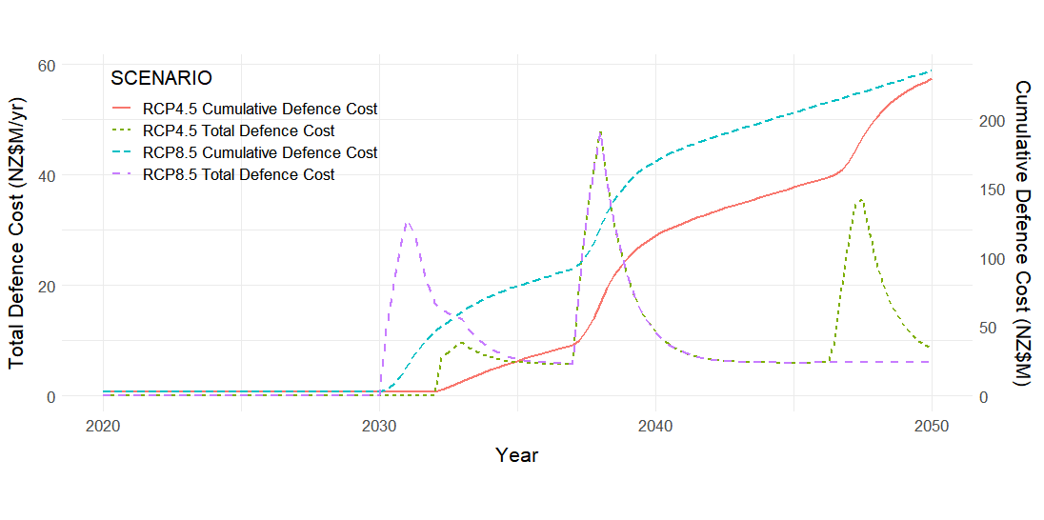

**Figure 9** An indicative Total Defence Cost (annual cost) and Cumulative Defence Cost (total project cost) for the Defence scenarios. The Clifton intervention occurs before 2020, and hence the Cumulative Defence Cost lines are above zero. The erosion-based triggers for the Northern and Southern cell are the same regardless of climate scenario. However, Pandora cell intervention is determined by the climate scenario.

Therefore the general synopsis is:

1. Local Government installs a property rating tax on the district and region to pay for coastal defence. Local Government introduces the general and targeted rate as outlined by HBRC in Sharpe (2019). Rates are set at a $15 regional rate and $15 district rate per property per year (Sharpe, 2019) and increase over the model period.
2. In the short-term, communities endure any nuisance flooding until defence structures are installed by Local Government.
3. Capital and maintenance costs from Table 8 are integrated into MERIT.
4. Local Government successively installs the coastal defence structures when trigger levels are exceeded. For inundation, two flood events exceed the 12 m NZVD2016 trigger for Pandora defence. For erosion, breach of the 7 m dwelling buffer zone triggers northern and southern cell defence.
5. Defence structures last 20 – 30 years before replacement is required.

### 1.1.8 The Climate Bonds Scenario

Climate bonds are an innovative funding approach currently under investigation by the New Zealand Government to manage climate change risk (Herd, 2018). It is the most common way for governments to generate capital (Maoate-Cox, 2020). A bond is a type of loan which institutions and companies use to finance projects (Climate Bonds Initiative, 2019). “The issuer of the bond (the borrower) owes the holder (the creditor) a debt and, depending on the terms they agree on, is obliged to pay back the amount lent within a certain time and with a certain interest” (Climate Bonds Initiative, 2019). There is currently NZ$80B in bonds issued by the New Zealand Government (Maoate-Cox, 2020). Investors are attracted to these highly liquid debt instruments that can break down the financial barriers to coastal adaptation investment (Bisaro & Hinkel, 2018). Climate bonds provide investors with opportunities to direct capital to climate change solutions, where before there were few opportunities (Climate Bonds Initiative, 2019).

The central government bonds intervention scenario enables a managed retreat by issuing climate bonds to investors to generate capital. Fortunately, there is already a system for generating and repaying bonds in place (Maoate-Cox, 2020). The capital generated is then invested in high-return offshore markets until it is drawn down for climate-related ventures across the country on an ‘as required’ basis. The central government takes the role of ‘development partner’ (Hall & Lindsay, 2017) by purchasing exposed properties from households and firms. Local government must still amend land-use zoning for relocation. Households and firms then invest elsewhere. The central government can then lease ceded properties until the risk becomes critical. Climate leasing was an outcome of the TAG expert workshop (8 November 2018). The following steps are involved in the process which covers procedure outlined by the Climate Bonds Initiative (2019), Climigration (Taylor-Hochberg, 2017) and Treasury’s acting director of capital markets Kim Martin (Maoate-Cox, 2020):

1. Banks create an investment fund to raise capital; for example, the New Zealand Green Investment Finance fund (Herd, 2018).
2. The investment fund issues a 10-year Climate Bond when the AEP > 1.2% (around 2024) to finance projects that address climate issues (Climate Bonds Initiative, 2019). They are managed under the existing mechanism for issuing New Zealand Government Bonds (Maoate-Cox, 2020). Issuance of a $35B bundle at the national level is implemented to cover all climate emergencies ( $35Bn based on model sensitivity analysis – Latin hypercube sampling).
3. The government auctions bonds to registered tender counterparties, such as domestic or offshore banks (Maoate-Cox, 2020).
4. Tender counterparties then seek diverse investors, such as fund managers, central banks, pension funds or individuals, to purchase bonds (minimum NZ$10,000) as a legal contract with the New Zealand Government managed by the Treasury (Climate Bonds Initiative, 2019; Maoate-Cox, 2020).
5. Capital generated from bonds is invested offshore in high-yield corporate bonds with an interest rate of 5% return to increase capital (Latin hypercube sampling).
6. Bonds mature after ten years with a fixed interest rate (coupon payment) of 3.13% p.a. 3.13% represents the average percentage annual return on investment from seven issues by the Climate Bonds Initiative (Tapley, 2016). The coupon payment to investors is generally twice a year, usually based on the prevailing market interest rate (Maoate-Cox, 2020). However, under this scenario, a monthly payment is made based on the fixed interest rate.
7. The central government then draws down on its available funds to purchase the exposed properties (TWL>12 mRL, or MSL>3.183 m, on two or more occasions).
8. Finance generated is directed into purchasing exposed properties by the central government. The owner can then use the payment to buy another property elsewhere.
9. Land-use zoning is increased to meet the supply for a managed retreat.
10. Some properties are leased medium-term to interested parties until exposure to coastal hazards is intolerable (when AEP>3%) and managed retreat is inevitable (Tanya Stul, Coastal Engineer Seashore Engineering, Australia, 9 September 2018).
11. Medium-term leases allow communities to carry out activities for a time and relocate in a timely fashion. They also provide a rental income stream to the Government.

Figure 10 illustrates the transactions for the climate bonds scenario from the climate bonds module. The Regional Bond Funds represent the annual cash flow from the central government to exposed properties in the CHZ. As the peak amount of funding is reached, illustrated by the Cumulative Bonds Funds, the rate of central government bond funding dries up. The accumulation of bond funding seeks to cover the NZ2007$2.4B of assets exposed under the 1% AEP for 2120, as outlined earlier in the direct impacts.

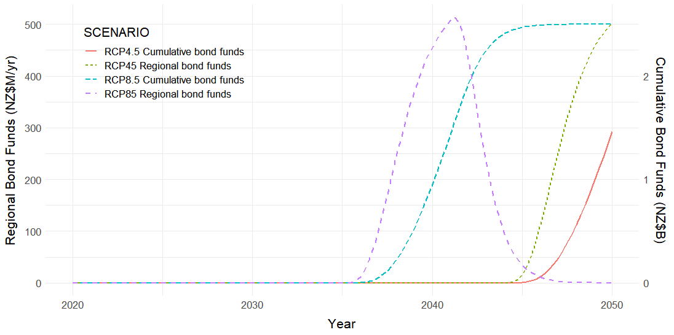

**Figure 10** The indicative outputs for allocating central government climate bonds to purchase exposed properties under the two climate projections. Note that the full allocation is not reached under the RCP4.5 scenario. The Regional Bond Funds is the annual rate of capital purchases by the central government, and the Cumulative Bond Funds is the tally of bond funding over the period.

### 1.1.9 The Property Rates Scenario

The general synopsis is that Local Government as ‘direct investor’ (Hall & Lindsay, 2017) generates capital to finance managed retreat through general and targeted rates, otherwise known as property taxes. Similar to climate bonds, the intervention requires amending land-use zoning for relocation. The two taxes are 1) a general rate for all property owners within the region and district, split into an enterprise rate and a household rate, and 2) a targeted rate or a specialised annual charge on properties in the CHZ. The general rate split is so a higher weighting is imposed on enterprises with more cash flow to absorb the tax than households. General rates are already employed by Local Government in Hawke’s Bay to generate capital to defend against sea-level rise and coastal erosion (Sharpe, 2019). The targeted rate applies a ‘beneficiary-pays’ approach, where some of the costs of the managed retreat are recouped from beneficiaries. Thus, differential (targeted) property rates are similar to a user fee as “they impose the heaviest cost burden of a project on residents who have the highest demand” (Mullin et al., 2019, p. 277). However, given the scale of managed retreat, a targeted rate alone will not generate enough capital to undertake the relocation.

There was firm support for property rates from the TAG expert workshop (8 November 2018) as the second-equal most acceptable option, after leaving it up to the household. However, the Local Government would like to see this issue funded by the Central Government. The RBNZ expert workshop (5 December 2018) also considered this as a viable option. The Waikato Regional Council (2018) currently use this approach for flood protection, river management and land drainage with a funding split of 85% generated through a targeted rate and 15% generated through the general rate.

Under the Property Rates Scenario, the Local Government assumes the role of ‘Direct Investor’ (Hall & Lindsay, 2017) through providing sufficient land, development services and subsidies (RBNZ communication, 5 December 2018). However, the managed retreat cost is beyond the financial capacity of many councils (RBNZ communication, 5 December 2018). Therefore, the three councils must set up a Council Controlled Organisation (CCO) to implement and control the managed retreat while the open market undertakes the construction. The following steps are involved:

1. The Local Government levies a targeted and general rate on properties when the AEP > 0.8%. The general rate includes a differential between households and enterprises.
2. The general rate for enterprise starts at NZ$262.50 p.a. for each property in the rating district. The general rate for households starts at NZ$87.50 p.a.
3. A local authority rate is set for each property in the NCC and HDC jurisdictions and the regional rate for each property in the HBRC Region. The rate is a fixed charge rather than based on capital value. A fixed-rate model was a preferred option from respondents of a proposed Water Quality Targeted Rate by Auckland Council (Auckland Council, 2017).
4. All rates increase at 5% p.a. The general rate incrementally increases as the rating base increases. The targeted rate decreases as properties leave the CHZ. The targeted rate also proportionally increases as properties leave the CHZ, which incentivises withdrawal.
5. Rates revenue gathered is invested by Local Government into capital projects for enterprises and households. Government expenditure is enabled when a TWL > 12 m is breached on two or more occasions.
6. A Local Government Council Controlled Organisation (CCO) administers and manages the relocation for households and industries (TAG communication 8 November 2018). Local Government undertakes land purchase and builds capital for the managed retreat. Both the Napier City Council and the Hastings District Council already have departments for managing economic development (see Hastings District Council, 2020; Napier City Council, 2020). Collaboration and integration of these departments into one CCO is required to reflect the objectives of HPUDS and manage the retreat.
7. The CCO allocates built capital to the private sector in collaboration with enterprise and households to match demand.

Figure 11 illustrates the transactions for the Rates scenario. It illustrates the time-series output for the allocation of Local Government investment funds generated through property taxes to construction projects and land acquisition. Similarly to bonds, the cumulative rates funds peak at NZ$2.4B. The model applies a 2-year lag between tax generated and capital expenditure.

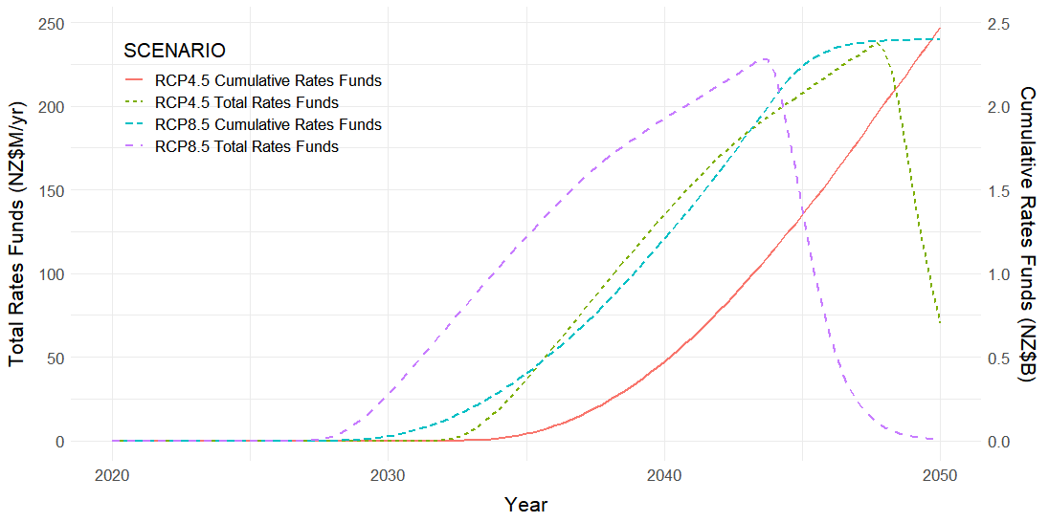

**Figure 11** Indicative Property Rates generated for capital investment by Local Government under the two climate projections. Similarly to the Bonds Scenario, RCP4.5 has not peaked during the modelling window. The Total Rates Funds is the annual rate of capital purchases (both land and built capital) by the Local Government, and the Cumulative Rates Funds is the tally of bond funding over the period.

### 1.1.10 Land-use Planning Scenario

The model derives the amount of land required under each scenario; whether greenfield conversion or intensification of current zoning. For both intervention scenarios, legislative change is required to enable a managed retreat. Thus, councils require an ‘Enabling Act’ from Central Government that provides powers to: condemn buildings unfit for habitation, streamline land-use zoning, enforce relocation and provide enforcement action for non-compliance (TAG communication 8 November 2018). Therefore, if an exposed area's withdrawal is required before risks become significant, then bespoke legislation to enable relocation should be considered (Grace et al., 2018). The Enabling Act alongside amendments to the RMA, as outlined by Grace et al. (2018) provide an avenue for effective implementation. The land-use planning steps are:

* 1. Amend the RMA1991 so that regional rules and regional policy statements can manage existing uses, existing development, future development and risk reduction (Grace et al., 2018):
     1. Introduce rules to manage the rebuilding of damaged dwellings, such as requiring buildings to be set back within the site.
     2. Introduce rules to require existing uses to necessitate a resource consent, with a finite duration that aligns with a particular increase in sea level. Permitted activities in the CHZ change to become discretionary activities in the medium-term, given prohibited activity status over the long term (TDC [2011] NZEnvC 47).
     3. Enhance risk reduction through rules that make existing uses prohibited activities.
  2. The Local Government Long Term Plan modifies the CHZ to a residential, commercial, industrial or rural closed zone; a zone closed to future development and subdivision (TDC [2011] NZEnvC 47). The TDC introduced zone closures with Plan Change 22 in 2011.
  3. The Long Term Plan also provides new zones in the District Plan of habitable land close to the CHZ to suit the adaptation needs of the community (Tasman District Council (TDC) [2011] NZEnvC 47). The Long Term Plan contains strategic structure plans that enable industries to relocate with similar business viability factors.
  4. The Long Term Plan should go beyond the usual ten year period and follow similar timeframes to that of the Urban Development Strategy and asset management plans of 30 years.
  5. Risk assessments of environmental trigger levels set the timing of the managed retreat of exposed communities. Exceeded trigger levels also lead to a scaling back of council service provision in the CHZ allowing the redirection of resources to new locations.

Finally, Figure 12 suggests appropriate areas for intensification and relocation given the current zoning according to NCC and HDC planning documents. Raster analysis through map algebra in ESRI ArcGIS devised suitable areas for relocation and infilling given current planning documents. Areas unfit for habitation or already allocated for public function were highlighted in black. What becomes clear is the abundance of primary production land which could be converted to commercial or industrial land. However, contestation exists on the Heretaunga Plains as these areas are most suitable and reserved for horticulture and fruit growing (Radio New Zealand, 2020) but are also the easy and cheap areas to develop for intensive land-use purposes due to topography.

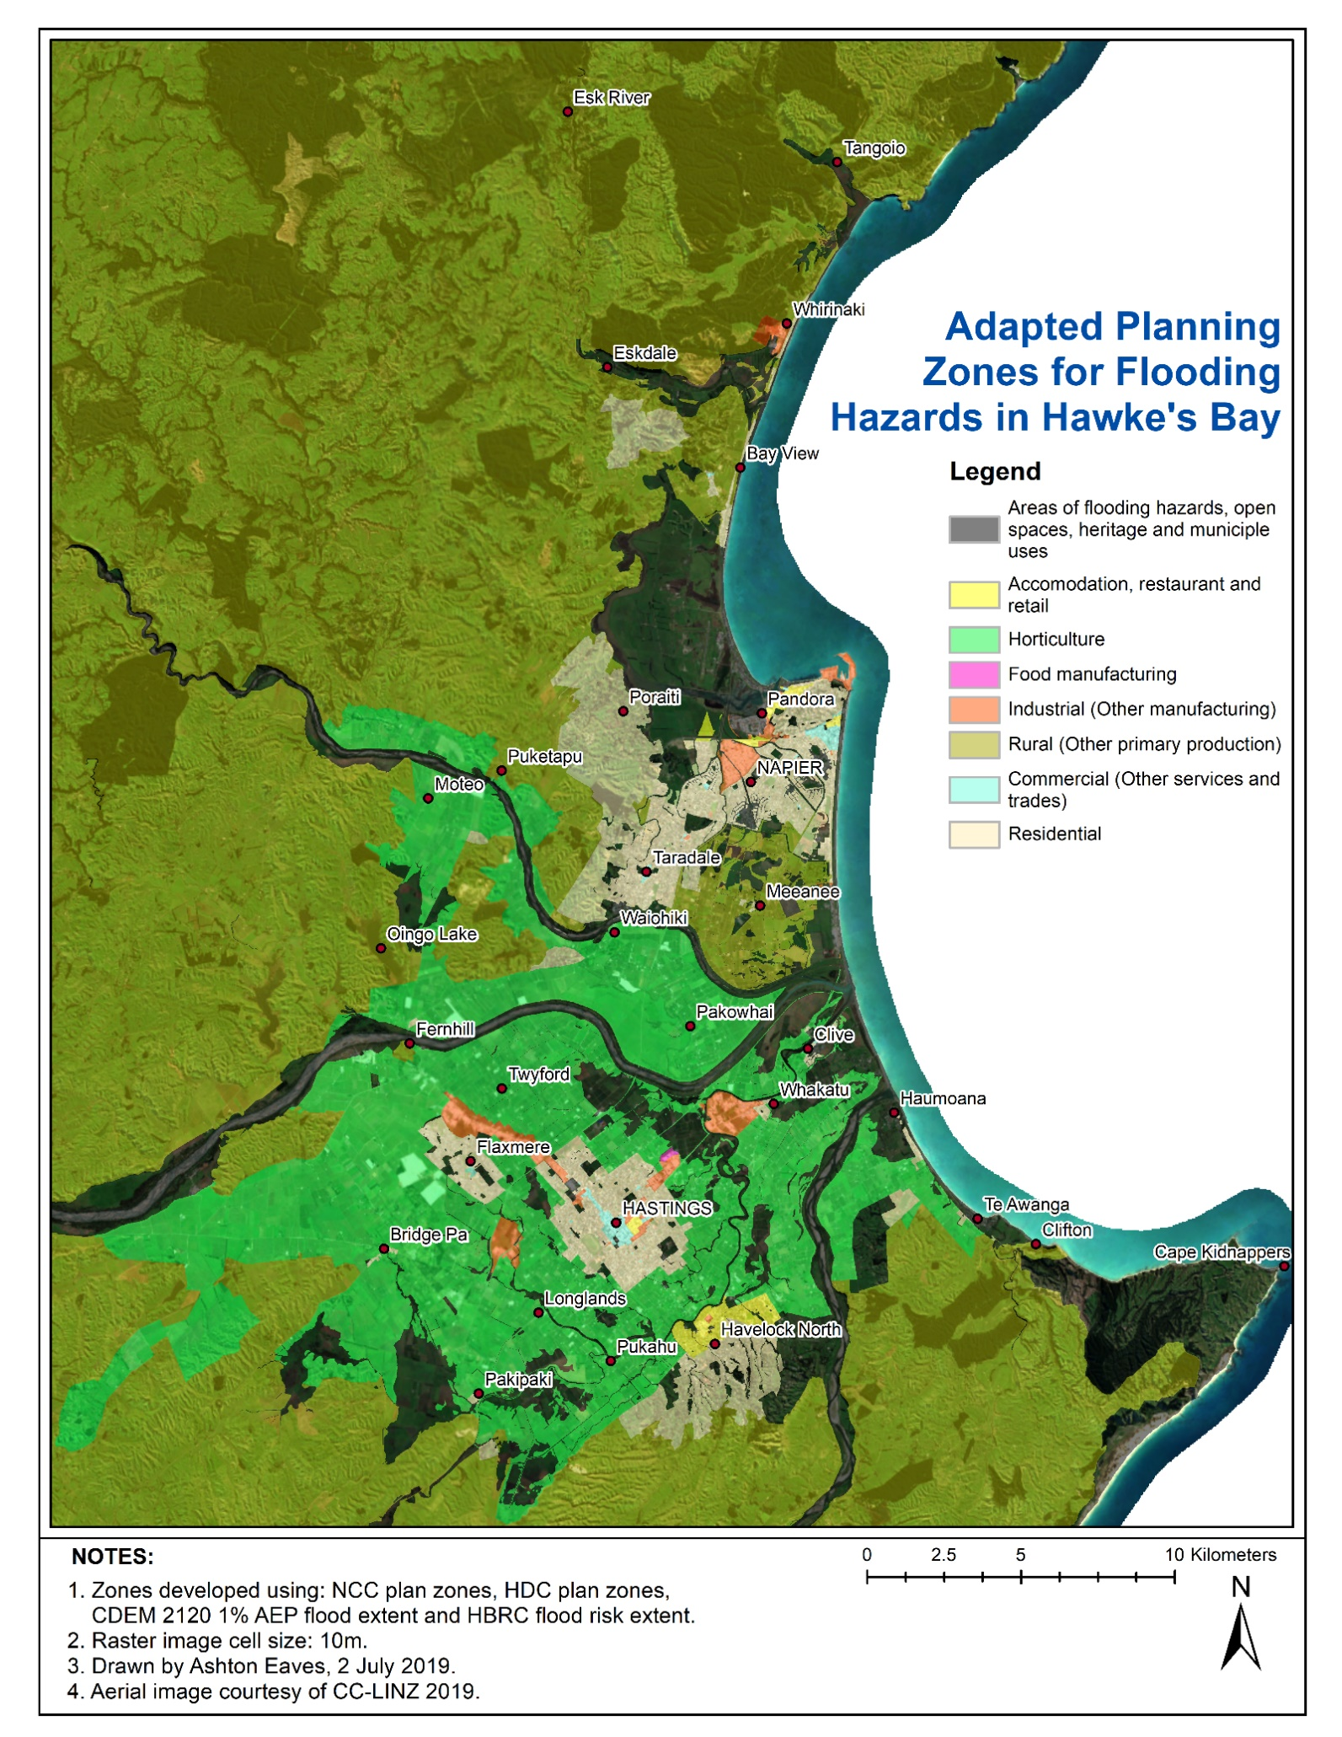

**Figure 12** Possible sites for a managed retreat based on ESRI ArcGIS raster analysis map algebra.

## 1.2 Develop modules for direct impacts and interventions

Input modules concentrate on causal relationships between variables to understand exogenous system drivers to MERIT. Initial causal mapping derives the modules to provide a theoretical framework of relationships, influences, external factors, lags and delays in the system (Smith, Orchiston, et al., 2016). Modules can represent activity models, natural systems models and valuation models (Turner, 2000) that allow for processing data and building system relationships through System Dynamics. They become hard-linked to MERIT in C-ADAPT to create an integrated (closed) system. A hard-linked IAM's strength is internal consistency, rigorous mathematical foundations, and the execution of long-term, multi-dimensional policy optimisation useful for risk and damage computations (Bosello, 2014). Conversely, soft-linked models involve massive interconnected interdisciplinary frameworks which tend to be more comprehensive at a point in time (Bosello, 2014).

Modules incorporate a) risk through assessing physical system drivers, spatial and hydrologic data from councils and LINZ; b) household and firm behaviours through socio-economic data from StatsNZ and logic from scenario planning; c) the cost of defending the shoreline from HBRC and d) finance and insurance interventions from scenario planning and e) land-use planning projections from council long term plans. Modules also utilise knowledge learned from the National Science Challenge: Living at the Edge; funded by the New Zealand Ministry for Business Innovation and Employment. Therefore, the modules are:

1. the Risk Assessment Module;
2. the Socio-Economic Module;
3. the Infrastructure Interdependencies Module;
4. the Defence Module;
5. the Climate Bonds Module;
6. the Rates Module;
7. and the Land-Use Zoning Module.

### 1.2.1 The Risk Assessment Module

The Risk Assessment Module calculates the physical hazard and economic exposure by applying stochastic floods and inundation that directly impacts natural and built capital as damages and losses to local communities. It combines geospatial information with time-dependent hydrological and socio-economic information. This approach is conceptually similar to Peck et al. (2014) who coupled ESRI ArcGIS® with Vensim® for flooding and infrastructure outages. The value of vulnerable capital assets and replacement costs were estimated at NZ$2007 2.4Bn [1] in the CHZ as defined by the 2009 Riskscape database (King & Bell, 2005; NIWA, 2017c; Reese & Ramsay, 2010) and Local Government valuations. The 1% AEP for 2120 outlined by the HBRC and Civil Defence and Emergency Management defines the CHZ, or spatial vulnerability (HBRC, 2017). There is 1094 Ha of vulnerable land (natural capital) in ownership, totalling NZ$2007248M (NIWA, 2017c) and a further 702 Ha of vulnerable land used for infrastructure, ecosystem services, and amenities. Figure 13 illustrates the stock-flow diagram for the Risk Assessment Model.

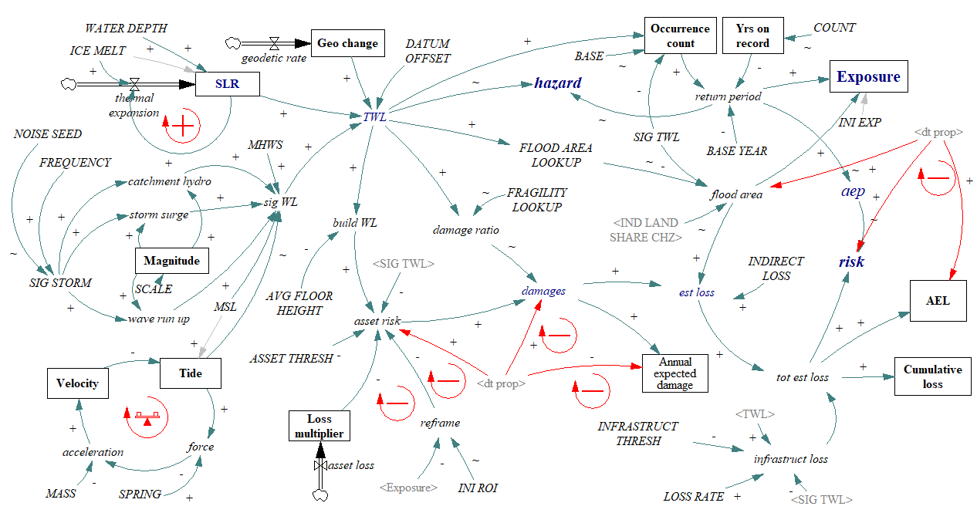

**Figure 13** The stock-flow diagram of the Risk Assessment Module. It features linear operation from significant total water levels (*TWL* and *SIG TWL*) to damages (*Annual expected damage*) and losses (*AEL* and *Cumulative loss*) incurred. Balancing dynamic feedback occurs through *dt prop,* or the percentage of properties in the CHZ, and behavioural reframing (*reframe*) of property investment decision making based on *exposure* and return on investment (*INI ROI*). *SLR* illustrates reinforcing environmental feedback from *thermal expansion.* Significant TWLs are triggered by a random *noise seed* acting on the frequency of storms and the *magnitude* of the event. The *tide* operates expectedly as a diurnal oscillation. Red arrows represent external module influence.

The Risk Assessment Module defines the physical drivers of sea level over time and the estimated damages expected from asset exposure. Sea level data is based on historical data supplied by Napier Port and the HBRC and adjusted to the New Zealand Vertical Datum 2016 (NZVD2016). MSL equals -1.118 m on the NZVD2016. NCC LIDAR validated inundation extents against the NZVD2016 for its area. The remaining area in HDC was validated against the LINZ topographical dataset, a contoured topography of less precision. Sea level rise projections from the IPCC (IPCC, 2014a, 2019b) RCPs, with the national and regional offset (Ministry for the Environment, 2017), are then added to the datum. Finally, the datum is adjusted to account for local geodetic change described in Beavan and Litchfield (2012). Critical water levels for marine storm surge (Komar & Harris, 2014), breaking waves (Komar & Harris, 2014), coastal waterway flooding (HBRC hydrograph) and tide (LINZ, 2012) alongside sea-level rise determine thresholds for inundation to coastal communities. Thus, it is the hazard escalating that is the critical driver of system change.

Quantification of hazard, exposure, vulnerability and risk for the study area are adapted from Foudi and Nuria (2014) for System Dynamics. Thus, inundation extents, return periods, AEPs and estimated damages define hazards, risks, vulnerabilities and exposure. Conceptually, the modelling approach is similar to Johnson et al. (2013) who modelled risk assessment through spatial flood depth and economic exposure to derive the Estimated Annual Damage. The module also uses the approach of Baron et al. (2015) for assessing community exposure to a changing total water level over time. The estimated capital damage and loss were calculated from the 2009 Riskscape database (see NIWA, 2017c), a comprehensive survey of socio-economic vulnerability to coastal flood inundation, and 2017 Local Government property valuations. Dwelling freeboard was also defined by the Riskscape database and stage damage functions defined by Reese and Ramsay (2010). Finally, the total estimated loss combined the estimated capital damage with land loss, clean-up, and remediation costs. Insurance claims highlighted by ICNZ (2019b) and Fleming et al. (2018b) and government valuations calibrate damage and loss.

Infrastructure assets were quantified and valued and added to the risk assessment. Local Government provided information on roads, rail and the three waters network, Unison provided electricity and communications network information, and Powerco provided the information on the gas network. Network valuation followed the same approach as Local Government New Zealand (LGNZ) (2019), who quantifies exposed infrastructure by overlaying GIS polygons of sea-level rise elevations with council infrastructure information to define replacement value. LGNZ value exposed infrastructure in 1.5 m geodetic height increments, whereas this study set to increments; one at 11.5 m RL and another at 2 m RL. LGNZ show that Canterbury has the greatest exposure, followed by Hawke’s Bay (2019). However, the Hawke’s Bay region has the greatest water infrastructure exposure with approximately $430 million exposed to 1 m (approximately 11 m RL) of sea-level rise which includes a treatment plant (Local Government New Zealand, 2019).

### 1.2.2 The Socio-Economic Module

The Socio-Economic Module analyses the components of insurability and the amenity value of coastal living to better understand household behaviour. It uses the stochastic damages and losses from the Risk Assessment Module to discover how stakeholders in the CHZ will respond. It focuses on the interactions between household wealth, income, coastal property amenity, capital vulnerability and insurance. Figure 14 illustrates the stock-flow diagram for the Socio-Economic Model.

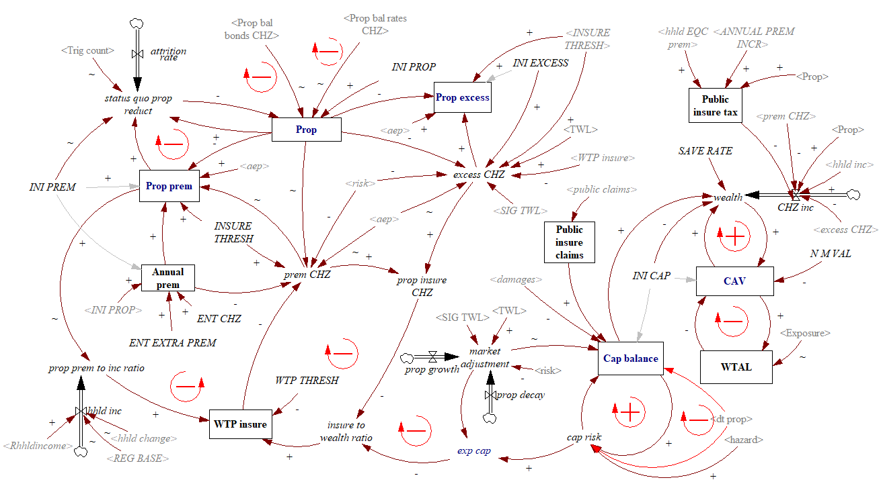

**Figure 14** The stock-flow diagram of the Socio-Economic Module. The left-hand side operators represent insurability (*Prop prem, Annual prem, prop excess,* and *WTP insure*) and properties (*Prop*). In contrast, the right-hand side loops represent capital in the Coastal Hazard Zone (*wealth, Cap balance,* *market adjustment*, and *exp cap*) and coastal amenity value (*CAV, N M VAL*-non-market value, and *WTAL*-willingness to accept loss). As risk increases, insurers increase premiums (*prem CHZ*) and excesses (*excess CHZ*) to a point where they become unaffordable to owners (*WTP THRESH* and *WTP insure*). The scenario alters the property balance (*Prop bal bonds CHZ*, *Prop bal rates CHZ* or *status quo prop reduct*), where implemented rates and bonds scenarios reduce the property count and repeated flooding (*Trig count*) influences the baseline scenario. Coastal amenity is reinforced by WTAL, wealth and the non-market value of coastal living derived from hedonic pricing. Next, the capital balance is influenced by impending hazard, changing property count (*dt prop*) and the risk-based rationalisation of the market (*market adjustment*). Light red arrows represent external module influence.

The Socio-Economic Module defines increasing risk-based insurance premiums and excesses. It also defines when insurers or consumers may withdraw from the market (when the AEP > 2% for insurers or 5% of income for consumers), forcing an *ad hoc* (unplanned) retreat. The model is programmed to undertake *ad hoc* retreat when three significant water levels occur (total water level > 12 m RL). The module also accounts for compulsory public insurance (EQC) to transfer the burden of financial losses from households to the Central Government from floods and inundation. Further detail on insurability is in the scenarios chapter as much of the model insight is derived from the expert workshops and interviews.

The Socio-Economic Module also calculates the non-market amenity value of coastal living through hedonic pricing. Calculating the amenity value helps define property owners’ behaviour given knowledge of the increasing risk to coastal hazards. Hedonic pricing is a form of contingent valuation (Willingness to pay for a non-market good or service) where the benefits of a location are observed through changes in the real estate market (Daniel et al., 2009; Ojea, 2014). A housing unit is considered a differentiated market good represented by a basket of qualitative and quantitative characteristics (Daniel et al., 2009). The implicit value of a characteristic, in this case, location amenity, can be determined through the partial first derivative of the properties’ sales price (Daniel et al., 2009).

The hedonic pricing method of valuation used in this study performed multiple linear regression analysis on 53,800 property sales within commuting distance of the study area. The sales price was the dependent variable, and the distance from the coast was one of the independent variables. This approach follows that of Filippova (2009) for the influence of sub-markets on water-view house price premiums in Auckland, New Zealand and Filippova et al. (2020) to influence future sea-level rise on property values. However, as stated by Daniel at al. (Daniel et al., 2009) and Filippova et al. (Filippova et al., 2020) the techniques of hedonic pricing and regression analysis include a potential bias as property owners may have a subjective perception of the level of risk a property may face from high-impact but low-probability events. Therefore it is often difficult to differentiate the positive influence of coastal environments and the negative influence of coastal hazards.

### 1.2.3 The Infrastructure Interdependency Module

The Infrastructure Interdependency Module determines industry operability given infrastructure outages, or a drop in the level of service provided by infrastructure providers to consumers due to floods. As expected, the level of service provided by critical infrastructure is determined by its reliance on other critical infrastructures for normal operation, with relationships developed by McDonald, Buxton and Fenwick (5 November 2014) and presented at the 2014 New Zealand Lifelines Forum. The loss of service in one infrastructure affects the level of service provision of other infrastructures, and these, in turn, impact other infrastructures and so on. Understanding these interdependencies can be achieved by simulating the reliance and volume of financial exchange between interconnected infrastructure, assumed through measured economic transactions in national accounts (Zorn, 2017).

It operates as follows. Once a significant TWL drives an outage, each infrastructure cycles through its dependency on the other infrastructures. The interdependent level of service for each type of infrastructure is discovered, with the delta time playing a critical role in module accuracy given the timestep of 1.8 days. Such a timestep is not a problem where damages take longer than 1.8 days to repair. However, communication and electricity networks are rapidly repaired or have inherent redundancies reducing the impact to negligible (Zorn, 2017). The individual infrastructures are averaged to discover an ‘average’ outage given the size of the study area. Any changes to the number of properties in the CHZ due to *ad hoc* or managed retreat are also incorporated by increasing an infrastructure’s level of service. The infrastructure assessed are:

1. Electricity
2. Water
3. Sewer
4. Port
5. Airport
6. Communications
7. Rail
8. Road
9. Gas
10. Petrol

Any changes to the number of properties in the CHZ as a result of *ad hoc* or managed retreat are incorporated by increasing the level of service. Not only does this account for the drop in CHZ occupation but also assumes the relocation of infrastructure assets (where possible). Figure 15 illustrates the stock-flow diagram for the Infrastructure Interdependency Model.

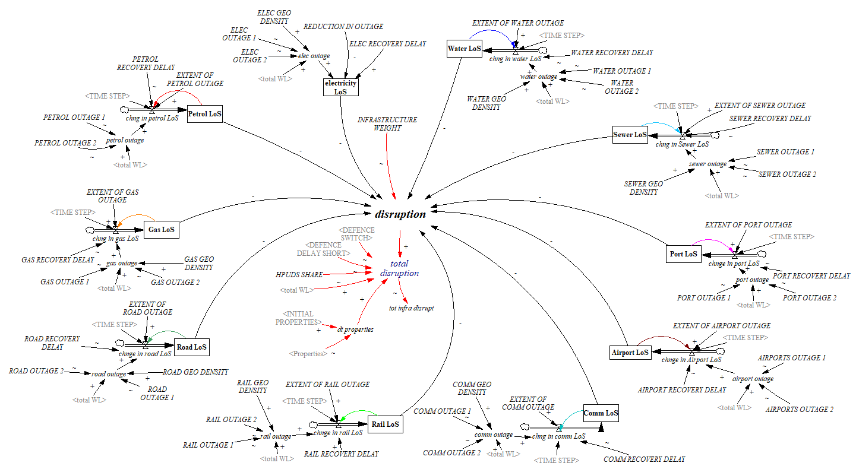

**Figure 15** Vensim® Stock-flow diagram for the Infrastructure Interdependency Module operating at the regional scale.

In addition to economic transactions, the spatial vulnerability, or geographic density of infrastructure, was adapted from Zorn (2017) using the ESRI ArcGIS® kernel density tool to develop time-stamped outage maps (see Appendix 2). The kernel density estimates are a function of the geographic vulnerability of the infrastructure network's spatial location. The GIS calculates the per unit density per unit area by aggregating multiple grids and adapting the quartic kernel function described by Silverman (1986). These estimates were adapted for use in Vensim® in the Infrastructure Interdependencies Module by utilising equation 2. 1 in Zorn (2017) and equation 16 in Brown et al. (2015) to form Equation 1.1. Where *i j* refer to the infrastructure type and *x* the spatial output. The log scalar determines a percentile relationship for density between 0 (very distributed) and 1 (very clustered). The search radius was set at 2 km to account for the CHZ and the infrastructure in the broader area servicing the CHZ.

$y_{j}^{i}=1-e^{-x}$ (1.1)

Table 1 shows the mean outputs by infrastructure type from the Kernel Density Spatial Analyst tool in ESRI ArcGIS® for the density of features in and beyond the CHZ. See section 2.3 for infrastructure outage maps and Table 10, the total kernel density estimates for the greater area.

**Table 10 Infrastructure Kernel Density Estimates from ESRI ArcGIS**® **and modified for Vensim**®**.**

|  |  |  |  |
| --- | --- | --- | --- |
| Infrastructure | CHZ > 2km (μ) | Scaling (μ) | Grouped (μ) |
| ELECTRICITY |  |  | 0.300 |
| HV cable | 0.35 | 0.295 |  |
| HV line | 0.364 | 0.305 |  |
| COMMUNICATIONS |  |  | 0.243 |
| Underground fibre | 0.395 | 0.326 |  |
| Aerial fibre | 0.173 | 0.158 |  |
| SEWER |  |  | 0.230 |
| HDC sewer mains | 1.162 | 0.687 |  |
| NCC main sewer non-critical | 0.002 | 0.002 |  |
| NCC main sewer line | 0.001 | 0.001 |  |
| WATER |  |  | 0.159 |
| HDC water mains | 0.169 | 0.155 |  |
| NCC water main non-critical | 0.003 | 0.003 |  |
| NCC water main critical | 0.0005 | 0.001 |  |
| STORMWATER |  |  | 0.131 |
| HDC stormwater mains | 0.302 | 0.261 |  |
| NCC drainage pipes | 0.002 | 0.002 |  |
| GAS |  |  | 0.495 |
| Distribution main | 1.249 | 0.713 |  |
| Service | 0.323 | 0.276 |  |
| ROADS | 0.758 | 0.531 | 0.531 |
| RAILWAY | 0.159 | 0.147 | 0.147 |

### 1.2.4 The Defence Module

The Defence Module provides MERIT with pathway costs for coastal defence structures courtesy of HBRC (HBRC, 2019, 2020) and implementation triggers outlined in the Defence Scenario. There are three costs introduced by different trigger levels to a series of functional delays to reflect an accurate value and timing. The short-term trigger for Pandora relies on counting the amount of total water level exceedances of the 12 m NZVD2016 height. Whereas the northern and southern short-term cells rely on the erosion timing outlined in the Defence Scenario implemented through a set of delays activated by the model Time variable. The Clifton cell cost is installed at the time of construction being 2018. The maintenance cost of defence structures is also employed here once implementation has been completed for a cell. Funding the defence structures is outlined by Sharpe (2019) and utilises the Rates Module for model integration. Figure 16 illustrates the stock-flow diagram.

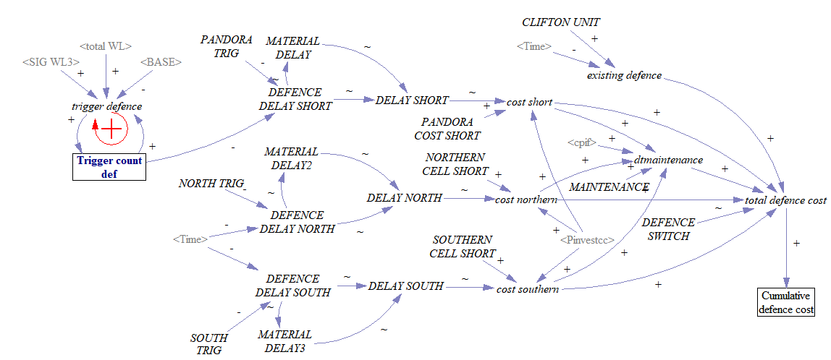

**Figure 16** Vensim® Stock-flow diagram for the Defence Module operating at the CHZ scale.

### 1.2.5 The Climate Bonds Module

The Climate Bonds Module allows the Central Government to raise capital by issuing a NZ$200735Bn bundle of climate bonds to cover all New Zealand climate disasters. Investors purchase bonds such as pension fund managers and individuals (Climate Bonds Initiative, 2019). The bonds reimburse investors 3.13% interest for a term of 10 years. Government capital is invested offshore in corporate high-yield bonds at 5% p.a. until required. Approximately NZ$20072.4Bn is allocated to Hawke’s Bay when the AEP of flooding exceeds 1%. The Central Government takes the role of ‘Development Partner’ (Hall & Lindsay, 2017) by purchasing exposed properties from households and firms. Finance generated is directed into mortgage contingent loans; where exposed owners cede their property to the government, which then issues them a commercial loan tied to their home's value to use to buy another property elsewhere (Taylor-Hochberg, 2017, www.climigration.org). The Central Government can then lease properties until the risk becomes severe. Figure 17 illustrates the stock-flow diagram.

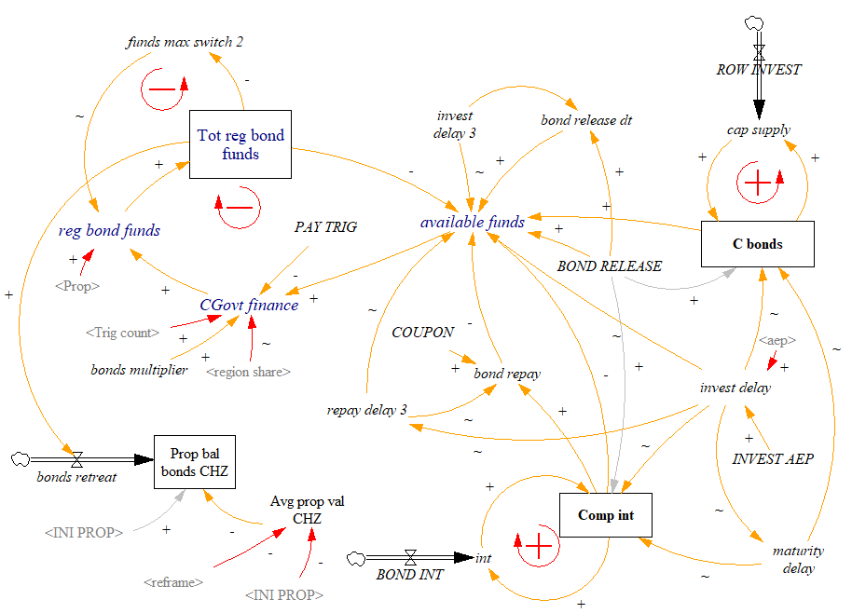

**Figure 17** The stock-flow diagram for the Climate Bonds Module operating at the national scale through central government by utilising Vensim® subscripting for governments. Reinforcing loops exist for Compound interest (comp int) and Climate bonds (C bonds) to generate increasing capital for relocation and loan repayment, with a balancing loop in place as available funds are drawn down for use in managed retreat (reg bond funds). As funds are spent (bonds retreat), the property balance in the CHZ is reduced (Prop bal bonds CHZ). A series of delays (invest delay, maturity delay and repay delay) enable the timing of transactions to suit the dynamic environmental change. The red arrow represents external module influence.

### 1.2.6 The Property Rates Module

The Rates Module sees the implementation of a general rate and targeted rate on properties by the Local Government when the AEP of flooding exceeds 1%. The general synopsis is that Local Government as ‘Direct Investor’ (Hall & Lindsay, 2017) generates capital to finance managed retreat through general and targeted rates. The two taxes are 1) a general rate for all property owners, split into an enterprise rate and a household rate at both the regional and district levels. And 2) a targeted rate, or specialised annual charge, on properties in the CHZ to incentivise managed retreat for vulnerable properties. The general rate is set at both the regional and local levels, similar to Sharpe (2019). Figure 18 illustrates the stock-flow diagram.

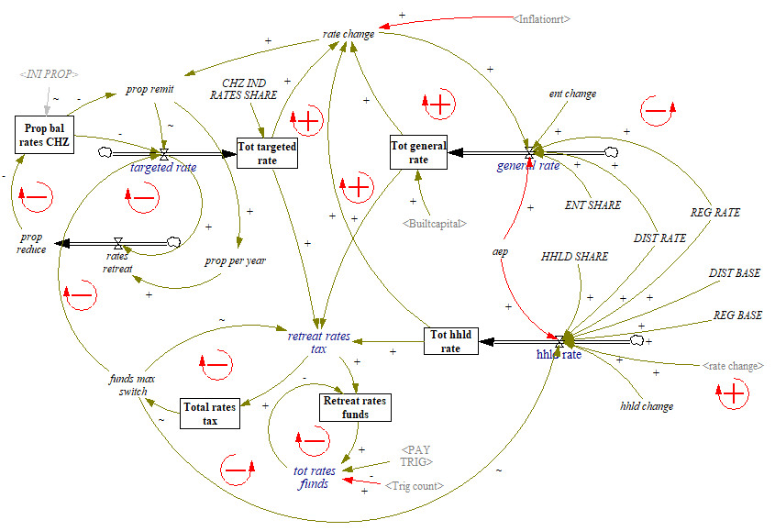

**Figure 18** The stock-flow diagram for the Property Rates Module operating at the regional scale through local government by utilising Vensim® subscripting for governments. The *targeted rate*, *general rate,* and the *hhld rate* respond to changes in the *Inflationrt* with feedback from each rate stock to limit the amount to the desired level of funding (*Total rates tax*) for managed retreat. First, the targeted rate disincentivises capital exposure through increasing over the period. Second, the general rate represents the proportion of rates paid by enterprises (*ENT SHARE* and *ent change*). Third, households pay less in the form of the household rate (*HHLD SHARE*), allocated over the regional and district rating base (*DIST RATE, REG RATE, DIST BASE* and *REG BASE*). Funding is then allocated based on environmental triggers (*Retreat rates funds* and *Trig count*). Again, managed retreat funding reduces the properties in the CHZ (*Prop bale rates CHZ*). The module also allows for capturing property rates for coastal defence through cumulative defence cost (*cum def*), where the *funds max switch* uses the cost of defence instead of the retreat cost. Red arrows represent external module influence.

### 1.2.7 The Land-use Module

The Land-use Module tracks spatial changes in land-use over the period. It incorporates planned conversion and intensification for growth outlined by the Matariki Regional Development Plan and the Heretaunga Plains Urban Development Strategy (HBRC, 2016; HBRC et al., 2017). The initial values for conversion and intensification derived from these plans are 823 Ha and 286 Ha, respectively. The Land-use Module provides the capacity to constrain industry land-use in MERIT, and therefore industries cannot meet their full regional capacity. The land-use module also converts regional development taxes into government (public) land supply. Figure 19 illustrates the stock-flow diagram.

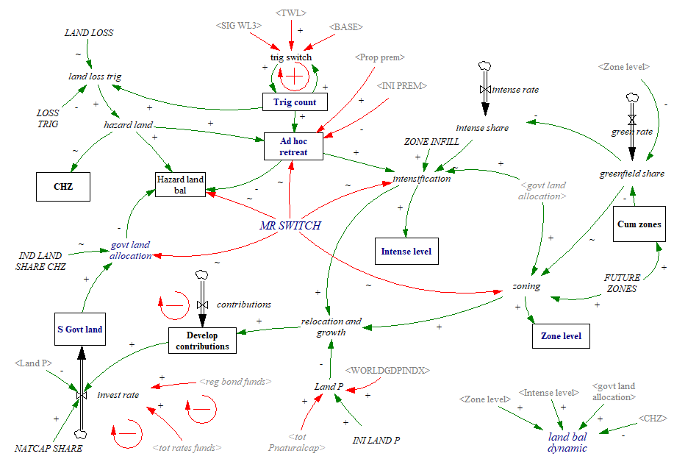

**Figure 19** The stock-flow diagram for the Land-use Module operating at the sub-regional scale. Here the land is allocated by the scenario in hectares before it is converted into dollars (*relocation and growth*). *Adhoc retreat* occurs when multiple triggers are breached (Trig count) or property premiums fail, constraining development. Managed retreat is accounted for through funding from bonds and rates (*total rates funds* or *reg bonds funds*), creating a balancing loop of government land allocation (*S govt land*) to the intensification rate (*intense rate*) and the new zoning rate (*zone rate*). Manged retreat also acts as a logic switch to control land-use (*MR SWITCH*). The *land bal dynamic* sums the various land transfers for use in MERIT for use in capital mobility.

### 1.2.8 Miscellaneous operators

The miscellaneous operators are fundamental changes to existing variables in MERIT to modify their standard operation. The variables significantly modified are:

1. **The Economic Operability** (inoperability) of firms due to coastal flooding and inundation (Figure 20).
2. **Aggregate and Mobile Investment** deviations from the regular operation of the economy (Figure 21). Here, immobile investment is constrained to changes in land-use supply.
3. **Industry Account** balances adjust to changes in insurance and rates (Figure 22).
4. **Economies of Scale** adjusts Multifactor Production from the implementation of the managed retreat scenarios (Figure 23).

The regional operability by industry is determined by the proportion of employees in the CHZ versus the region as adapted from StatsNZ (2013b) Employee Count measure. Market Economics (2017) adapts the Employee Count measure to include working proprietors to provide a more comprehensive measure of total employment known as a ‘Modified Employee Count’. The disruption to business and infrastructure initiates with a system shock followed by a logarithmic decay after an event as operability returns to normal using the Vensim® SMOOTH function. It is logically similar to Brown et al.’s (2015) approach, which shows a logarithmic return to normal following disaster. The modification of operability in MERIT is visible in Figure 20, which provides MERIT with an outage timeframe, i.e. the proportion of an industry not operating at full capacity across the region.

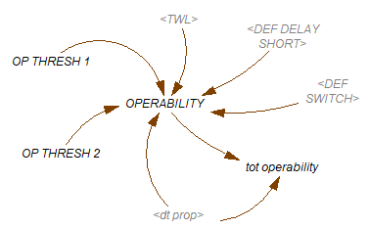

**Figure 20** Modified operability function in MERIT for coastal hazards.

Aggregate and mobile investmentdeviate from the MERIT economy's regular operation in C-ADAPT (Figure 21). Here, immobile investment is constrained by a reduction in industry land-use supply. Therefore mobile investment takes up the surplus brought on by capital investment in insurance rebuilds or managed retreat. Investment is also dynamically linked to the investment composite commodity consumption price (Pinvestcc), significantly altering composite capital supply. Therefore, as shown in Figure 21, *aggregateinvestv baseline* represents standard MERIT, and *aggregateinvestv1* is the module integration of the various scenarios.

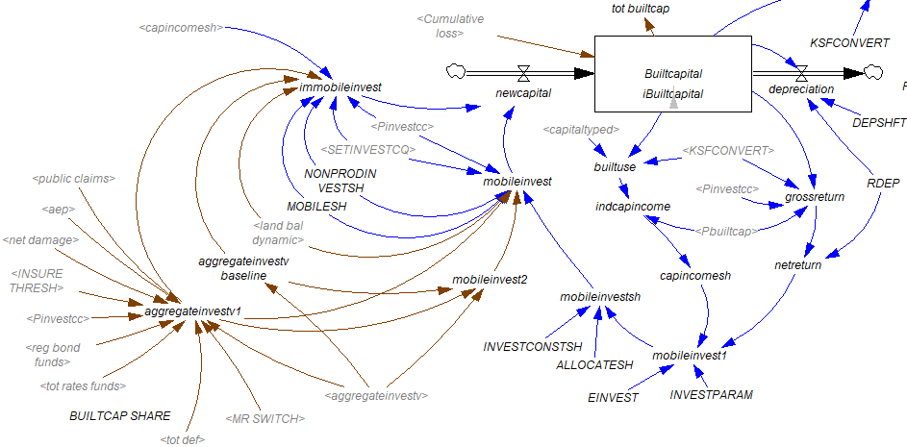

**Figure 21** Modified aggregate investment function and the mobility of investment in MERIT (brown). Standard MERIT operation in blue.

MERIT is also fundamentally altered for industry income and industry expenses by insurability and property rates (Figure 22). Under normal operating conditions, industries pay insurers for risk transfer. As climate change exacerbates coastal risk, risk-based insurance or insurance withdrawal are beyond MERIT’s regular operation, and therefore the *industry account* requires modification. Similarly, changes to property rates and public insurance from the baseline tax already established now account for a changing climate as outlined in the scenarios.

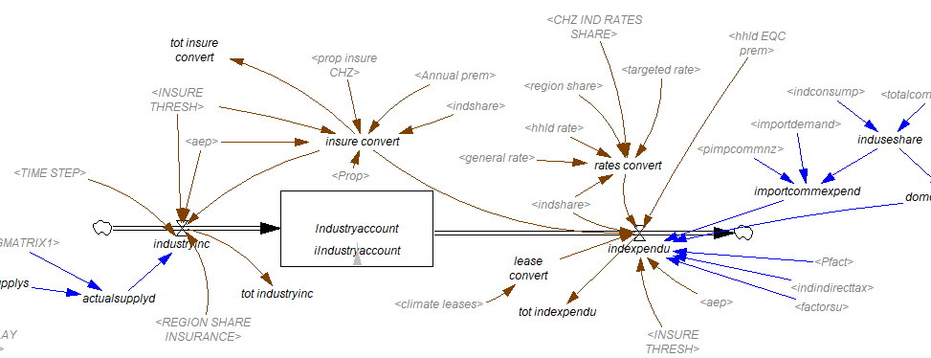

**Figure 22** The modified Industry Income (Industryinc) and Industry Expenditure (indexpendu) in MERIT. Modifications adjust the industry account to insurance and rates changes (brown) and standard MERIT operation (black and blue).

Economies of Scale, or a falling long-run average cost curve,adjust multifactor production for the managed retreat scenarios (Figure 23). It is calculated as an increase in the productive capacity as the construction industry gains efficiencies through development at scale with managed retreat. C-ADAPT employs a 17.7% increase in economies of scale in the construction sector, derived from the average gain from 12 building construction and civil engineering projects as reported in Ramachandra, Geekiyanage and Perera (02 July 2017).

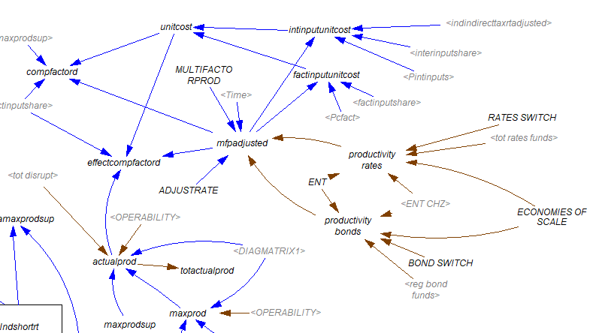

**Figure 23** Modified Multifactor Production to enhance the Economies of Scale with the managed retreat scenarios (brown) and standard MERIT operation (blue).

## 1.3 Calibration and module structure tests

During the construction phase, the modules require testing throughout the process before they are accepted. Testing is often incorrectly referred to as validation because all models simplify a reference system; they are never totally valid in the sense of being supported by objective truth (Greenberger et al., 1976). Useful, convincing, or inspiring confidence are more appropriate descriptors of models (Greenberger et al., 1976).

Testing the C-ADAPT modules comprised face validity tests, calibration, validation, sensitivity analysis and System Dynamics testing by utilising the Reality Check feature in Vensim® and the SDM-doc Tool (Bragen & Martinez-Moyano, 2014) recommended by the editorial board of the System Dynamics Review. First, the initial ‘face validity’ tests established rational logic or whether the model makes common sense (Ford, 2010). After face validity tests, it relied on the two approaches for fault finding outlined by Goel (1985). First, program calibration examines a sequence of formal and mathematical logical statements (Goel, 1985). Second, program testing through the practical execution of a set of test cases to expose embedded faults (Goel, 1985).

Test results are highlighted in Appendix 3 for the table of tests, Appendix 4 for a summary from the SDM-doc Tool and Appendix 5A for the sensitivity analysis. The table of tests describes the empirical and theoretical direct structure tests (do the modelled trends reflect that of actual data and observable rules over the calibration period), structure orientated behaviour tests (testing through Vensim® Reality Check) and behaviour pattern tests (expectations of the behaviour of the variables over the calibration period) conducted on the modules. Appendix 4 describes the results of the SDM-doc Tool used to test and refine the Risk Assessment Module and the Socio-Economic Module. Similarly, Appendix 5 shows the sensitivity analysis for the Risk Assessment Module and the Socio-Economic Module. The Interdependency, Land-use, Defence, Rates and Bonds modules primarily performed linear operations and were only validated for empirical and theoretical direct structure tests, structure orientated behaviour tests, and behaviour pattern tests.

Program calibration was conducted against the baseline period from 2007-2018 and applied logic statements to Scenario Planning hypotheses. Calibration enables refinement of time-dependent variables to maximise model agreement with a set of experimental (or real-world) data (Trucano et al., 2006). Therefore the modules were tested against real-world data (hindcast calibration) to determine whether the outcomes match or diverge with prior knowledge and observations, a process of evaluation outlined by Ebersberger and Pyka (2009). Module calibration uses data from 2007 to 2018 shown in Table 11. Models were adjusted where calibration and validation expectations were unfulfilled. Proving also required that the modules met logical statements (using Vensim’s Reality Check functionality) to test Scenario Planning outcomes for the future through to 2050.

Table 11 Datasets used for module calibration

|  |  |
| --- | --- |
| Module | Dataset |
| Risk Assessment | Napier Port sea-level data |
| Risk Assessment | Ahuriri Estuary water level recorder |
| Risk Assessment | LiDAR |
| Risk Assessment | NIWA exposure estimates |
| Risk Assessment | IPCC SLR estimates |
| Socio-Economic | The University of Auckland National House Sales Database |
| Socio-Economic | The Insurance Council of New Zealand Insurance claims (2019b) |
| Socio-Economic | Fleming et al. (2018a) private and public insurance claims |
| Socio-Economic | Local government property valuations |
| Socio-Economic | StatsNZ household income and unemployment |
| Socio-Economic | Core Logic insurance change |
| Land-use | HPUDS and Matariki Plan projections |
| Land-use | The New Zealand Land Resource Inventory |

Note that only modules used for the baseline were calibrated against actual data.

Program testing involved iteration, sensitivity analysis and ‘extreme’ testing to reduce uncertainty. Sensitivity analyses involve the iterative processing of multiple model runs given rational and random distributions of constants given simultaneous changes to multiple parameters to find faults and adjust for uncertainty (Kapmeier & Gonçalves, 2018). Thus, sensitivity analysis in model testing provides probabilistic confidence in the model's numerical accuracy (Trucano et al., 2006). Sensitivity analysis also simplifies the IAM by a) removing ineffectual variables or b) deriving constant values as inputs instead of complex tables. This study's sensitivity testing on modules involved 100 Latin Hypercube simulations per scenario in Vensim® using rational and random distributions of constants. Latin hypercube is particularly useful as it allows for automated orthogonal sampling across a grid space whilst remembering what points have already been chosen to minimize repetition and represent real variability (Ford, 2010) 100 simulations were deemed appropriate as the final results produced were statistically significant. Any failure resulted in model adjustment and a further 100 simulations. Sensitivity analysis also accounted for ‘extreme conditions’ to account for dimensional consistency and feasibility, a prerequisite of model testing, according to Barlas (1996) and Macmillan (2012). However, stochastic ‘extreme conditions’ were rationalised to events that could feasibly occur as the simulations fail otherwise. Fully probabilistic and full temporally random simulation approaches account for dependencies between variables, build robustness and include the non-stationarity associated with climate change (Baron et al., 2015).

## 1.4 Integrate modules into MERIT for indirect impacts to the regional economy

MERIT discovers the underlying behaviour of the agents of industry, household, enterprise, government and the effects on commodities, income, expenditure and transfers (Smith, McDonald, et al., 2016). Modules provide MERIT with components that are not already covered by the economic model and extend its use. Thus, key parameters and equations in MERIT are altered to reflect the modules' influence (Smith, Orchiston, et al., 2016). This approach to integrating pre-processing modules is nothing new for MERIT. It was used to assess the impacts of the Kaikoura Earthquake on tourism (Market Economics Limited, 2017) and Auckland water outage scenarios (Smith, Kim, et al., 2016).

MERIT operates on embedded regional Social Accounting Matrices (SAM) generated from the input-output tables of the New Zealand National Accounts published by StatsNZ at the regional and national scales. These National Accounts input-output tables describe the New Zealand economy's structure by quantifying the relationship between goods and services produced by industries and who uses them (StatsNZ, 2013c). Typically Input-Output models lack dynamic properties as they are a snapshot in time for comparative analysis (Turner, 2000). However, MERIT as a dynamic computational general equilibrium model allows for an evolving output every 1.8 days. The regional SAMs constructed for the model are from the financial year ending March 2007, the base year for the model, (Smith, McDonald, et al., 2016) through to 2018. The model structure is summarised by Smith et al. (2016, p. 4) below:

“For each region, the model describes the behaviour of representative agents (10 industry categories, one household, one enterprise, a Local Government within each region, and a Central Government). Each industry agent chooses the quantity and type of commodities (aggregated to 10 commodity categories) to produce, based on the prices of those commodities relative to production costs. Household, enterprise, and government agents receive income from a variety of sources (e.g. wages and salaries, business profits, dividends, taxes, and transfers from other agents), and then allocate this income towards a variety of expenditure options (e.g. purchases of goods and services, savings, taxes, and transfers to other agents).”

The industries and commodities used for this study were aggregated from 106 industries and 205 commodities to 10 industries and 10 commodities (Table 12). MERIT then tracks changes in stocks and flows over time in the counter-factual reference mode (baseline) (Smith, McDonald, et al., 2016) given stochastic damages and losses for comparison against intervention scenarios. Industries were selected based on their relevance to the study area. Note that MERIT also tracks changes over time in demographics, such as population, employment, savings, investment and international transfers. Table 13 illustrates an overview of the module integration into MERIT, with a more comprehensive account in the model set up and equations.

Table 12 Aggregated industries and commodities used.

|  |  |  |
| --- | --- | --- |
| Index | Industry | Commodity |
| 1 | Accommodation, restaurant & retail services | Accommodation, restaurant & retail services |
| 2 | Construction | Construction |
| 3 | Government, education & healthcare | Government, education & health services |
| 4 | Horticulture & fruit growing | Horticulture & fruit |
| 5 | Food product manufacturing | Food products |
| 6 | Other manufacturing | Other manufactures |
| 7 | Other primary production | Other primary products |
| 8 | Other services & trades | Other services & trades |
| 9 | Residential & real estate services | Residential & real estate services |
| 10 | Wood & paper manufacturing | Wood & paper products |

Table 13 Overview of input module integration into MERIT.

|  |  |  |
| --- | --- | --- |
| Action | Input Module | MERIT module |
| BASELINE SCENARIOS | | |
| Industry operability | Sub-module Industries | Industries |
| Infrastructure disruption | Infrastructure Interdependency | Industries |
| Lost built capital replacement | Risk Assessment | Capital & Investment and Savings |
| Land lost to storms and sea-level rise | Land-use | Capital |
| Insurers pay storm damages | Socio-economic | Industries & Capital |
| Increasing insurance premiums | Socio-economic | Industries |
| Development contributions | Land-use | Government & Investment and Savings |
| Net increase in EQC tax | Sub-module government | Government & Industries |
| EQC claims for flooding | Sub-module government | Government, Industries & Households |
| Zoning intensification | Land-use | Capital |
| DEFENCE SCENARIOS | | |
| Coastal defence structures | Defence | Capital & Investment and Savings |
| Coastal defence cost | Rates | Government & Industries |
| RATES SCENARIOS | | |
| Local GOVT rating tax revenue | Rates | Government & Industries |
| GOVT capital investment | Rates | Government & Capital |
| BONDS SCENARIOS | | |
| Initial bond release | Bonds | Investment and Savings |
| Revenue generated offshore from bonds | Bonds | Rest of World & Government |
| Government purchases exposed properties | Bonds | Government & Industries |
| Ind invest in new capital | Bonds | Capital & Industries |
| Government paying back bonds | Bonds | Government & Investment and Savings |
| Government rental income | Government | Government & Industries |

## 1.5 Calibrate and test C-ADAPT and apply model feedback

Testing undertaken in Section 1.3 (except those that apply Vensim® Reality Check) repeats once the module-MERIT integration is complete. Standard MERIT is thoroughly calibrated and validated over ten years (2007 to 2018) using several key aggregates and observed datasets (see Appendix 5B). Thus it replicates the essential dynamic behaviour of Hawke’s Bay and the rest of New Zealand economies over this period. However, only modules developed and integrated into MERIT as part of this thesis are tested further here. The next step would be a total re-calibration of MERIT to the new boundary conditions. However, this was not possible within the scope of this thesis, given time and resource constraints. In addition, C-ADAPT’s usefulness was assessed at this step in collaboration with experts and included reflections on functionality and reliability. Again see Appendix 3 for the table of tests and Appendix 5B for the sensitivity analysis on module-MERIT integration as a measure of success of the integration. The SDM-Doc Tool failed to produce a result after a month of operation on the entire C-ADAPT model.

The IAM timestep of 1.8 days was also tested against 3.6 and 7.2 days at this step. The latter two timesteps were, however, shown to compromise model accuracy. Therefore, the differential time (*dt*) of 1.8 daysis an applicable rate of change because it represents model stability and accuracy in numerical integration proposed by Ford (2010). However, this *dt* leads to over 8,800 timesteps, increasing computational time, data processing time and goes beyond the maximum recommended rule of thumb of 1,000 steps (Ford, 2010). Exceeding the recommended timesteps is more the consequence of the long period over which C-ADAPT runs rather than the operation of the model itself.

## 1.6 Define key aggregates for scenario comparison

The KPIs, or key aggregates, should represent the system's dynamic parts and be comprehensible and compelling to their audience (Turner, 2000). Similarly, the indicator system data should be drawn from the broadest range of human activities and facilitate tracing management efforts more directly to environmental and social realities (Boston, 2017). Such an assessment approach provides an effective instrument to link policy performance measures with a broader sustainability perspective (Kourgialas & Karatzas, 2011), in this case, community resilience.

It is useful to determine where the key aggregates reside in the system to ensure acceptable coverage of the system as a whole. Key aggregates are described as either being state, impacts or response indicators. State indicators define observable changes in the environmental dynamics and functions; whereas the impacts are the discrete measured changes in condition; and response indicators are defined as the institutional response to system changes that are primarily driven by state and impact indicators (Brouwer & Schaafsma, 2013). An indicator framework with state and impact indicators can facilitate tracing management efforts more directly to environmental and social realities (Boston, 2017).

Similarly, it is also useful to define the model type. Flow measures are more illustrative of the real cost of a disaster than stock measures due to being able to account for the disruption effect over time (Boston, 2017). In contrast, stocks are a single point in time value of production or asset (Boston, 2017). Therefore flow values capture the time of the disruption and recovery (Boston, 2017).

The key aggregates used to evaluate the performance of the simulations and scenarios are visible in Table 14. They represent the sectors of household (HHLD), government (GOVT), Industry (IND) and also changes to land-use. MERIT provides many indicators on which an evaluation of the disruptive impacts can be undertaken at an aggregated or industry scale (Smith & McDonald, 2016b). However, MERIT consists of over 2000 variables and so discussions with supervisors aided narrowing the field to those that best represent regional economic behaviour. The other key aggregates derive from the input modules. Another goal of the key aggregates is also to account for intergenerational risk transfer and spatial risk transfer. Figure 24 illustrates an indicative output for the Key Aggregate Total Value Added.

Table 14 Key Aggregates Reported

|  |  |  |  |  |  |
| --- | --- | --- | --- | --- | --- |
|  | Variable (metric) | Description | Sector | System Type | Variable Type |
|  | Risk (%) | The probability of an event occurring multiplied by its consequence | HHLD, IND & GOVT | State | Stock |
|  | Damages ($) | Replacement value of built capital | HHLD, IND & GOVT | Impact | Stock |
|  | Operability (%)* | Business operability compromised by storms. | IND | State | Flow |
|  | Infrastructure Disruption (%) | The reduction in the level of service to industries by interdependent infrastructure | IND | State | Flow |
|  | Annual Expected Loss ($ a-1) | Loss of built capital and land | HHLD | Impact | Flow |
|  | Coastal Amenity Value ($) | Non-market value of coastal living | HHLD | State | Stock |
|  | HHLD Insurance Premiums ($ a-1) | Risk transfer | HHLD | State | Flow |
|  | Real HHLD Consumption Rate (%)* | The rate of change in real household consumption. Illustrates whether households are better off to spend or save | HHLD | State | Flow |
|  | Unemployment Rate (%)* | Reflects unemployment in the labour market | HHLD | State | Flow |
|  | Local GOVT Consumption ($ a-1)* | The total spending by the government | GOVT | Response | Flow |
|  | Central GOVT Consumption ($ a-1)* | The total spending by the government | GOVT | Response | Flow |
|  | Total Value-Added  ($ a-1)* | Similar to Gross Regional Product as a measure of productivity, except it, excludes taxes and includes subsidies | IND | State | Flow |
|  | IND Value-Added  ($ a-1)* | The gross industry output (sales) less the cost of intermediate inputs | IND | State | Flow |
|  | Totactualprod  ($ a-1)* | Total actual production | IND | State | Flow |
|  | Pinvestcc ($ a-1)* | Investment composite commodity consumption price | IND | Impact | Stock |
|  | Land-use Ratio (Ha) | The ratio of greenfield development to zone intensification | Land-use | Impact | Stock |

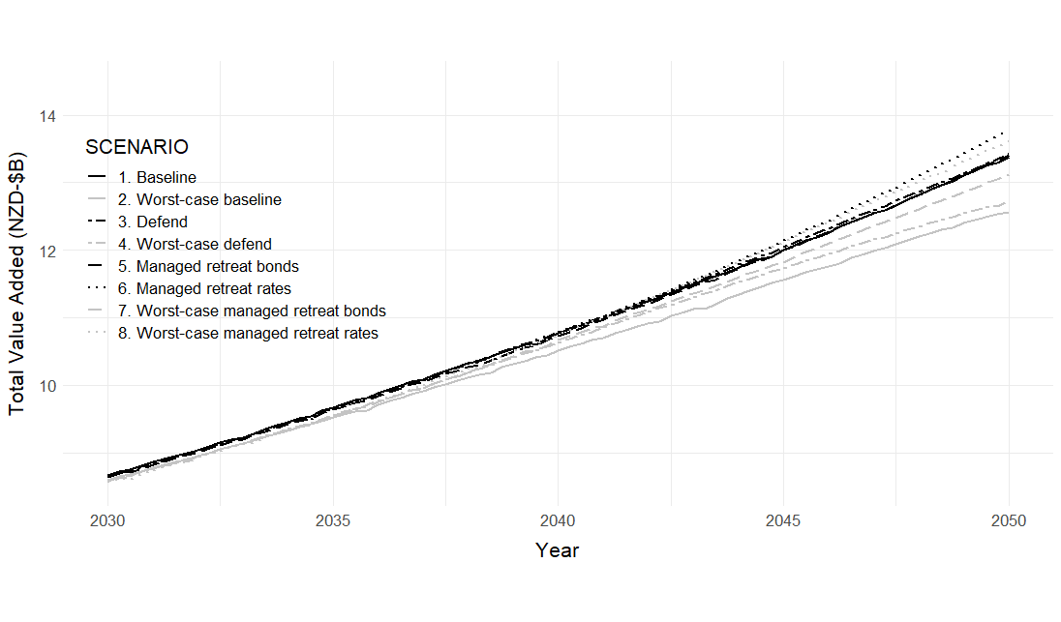

**Figure 24** Indicative simulation results for the Regional TVA. The managed retreat interventions stimulate regional output more so than the baseline or defence scenarios.

## 1.7 Develop adaptation pathways

The concept here follows that of Callaway (2014), where planners can translate risk parameters into economic costs, aggregate costs based on explicit risk trade-off preferences, then aggregate the regrets cost to compare planning designs over some climate futures, to finally select a design that minimises some over-all regrets-based decision-making criteria. Table 14 illustrates this approach by Callaway (2014). The tools used to develop this approach are Vensim® and RDM theory on the Python 3 platform. Lempert et al. (2013) utilised RDM for ensuring robust flood risk management under deep uncertainty with complex challenges. The idea is that RDM helps policymakers derive strategies that satisfy objectives in many plausible futures rather than optimising to a singular optimal future through iterative processing (Lempert et al., 2013). RDM compares the performance of alternative combinations of policies evaluated by the metrics, over a wide range of uncertain futures using relationships in models (Lempert et al., 2013).

Table 15 The calculation of economic regret from economic cost by Callaway (2014)

|  |  |  |  |  |
| --- | --- | --- | --- | --- |
| 1. The ex-post net present value for an ex-ante generic project with four designs and three climate states (106 €) | | | | |
| *Project design* | *Expected climates* | | | *Mean and max. (rank)* |
| *C1* | *C2* | *C3* |
| D 1 | 120 | 40 | 5 | 55.00 (1) |
| D 2 | 50 | 70 | 20 | 46.67 (4) |
| D 3 | 10 | 50 | 70 | 43.33 (3) |
| D Robust | 50 | 55 | 50 | 51.67 (2) |
| 1. The ex-post regrets matrix for an ex-ante generic project with four designs and three climate states (106 €) | | | | |
| *Project design* | *Expected climates* | | | *Mean and min. (rank)* |
| *C1* | *C2* | *C3* |
| D 1 | 0 | -30 | -65 | -31.67 (1) |
| D 2 | -70 | 0 | -50 | -40.00 (3) |
| D 3 | -110 | -20 | 0 | -43.33 (4) |
| D Robust | -70 | -15 | -20 | -35.00 (2) |

Kwakkel et al. (2015) utilised this approach and extended it to incorporate DAPP through building an Integrated Assessment Meta Model to assess the performance of pathways based on multiple objectives called Exploratory Modelling and Analysis. Developing the pathway evaluation for PYRDM follows a similar rationale. Repeated computational assessment of interventions contrast against an ensemble of status quo scenarios to explore the performance of actions to analyse complex and uncertain systems (Kwakkel et al., 2012). Evaluation of the key aggregates utilises RDM (Hamarat et al., 2013; Kwakkel et al., 2015; Lempert et al., 2013) and preference functions of least regret (Callaway, 2014; Macharis, 2000) to derive a novel DAPP for managed retreat. Calibration and sensitivity analysis in Vensim® optimised outputs for key aggregates. Statistical preference functions are then calculated in a Python 3 RDM matrix (PYRDM) for the scenario simulations to minimise regret and establish points in time where scenarios perform well or poorly. Figure 25 illustrates the workflow. The least-regret approach seeks to derive the option which performs best across the range of climate futures rather than optimising toward one dominant climate scenario (Callaway, 2014).

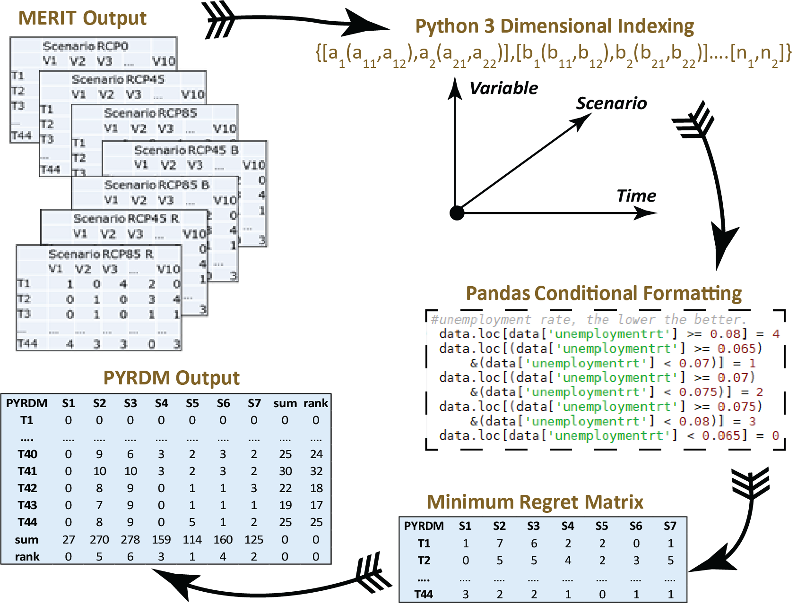

**Figure 22** Workflow from MERIT to the matrix in Python 3.6 (PYRDM). Steps include: 1) condensing MERIT output variables into a 3-dimensional index. 2) Conditional formatting with Pandas on variables to compare them. 3) Calculate minimum regret matrix (Callaway, 2014) between variables for each timestep. 4) Stack variables by scenario and rank.

Therefore, the least-regret preference function to enable DAPP utilises the following steps:

Conduct calibration and sensitivity analysis in Vensim® (Ventana System Inc, 2015) to produce optimised outputs of key aggregates.

Import key aggregates into Spyder 3.3.6, the Scientific Python Development Environment (Raybaut, 2009) for use in the Python 3 (Python Software Foundation, 2017), PYRDM script (<https://gitlab.com/aceaves/dappy>). See Chapter 2.10 for the full PYRDM script.

Sort datasets into a 3-dimensional indexed matrix (key aggregate, time and scenario) for manipulation using the following structure:

$\left\{[a1(a11,a12),a2(a21,a22)],[b1(b11,b12),b2(b21,b22)]….[n1,n2]\right\}$

Format the data for comparison through Pandas boolean selection (Pandas Development Team, 2014) that applies a logical expression to the index's values for comparison. The boolean selection allows the algorithm to satisfy predefined objectives amongst combinations of uncertain conditions, a similar step employed in RDM for scenario discovery outlined by Lempert et al. (2013).

Calculate the minimum regret over the matrix based on Callaway (2014) between variables for each timestep. The least-regret approach seeks to derive the option that performs best across the range of climate futures rather than optimising one dominant climate scenario (Callaway, 2014).

Stack key aggregate matrices by scenario for each timestep, rerun the minimum regret code, and rank scenarios to define DAPP.

The model outputs are assessed against any aims and objectives. If the outputs were not logical, then the modeller returns to Step 1 of the Agile Development Methodology to examine system failures, abnormal variables or irrational timing of events and adjust accordingly.

The results of PYRDM are expressed in two ways: 1) the contrasting performance of scenarios across all timesteps, and 2) the contrasting performance of each scenario for each timestep, or DAPP. The first step is to take the variable outputs of the modules and MERIT from the RDM analysis in System Dynamics and convert them to a common scale for comparison through the PYRDM matrix. Table 16 shows the boolean selection for each variable’s results and the corresponding value. Here the variable outputs are computed on a scale of 0 - 4 (0 being the best and 4 being the worst). The exception being AEL and TVA, which have been given a greater weighting of 0 - 8 due to their significant influence on managerial decisions (see IPCC, 2012; McDonald & McDonald, 2018). For more detail, Appendix 6 shows the resulting matrix of PYRDM once the least regret computations have been performed for each scenario and timestep.

Table 16 Input variables and output boolean selection used for PYRDM assessment

|  |  |  |  |  |  |
| --- | --- | --- | --- | --- | --- |
| Key Aggregate | Input | | | | Output |
| Annual Expected Loss (NZD) | < | 25M |  |  | 0 |
| >= | 25M | < | 50M | 2 |
| >= | 50M | < | 75M | 4 |
| >= | 75M | < | 100M | 6 |
| >= | 100M |  |  | 8 |
| Property Premium (NZD) | >= | 0 | < | 1000 | 4 |
| >= | 1000 | < | 2000 | 0 |
| >= | 2000 | < | 3000 | 1 |
| >= | 3000 | < | 5000 | 2 |
| > | 5000 |  |  | 3 |
| Household Consumption Rate (%) | < | 1.24 |  |  | 4 |
| >= | 1.24 | < | 1.245 | 3 |
| >= | 1.245 | < | 1.25 | 2 |
| >= | 1.25 | < | 1.255 | 1 |
| >= | 1.255 |  |  | 0 |
| Unemployment Rate (%) | < | 0.044 |  |  | 0 |
| >= | 0.044 | < | 0.045 | 1 |
| >= | 0.045 | < | 0.046 | 2 |
| >= | 0.046 | < | 0.048 | 3 |
| >= | 0.048 |  |  | 4 |
| Central Government Consumption (NZD) | < | 1400M |  |  | 4 |
| >= | 1400M | < | 1800 | 3 |
| >= | 1800M | < | 2000 | 2 |
| >= | 2000M | < | 2200 | 1 |
| >= | 2200M |  |  | 0 |
| Local Government Consumption (NZD) | < | 200M |  |  | 4 |
| >= | 200M | < | 250 | 1 |
| >= | 250M | < | 300 | 2 |
| >= | 300M | < | 350 | 3 |
| >= | 350M |  |  | 0 |
| Total Value Added (NZD) | < | 8B |  |  | 8 |
| >= | 8B | < | 9.5B | 6 |
| >= | 9.5B | < | 11B | 4 |
| >= | 11B | < | 12.5B | 2 |
| >= | 12.5B |  |  | 0 |
| Total Actual Production (NZD) | < | 24B |  |  | 4 |
| >= | 24B | < | 28B | 3 |
| >= | 28B | < | 32B | 2 |
| >= | 32B | < | 36B | 1 |
| >= | 36B |  |  | 0 |
| Pinvestcc (%) - Investment composite commodity consumption price | <= | 1.05 |  |  | 0 |
| >= | 1.05 | < | 1.2 | 1 |
| >= | 1.2 | < | 1.3 | 2 |
| >= | 1.3 | < | 1.4 | 3 |
| >= | 1.4 |  |  | 4 |
| Land-use Ratio (%) | < | 0.5 |  |  | 4 |
| >= | 0.5 | < | 1 | 3 |
| >= | 1 | < | 1.5 | 2 |
| >= | 1.5 | < | 2 | 1 |
| >= | 2 |  |  | 0 |

### 1.7.1 The robust scenario of least regret

Comparing scenarios across all timesteps provides an overview of DAPP performance between 2020 and 2050, illustrated in Figure 26 and annotated in Table 17. Understandably, enhancing climate change effects in C-ADAPT increases regret, leading to the scenario with no SLR (1) having the least regret or minimum negative impact compared with the robust option over the period. Generally and expectedly, the mid-range (RCP4.5) scenarios (2, 4, 6 and 7) offer better pathways than the worst-case (RCP8.5) scenarios (3, 5, 8 and 9).

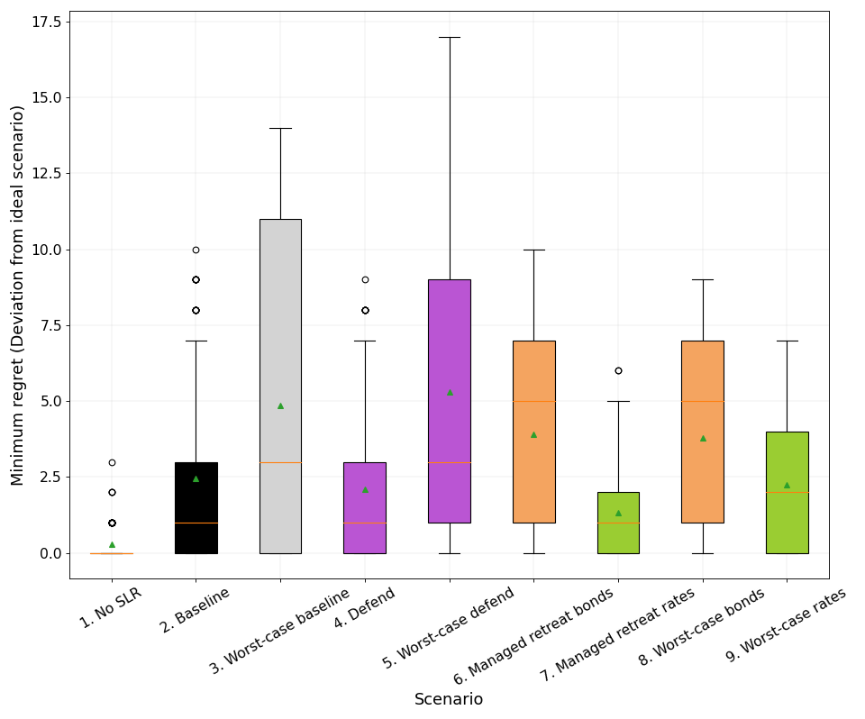

**Figure 26** Boxplot of minimum regret for scenarios across all timesteps. As expected, scenarios with less climate change, such as no SLR (RCP0) and mid-range (RCP4.5) represented by (1, 2, 4, 6 and 7), are better off than the worst-case (RCP8.5) scenarios (3, 5, 8 and 9). Note that the colours are sequenced to reflect the scenarios from module to outputs.

Table 17 Scenario rank across all timesteps

|  |  |
| --- | --- |
| Scenario | Rank |
| 1. No SLR | 0 |
| 2. Baseline | 4 |
| 3. Worst-case baseline | 7 |
| 4. Defend | 2 |
| 5. Worst-case defend | 8 |
| 6. Managed retreat bonds | 6 |
| 7. Managed retreat rates | 1 |
| 8. Worst-case managed retreat bonds | 5 |
| 9. Worst-case managed retreat rates | 3 |

### 1.7.2 A trade-off timeframe

When analysing quarterly intervals over time, a novel pattern emerges in DAPP as scenarios are compared against each timestep. A general trend is evident in Figure 27, where interventions and baselines diverge around 2032 as C-ADAPT triggers begin to activate the various interventions.

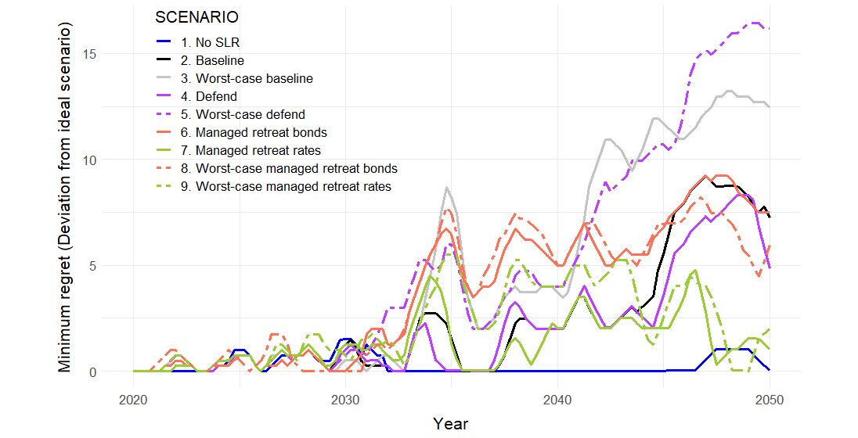

**Figure 27** All DAPP scenarios by timestep. Regret increases over time, moving away from the no SLR scenario as interventions and climate change ramp up. Significant divergence in regret occurs between the mid-range (RCP4.5) scenarios and the worst-case scenarios (RCP8.5) by the end of the modelling period. The managed retreat rates scenarios offer the minimum regret by the end of the period when excluding the no SLR scenario. A Simple Moving Average of one year is applied to the quarterly interval dataset to smooth out the graph.

## 1.9 All functionalities complete

Model building is cyclical and dynamic through running, comparing, and changing, which improves the modellers' understanding of reality (Ruth & Hannon, 1997). Therefore the modeller must decide with each iteration of development whether to reject, accept or revise the model in light of new knowledge or experience learned from the real world (Ruth & Hannon, 1997). If all the functionalities pass, then C-ADAPT moves to the beta stage. If not, the modeller reiterates the processes until C-ADAPT and its outputs are robust, a process that took over three years.

## 1.10 Limitations and assumptions

In general, when coastal hazard risk is low, the model assumes that socio-economic wellbeing increases with increasing capital wealth, whereas higher risk is associated with decreased socio-economic wellbeing. However 'Deep uncertainty' or 'Knightian uncertainty' exists for futures which we cannot reliably quantify (Smith, McDonald, et al., 2016) and therefore, plausible scenarios contain constraining assumptions.

Modelling adaptation pathways also requires that logical trigger points are assumed and embedded in the system model. Triggers are based on trends, expert opinions, management plans and logical guesses to initialise the adaptive policy (Secretariat of the Convention on Biological Diversity, 2009). Environmental triggers act as an early warning system to enact policy decisions. There should be trigger points for planning and critical trigger points for action which are crucial to the performance of an adaptation policy (Hamarat et al., 2014).

Table 16 Key assumptions and limitations of C-ADAPT

|  |  |
| --- | --- |
| **Assumptions** | |
| **General** | * Households rebuild in-situ after a disaster aided by insurance or savings. * The model uses mathematical constants where source information is limited, such as the Insurance Threshold, Non-market Amenity Value, Desired Funding and District Base. * Appropriate spatial and temporal model resolution to effectively derive data on impacts (Smith & McDonald, 2016a). * See Smith et al. (2016) for detailed MERIT assumptions. * Weak links in the network limit infrastructure interdependencies. |
| **Spatial** | * The 2120 1% AEP flood and inundation extents define the CHZ. * The aerial extent of inundation is modelled through step changes in inundation levels aligned with the 1% AEP’s at 2065 and 2120. * The geodetic change for the CHZ (see Figure 1) is -0.086m for the model period, aligning with the Ministry for the Environment’s projections (Ministry for the Environment, 2017). |
| **Valuation** | * Estimated built capital losses are derived from Riskscape, and the damage function is the average of seven different building types as described in Reese and Ramsay (2010). * Land losses are set at 1% of government land valuations for each storm event. * Foreseen risk in the CHZ leads to a decline in the market value of capital. |
| **Insurability** | * Insurer's tolerance threshold to cover vulnerable properties is where the AEP<2%. Otherwise, insurers withdraw from the market. * Household’s tolerance threshold is where they are only willing to pay up to 5% of household income toward insurance or lose 5% of their capital wealth. Otherwise, they withdraw from the market. * Model iteration and feedback defined these values. * Excesses increase with insurance claims following flood events. |
| **Amenity** | * Amenity value is based on the assumption that the hedonic pricing calculation reflects consumer demand for coastal property in at-risk areas. * Lags and feedback reflect the non-monetary benefits of seaside habitation and behavioural response to capital losses and the coastal environment's reduction. |
| **Adaptation** | * Once a property floods thrice (where flooding > 12 m NZVD2016, or MSL>3.183 m) under the baseline scenario, households and firms perform *ad hoc* relocation with support from the public insurance provider EQC. * Where *ad hoc* or forced retreat occurs under the baseline scenarios, Central Government, as the public insurer, underwrites lost land with the replacement of a modest section away from hazards. * Managed retreat scenarios reduce exposure in the model by reducing the exposed properties as funding becomes available. * Managed retreat scenarios employ economies of scale for the construction sector. Thus, new assets can be provided more efficiently due to scale. * Coastal defence structures eliminate risk, and properties remain in the short to medium-term once installed. |
| **Triggers** | * Environmental triggers act as an early warning system to enact policy decisions. * Logical trigger points are assumed and embedded in the system model based on trends, expert opinions, management plans and logical guesses to initialise the adaptive policy (Secretariat of the Convention on Biological Diversity, 2009). * There are trigger points for planning and trigger points for action, which are crucial to an adaptation policy’s performance (Hamarat et al., 2014). |
| **Limitations** | |
| * Future conditions and risks can only be estimated using some type of mathematical model, which are inherently error-prone because of the complexities of the underlying systems and the difficulty of translating that complexity into mathematical statements (Knopman & Lempert, 2016). | |
| * Model uncertainty due to limited knowledge, inherent system randomness, dynamic chaos, non-stationarity, and future policy actions (Kwakkel et al., 2015). | |
| * Limited timeframe for refinement, reflection, calibration and sensitivity analysis (Smith, McDonald, et al., 2016). | |
| * Trade-offs between computational capacity and processing times (Eaves & Doscher, 2015; Kwakkel et al., 2015; Smith, McDonald, et al., 2016). | |
| * Quantifying intergenerational and spatial risk transfer. | |
| * Uncertainty Analysis is required to better understand and interpret the outputs of MERIT (Smith & McDonald, 2016a). | |
| * Uncertainty of the MERIT model between 5-10%. | |

# **Model set up, equations and source material**

The following abbreviations are used throughout the following section:

|  |  |  |
| --- | --- | --- |
| * SLR Sea-Level Rise | * HHLD Household | * Dmnl Dimensionless |
| * AEP Annual Exceedance Probability | * dt Differential time | * n Count |
| * WL Water Level | * m Meters | * Ha Hectares |
| * IND Industry subscript | * a Annum | * T Time |
| * m Meters | * GOVT Government |  |
| * RCP Representative Concentration Pathway |  |  |

Note variables with an asterisk (*) are endogenous to MERIT and therefore are not defined here but in the MERIT documentation (see Smith, McDonald, et al., 2016).

### 2.1 The Risk Assessment Module

|  |  |  |  |  |
| --- | --- | --- | --- | --- |
|  | Variable (units) | Type | Value / formula | Comments |
|  | **Sea-level rise (m)** | Level | $$\frac{d}{dt}SLR= thermal expansion+water depth+SLR$$ $$SLR\left(t_{0}\right)=ICE MELT$$ | Consistent with IPCC (2014) projections. |
|  | **Water depth (m)** | Constant | $$RCP 4.5\left(t_{0}\right)=0.006$$ $$RCP 8.5\left(t_{0}\right)=0.008$$ $$No SLR\left(t_{0}\right)=0$$ | Initial water depths. |
|  | **Ice melt (m)** | Constant | $$ICE MELT=0.0011$$ | Arbitrary value to calibrate the system to IPCC (2014) projections. |
|  | **Thermal expansion (m a-1)** | Rate |  | Provides reinforcing feedback to the system. |
|  | **Geodetic rate**  **(m a-1)** | Rate |  | Geodetic subsidence for the Heretaunga Plains, Hawke’s Bay (Ministry for the Environment, 2017). |
|  | **Geo change (m)** | Level | $$\frac{d}{dt}Geo change=Geodetic rate+Geo change$$ $$Geo change\left(t_{0}\right)=DATUM OFFSET$$ | Change to the geodetic datum. Compounds the land movement. |
|  | **Datum offset (m)** | Constant | $$DATUM OFFSET=8.446$$ | Datum calibration to NZVD2016. |
|  | **Storm trigger (Dmnl)** | Auxiliary | $$storm trigger$$ $$=RANDOM NORMAL DISTRIBUTION$$ $$(0, 1, 0.5, FREQUENCY, NOISE SEED)$$ Where: min = 0; max = 1; mean = 0.5; std dev = FREQUENCY; seed = NOISE SEED. | Random probability distribution to enable a significant storm event to occur. |
|  | **Noise seed (Dmnl)** | Constant | $$NOISE SEED\left(t_{0}\right)∩(0,499999)$$ | Random number generator to seed stochastic simulations. |
|  | **Frequency (σ)** | Constant | $$RCP 4.5\left(t_{0}\right)=0.066$$ $$RCP 8.5\left(t_{0}\right)=0.068$$ $$No SLR\left(t_{0}\right)=0.06$$ | Changing the standard deviation of Storm Trigger to change the frequency of events. |
|  | **Sig storm (%)** | Constant | $$SIG STORM=0.66$$ | Enables model activation on storm events that are greater than 66%. |
|  | **Catchment hydro (m)** | Auxiliary | $$catchment hydro(storm trigger)$$ $$=\left\{\begin{matrix}0 for storm trigger<0.66 \\ RANDOM WEIBULL\left(0.069,1.261, 1.69, 0.481, 0.33, 0\right) \\ ×Magnitude for storm trigger ≥0.66\end{matrix}\right\}$$ Where: min = -0.069; max = 1.261; shape = 1.69; mean = 0.481; std dev = 0.157; seed = 0. | A logic statement calling a Random Weibull distribution when triggered by a significant storm (>66%). Statistics based on Ahuriri Estuary level data. Standard deviation is adjusted up from 0.157 to 0.33 to calibrate. |
|  | **Storm Surge (m)** | Auxiliary | $$storm surge(storm trigger)$$ $$=\left\{\begin{matrix}0 for storm trigger<0.66 \\ RANDOM WEIBULL( 0, 0.25, 1.7, 0, 0.2, 0)×Magnitude \\ for storm trigger ≥0.66\end{matrix}\right\}$$ | A logic statement calling a Random Weibull distribution when triggered by a significant storm (>66%). The value is from Komar & Harris (2014). |
|  | **Wave run-up (m)** | Auxiliary | $$Wave run up(storm trigger)$$ $$=\left\{\begin{matrix}0 for storm trigger<0.66 \\ RANDOM WEIBULL(0, 0.5, 1.7, 0, 0.4, 0)×Magnitude \\ for storm trigger ≥0.66\end{matrix}\right\}$$ | A logic statement calling a Random Weibull distribution when triggered by a significant storm (>66%). It is calculated from Figure 6-5 on Hawke’s Bay wave run-up levels (Komar & Harris, 2014). |
|  | **Magnitude (Dmnl)** | Level | $$\frac{d}{dt}Magnitude=\left(\frac{1}{SCALE}\right)$$ $$Magnitude\left(t_{0}\right)=1$$ | Multiplier added to simulate the increasing storminess. Based on MfE 2017 guidance of a 10% increase in storm intensity by 2100 under RCP4.5. |
|  | **Scale (Dmnl)** | Constant | $$RCP 4.5\left(t_{0}\right)=1000$$ $$RCP 8.5\left(t_{0}\right)=250$$ $$No SLR\left(t_{0}\right)=10,000$$ | Initial driver of the magnitude of a storm. Adjusted to climate scenario. |
|  | **Tide (m)** | Data | $$\frac{d}{dt}Tide=Velocity$$ $$Tide\left(t_{0}\right)=MSL$$ | Tidal data from LINZ data service. A tidal range of 1.98m (HAT) oscillates around an MSL of 0.97 m. |
|  | **Spring (Dmnl)** | Constant | $$SPRING=1.125$$ | Adapted from a Vensim public model to replicate tide. |
|  | **Force (Dmnl)** | Auxiliary | $$force=-Tide×SPRING$$ | Adapted from a Vensim public model to replicate tide. |
|  | **Acceleration (Dmnl)** | Auxiliary | $$acceleration=\frac{force}{MASS}$$ | Adapted from a Vensim public model to replicate tide. |
|  | **Mass (Dmnl)** | Constant | $$MASS=0.125$$ | Adapted from a Vensim public model to replicate tide. |
|  | **Velocity (Dmnl)** | Level | $$\frac{d}{dt}Velocity=acceleration×100+Velocity$$ $$Velocity\left(t_{0}\right)=0$$ | Adapted from a Vensim public model to replicate tide. |
|  | **MSL (m)** | Constant | $$MSL=0.97$$ | Mean Sea Level taken from LINZ tide predictions for Napier Port. |
|  | **MHWS (m)** | Constant | $$MHWS=1.89$$ | Mean High Water Springs taken from LINZ tide predictions for Napier Port. |
|  | **Sig WL (m)** | Auxiliary | $$sig WL\left(max\right)$$ $$=\left\{\begin{matrix}catchmenthydro+storm surge+wave runup+Tide+MSL \\ OR \\ MHWS\end{matrix}\right\}$$ | Logic statement to set the significant water level at high tide or greater, thereby removing low values. |
|  | **TWL (m)** | Auxiliary | $$TWL=SLR+sig WL+Geo change$$ | Total Water Level. Sum of water levels. |
|  | **Occurrence count (n)** | Level | $$\frac{d}{dt}Occurrence count\left(total WL\right)$$ $$=\left\{\begin{matrix}0 for total WL<SIG WL2 \\ BASE for total WL≥SIG WL2\end{matrix}\right\}+Occurence count$$ $$Occurrence count\left(t_{0}\right)=1$$ | Cumulative count of flood events. Count accumulates with each successive high water event (>11.5m). |
|  | **BASE (Dmnl)** | Constant | $$BASE=150$$ | Calibrates occurrence count. |
|  | **Count (Dmnl)** | Constant | $$COUNT=0.96$$ | Calibrates years on record. |
|  | **Yrs on record (n)** | Level | $$\frac{d}{dt}Yrs on record$$ $$=COUNT+Yrs on record$$ $$Yrs on record \left(t_{0}\right)=INI YEARS$$ | Records the accumulation of years. 192 is the number of iterations of the model in 1 year. |
|  | **Ini years** | Constant | $$INI YEARS=20$$ | Twenty years is the length of reliable data from the Ahuriri gauge. |
|  | **Return period (a)** | Auxiliary | $$return period= -\left(\frac{{Occurrence count}^{2}}{Yrs on record}\right)+BASE YEAR$$ | Calculates the decreasing return period as occurrences increase. |
|  | **Base year (Dmnl)** | Constant | $$BASE YEAR=92$$ | Model period starts at 100 years but less 8 years for the sea level record start date of late 1998. |
|  | **AEP (%)** | Auxiliary | $${aep}_{SMOOTH1}= \left(\frac{1000}{return period}\right)-10$$ | The AEP is the inverse of the return period. 1000 and 10 are for scaling. |
|  | **Flood area lookup (Ha)** | Lookup | $$Flood area lookup\left(m\right)=\left[\begin{aligned}\begin{matrix}10.5 & 0 \\ 11 & 197 \\ 11.5 & 265\end{matrix} \\ \begin{matrix}12 & 918\end{matrix} \\ \begin{matrix} 13 & 1634\end{matrix}\end{aligned}\right]$$ | Lookup based on the relationship between area inundated and geodetic height. Derived according to CDEM extents. X = height (m), Y = area (ha). |
|  | **Flood area (Ha)** | Auxiliary | $$flood area\left(total WL\right)=\left\{\begin{matrix}0 for TWL<SIG WL1 \\ FLOOD AREA LOOKUP \\ for TWL ≥SIG WL1\end{matrix}\right\}$$ $$×dt properties$$ $$for DEF SWITCH=0 and DEF DELAY SHORT=0$$ | Trigger variable so that the flooded area lookup only activates above 11m. |
|  | **Sig WL1 (m)** | Constant | $$SIG WL1=11$$ | Defines significant water level. A value > 11m represents the current 1% AEP (HBRC CDEM). |
|  | **Sig WL2 (m)** | Constant | $$SIG WL2=11.5$$ | Defines significant water level. A value >11.5m but <12 equates to the 2065 1% AEP. |
|  | **Sig WL3 (m)** | Constant | $$SIG WL3=12$$ | Defines significant water level. Values >12m equates to the 2120 1% AEP. |
|  | **Avg floor height (m)** | Data | $${AVG FLOOR HEIGHT}_{IND}=\left[\begin{aligned}\begin{matrix}Ind1 & 0.45 \\ Ind2 & 0.7 \\ Ind3 & 0.5\end{matrix} \\ \begin{matrix}⋮ & ⋮\end{matrix} \\ \begin{matrix}Ind10 & 0.5\end{matrix}\end{aligned}\right]$$ | Average floor height by industry to account for the building height above datum (Riskscape database). |
|  | **Build WL (m)** | Auxiliary | $${build WL}_{IND}=TWL-AVG FLOOR HEIGHT$$ | Total water level accounting for building floor height. |
|  | **Asset risk ($)** | Auxiliary | $${asset risk}_{IND}(build WL)$$ $$=\left\{\begin{matrix}0 for build WL<SIG WL2 \\ ASSET THRESH 1 for SIGWL2≤build WL<SIGWL3 \\ ASSET THRESH 2 for build WL ≥SIG WL3\end{matrix}\right\}$$ $$×dt prop×reframe$$ | Logic statement to set thresholds to call assets at risk and correct to property change and market behaviour. |
|  | **Assets thresh 1($)** | Constant | $${ASSET THRESH 1}_{IND}=\left[\begin{aligned}\begin{matrix}Ind1 & \$25M \\ Ind2 & \$7M \\ Ind3 & \$32M\end{matrix} \\ \begin{matrix}⋮ & ⋮\end{matrix} \\ \begin{matrix}Ind10 & \$7M\end{matrix} \end{aligned}\right]$$ | Assets at risk given an inundation between 11.5m and 12m calculated from the Riskscape database. |
|  | **Assets thresh 2($)** | Constant | $${ASSET THRESH 2}_{IND}=\left[\begin{aligned}\begin{matrix}Ind1 & \$92M \\ Ind2 & \$79M \\ Ind3 & \$135M\end{matrix} \\ \begin{matrix}⋮ & ⋮\end{matrix} \\ \begin{matrix}Ind10 & \$64M\end{matrix} \end{aligned}\right]$$ | Assets at risk given an inundation >12m calculated from the Riskscape database. |
|  | **Fragility Lookup (%)** | Lookup | $$Fragility lookup\left(m\right)=\left[\begin{aligned}\begin{matrix}10.5 & 0.183 \\ 11 & 0.263 \\ 11.5 & 0.327\end{matrix} \\ \begin{matrix}12 & 0.392\end{matrix} \\ \begin{matrix} 13 & 0.498\end{matrix}\end{aligned}\right]$$ | The flood fragility curve (damage ratio) based on the average of 6 building types. Derived from Reese and Ramsay (2010) flood fragility curves. |
|  | **Damage ratio (Dmnl)** | Auxiliary | $$damage ratio\left(total WL\right)=FRAGILITY LOOKUP$$ | Calls the fragility lookup based on the total WL. |
|  | **Trig (Dmnl)** | Auxiliary | $$trig\left(TWL\right)=\left\{\begin{matrix}0 for TWL<SIG WL3 \\ Trig count+BASE for TWL<SIG WL3 \end{matrix}\right\}$$ | Activates the trigger count. |
|  | **Trig count (n)** | Level | $$\frac{d}{dt}Trig count=trig+Trig count$$ $$Trig count\left(t_{0}\right)=INI TRIG$$ | Counts the number of high water events. |
|  | **Ini trig (n)** | Constant | $$INI TRIG=0$$ | Initial trigger level set to zero. |
|  | **Damages ($ a-1)** | Auxiliary | $${damages}_{IND}\left(DELAY\right)$$ $$=\frac{\left(\frac{asset risk×damage ratio}{CALIBRATION×dt prop}\right)}{0.01}$$ $$for DEF SWITCH=0 and DEF DELAY SHORT=0$$ | Variable combines the flood damage ratio with asset risk and the behavioural reframing. The function is delayed to create a lag on the rebuild and repair process. |
|  | **Calibration (Dmnl)** | Constant | $$CALIBRATION=10$$ | Adjusts damages to Real Cumulative Loss from real data. |
|  | **Reframe (%)** | Level | $${reframe}_{SMOOTH10}$$ $$=\left[ROI-Exposure\right]$$ | Behavioural reframing. Adjusts the return on investment of exposed assets. |
|  | **Loss multiplier (Dmnl)** | Level | $$\frac{d}{dt}Loss multiplier=\frac{1}{8}$$ $$Loss multiplier (t_{0})=1$$ | Enables changing asset values over time. Based on the change in the Housing Price Index (2007-2018, RBNZ). |
|  | **Total damages ($)** | Level | $$\frac{d}{dt}Total damages=damages$$ $$Total damages \left(t_{0}\right)=INI TOT DAMAGES$$ | Accumulates damages. |
|  | **Ini tot damages ($)** | Constant | $$INI TOT DAMAGES=0$$ | Initially zero. |
|  | **AEP limit (%)** | Constant | $$AEP LIMIT=1.5$$ | The limit in terms of the AEP at which investment behaviour changes. |
|  | **Indirect loss($ ha-1)** | Constant | $${INDIRECT LOSS}_{IND}=\left[\begin{aligned}\begin{matrix}Ind1 & \$39,172 \\ Ind2 & \$16,918 \\ Ind3 & \$3,146\end{matrix} \\ \begin{matrix}⋮ & ⋮\end{matrix} \\ \begin{matrix}Ind10 & \$11,080\end{matrix} \end{aligned}\right]$$ | Computes the indirect loss per hectare. Imported government land valuation data obtained from Hastings DC and Napier CC. |
|  | **Est loss ($a-1)** | Auxiliary | $${est loss}_{IND}$$ $$=damages+flood area×INDIRECT LOSS$$ | Quantifies the estimated direct and indirect losses. |
|  | **Tot est loss ($)** | Auxiliary | $$tot es loss=\sum{{est loss}_{IND}}+\sum{{infrastruct loss}_{IND}}$$ | Estimates total loss for period. To correlate with NIWA 2019 report. |
|  | **ROI (%)** | Constant | $$ROI=1.045$$ | Initial Return on Investment. Based on the change in the Housing Price Index 2007-2018 of 4.5% p.a. (RBNZ, 2018). |
|  | **AEL ($ a-1)** | Level |  | Annual Expected Loss. The estimated loss per year. |
|  | **RISK (%)** | Auxiliary | $$risk\left(dt prop\right)=$$ $$\left[\begin{matrix}{risk}_{SMOOTH 3}=\left(\frac{\sum{{tot est loss}_{IND}}×aep}{100000}\right) \\ \begin{matrix}for dtprop>0 \\ {risk}_{SMOOTH 3}=0 for dtprop=0\end{matrix}\end{matrix}\right]$$ | Variable derives the percentage of risk to assets from an increasing AEP. |
|  | **HAZARD (%)** | Auxiliary | $$hazard=\frac{TWL}{\sqrt{return period}}$$ | The frequency and extent of flooding. |
|  | **EXPOSURE (%)** | Level | $$\frac{d}{dt}Exposure=\frac{return period×flood area}{SCALAR}+Exposure$$ $$Exposure\left(t_{0}\right)=INI EXP$$ | Exposure of CHZ. |
|  | **Ini Exp (%)** | Constant | $$INI EXP=0.01$$ | Initial exposure. |
|  | **Scalar (Dmnl)** | Constant | $$SCALAR=25000$$ | Calibrates exposure to a useful percentage. |
|  | **VULNERABILITY (%)** | Auxiliary | $${vulnerability}_{SMOOTH 5}=\left(\frac{tot est loss}{1e+006}\right)$$ | Expresses damages and disruption. |
|  | **Net damage ($ a-1)** | Auxiliary | $${net damage }_{SMOOTH 1}= -BASELINE DAMAGES+damages$$ | Net damage for MERIT so as to not double-count the predetermined damages already implicit. |
|  | **Baseline damage ($)** | Data | $$BASELINE DAMAGE (t=44)=\left[\begin{aligned}\begin{matrix}Ind1 & \$260,261 \\ Ind2 & \$27,083 \\ Ind3 & \$488,518\end{matrix} \\ \begin{matrix}⋮ & ⋮\end{matrix} \\ \begin{matrix}Ind10 & \$60,994\end{matrix} \end{aligned}\right]$$ | Calculation of what MERIT already accounts for in the way of damages. |
|  | **Annual expected damage ($ a-1)** | Level |  |  |
|  | **Tot asset replace CHZ ($)** | Level | $${tot asset replace CHZ}_{IND}=\sum{Damages}$$ | Sums the individual industries to get a replacement value. |
|  | **Loss rate (%)** | Constant | $$LOSS RATE=0.1$$ | Multiplier to increase infrastructure loss. |
|  | **Infrastruct thresh 1 ($)** | Data | $$INFRASTRUCT THRESH 1=\left[\begin{matrix}Ind3 & \$30,110,961 \\ Ind8 & \$11,777,304\end{matrix}\right]$$ | Direct impacts on infrastructure AEP>1% 2065. |
|  | **Infrastruct thresh 2 ($)** | Data | $$INFRASTRUCT THRESH 2=\left[\begin{matrix}Ind3 & \$53,972,213 \\ Ind8 & \$23,224,648\end{matrix}\right]$$ | Direct impacts on infrastructure AEP>1% 2120. |
|  | **Infrastruct loss ($)** | Auxiliary | $$infrastruct loss(TWL)$$ $$=\left\{\begin{matrix}0 for TWL<SIG WL 2 \\ \begin{matrix}INFRA THRESH 1 for SIG WL 2 \\ ≤TWL<SIG WL 3\end{matrix} \\ \begin{matrix}INFRA THRESH 2 \\ for TWL ≥SIG WL 3\end{matrix}\end{matrix}\right\}$$ $$×LOSS RATE$$ | Estimates loss of infrastructure. |
|  | **Cum infrastruct loss ($)** | Level | $$\frac{d}{dt}Cum infrastruct loss=\frac{infrastruct loss}{TIME STEP}$$ $$+Cum infrastruct loss$$ $$Cum infrastruct loss\left(t_{0}\right)=INI CUM LOSS$$ | Estimates loss of infrastructure over model period. |
|  | **Ini infra loss** | Constant | $$INI INFRA LOSS=0$$ | Initial value set to zero. |
|  | **Cumulative loss ($)** | Level | $$\frac{d}{dt}Cumulative loss=\frac{tot est loss×TIME STEP}{10}$$ $$+Cum infrastruct loss$$ $$Cumulative loss\left(t_{0}\right)=INI CUM LOSS$$ | Estimates loss over model period. To correlate with NIWA 2019 report. |
|  | **Ini cum loss ($)** | Constant | $$INI CUM LOSS=0$$ | Initial value set to zero. |
|  | **HB flood insurance cost ($)** | Data | $$HB FLOOD INSURANCE COST(t)=\left[\begin{aligned}\begin{matrix}t1 & \$1,300,00 \\ t2 & \$337,000 \\ t3 & \$18,675,000\end{matrix} \\ \begin{matrix}⋮ & ⋮\end{matrix} \\ \begin{matrix}t10 & \$1,156,000\end{matrix} \end{aligned}\right]$$ | Actual flood costs as reported by the Insurance Council of New Zealand. |
|  | **Actual cumulative payout** |  | $$\frac{d}{dt}Actual cumulative cost=Actual insurance cost$$ $$+Actual cumulative cost$$ $$Actual cumulative cost\left(t_{0}\right)=INI ACTUAL COST$$ | Actual cumulative insurance payout from 2007 to 2018. |
|  | **Ini actual cost ($)** | Constant | $$INI ACTUAL COST=0$$ | Initial value set to zero. |

### 2.2 The Socio-Economic Module

|  |  |  |  |  |
| --- | --- | --- | --- | --- |
|  | Variable | Type | Value / formula | Comments |
|  | **Wealth ($)** | Level | $$Wealth={Cap balance}_{IND9}+cav+Public claims+\left(CHZ income×SAVE RATE\right)-Wealth$$ $$Wealth\left(t_{0}\right)=INI CAP$$ | CHZ wealth accumulation is 2% p.a. of income, initial capital, amenity value and the change in capital. |
|  | **CHZ Inc ($ a-1)** | Auxiliary | $$CHZ inc=hhld inc×hhlds-PUBLIC ANNUAL PREMIUM×hhlds$$ | Total income for all households on the CHZ. |
|  | **Hhld inc ($ a-1)** | Auxiliary / Constant | $$hhld inc (MERIT)$$ $$=\left[\frac{{Rhhldincome}^{*}}{\left(REG BASE×hhld change\right)}\right]×1e+006$$ $$hhld inc (RASE)=INI HHLD INC-prop excess-Prop premium$$ | Household income calculated from MERIT income. Calculated for RASE from Infometrics Consulting Limited (2020). |
|  | **Hhlds (n)** | Auxiliary | $$hhlds=\left(INI PROP-ENT CHZ\right)×dt prop$$ | Dynamic number of households in the CHZ. |
|  | **Hhld change (n)** | Auxiliary | $$hhld change=\left[\frac{\left(\frac{POPULATION-INI POPULATION}{INI POPULATION}\right)}{AVG HHLD SIZE+1}\right]$$ | Change in households based on the projected population in MERIT. |
|  | **Population (n)** | Data | $$POPULATION(t)=\left[\begin{aligned}\begin{matrix}t1 & \$152940 \\ t2 & \$153500 \\ t3 & \$154520\end{matrix} \\ \begin{matrix}⋮ & ⋮\end{matrix} \\ \begin{matrix}t44 & \$6326601\end{matrix} \end{aligned}\right]$$ | Taken from MERIT. |
|  | **Ini population (n)** | Contant | $$INI POPULATION=152940$$ | Taken from MERIT. |
|  | **Avg hhld size (n)** |  | $$AVG HHLD SIZE=2.7$$ | Derived by StatsNZ (2013a) |
|  | **Ini prop (n)** | Constant | $$INI PROP=2451$$ | The number of properties exposed to the 2120 1% AEP CHZ (LINZ database). |
|  | **Prop (n)** | Auxiliary | $$Prop\left(Def switch \right)=\left\{\begin{matrix}0 for Def switch=0 \\ \left(\begin{aligned}INI PROP-status quo prop reduct \\ -INI PROP\end{aligned}\right) \\ for Def switch=1\end{matrix}\right\}$$ $${Prop\left(Rates switch \right)}_{SMOOTH 20}=\left\{\begin{matrix}0 for Rates switch=0 \\ \left(Prop bal rates CHZ-INI PROP\right) \\ for Rates switch=1\end{matrix}\right\}$$ $${Prop\left(Bonds switch \right)}_{SMOOTH 5}=\left\{\begin{matrix}0 for Bonds switch=0 \\ \left(Prop bal bonds CHZ-INI PROP\right) \\ for Bonds switch=1\end{matrix}\right\}$$ | Scenario-based property adjustment. |
|  | **Save rate (%)** | Constant | $$SAVE RATE=1.02$$ | Arbitrary percentage of income. Based on the average of a basket of top institutional savings rates (Finance.co.nz, 2019). |
|  | **Prem CHZ ($ a-1)** | Auxiliary | $${prem CHZ\left(DELAY\right)}_{SMOOTH 2}$$ $$=\left\{\begin{matrix}ANNUAL PREM×PROP for DELAY=0 \\ \left(\begin{matrix}ANNUAL PREM×\left(1+risk\right)× \\ PROP×PROFIT\end{matrix}\right) for DELAY=1\end{matrix}\right\}$$ $$prem CHZ\left(aep \right)$$ $$=\left\{\begin{matrix}0 for aep>2 \\ \frac{d}{dt}aep=\left(\begin{matrix}ANNUAL PREM×\left(1+risk\right)× \\ PROP×PROFIT\end{matrix}\right) \\ for aep≤2\end{matrix}\right\}$$ $$prem CHZ\left(WTP insure \right)$$ $$=\left\{\begin{matrix}0 for WTP insure=0 \\ \frac{d}{dt}aep=\left(\begin{matrix}ANNUAL PREM×\left(1+risk\right)× \\ PROP×PROFIT\end{matrix}\right) \\ for WTP insure>0\end{matrix}\right\}$$ | Calculates premiums with qualifiers for insurance companies and consumers. Qualifier derived from the expert workshop. Insurers withdraw when the AEP exceeds 2%. Consumers withdraw when insurance is greater than 5% of income and insurance is less than 5% of their socio-economic wellbeing. The function is smoothed over 2 years. |
|  | **Excess CHZ ($ a-1)** | Auxiliary | $$excess CHZ\left(aep \right)=\left\{\begin{matrix}0 for aep>2 \\ \left(\begin{matrix}\left(1+risk\right)×INI EXCESS× \\ PROP×PROFIT\end{matrix}\right) \\ for aep≤2\end{matrix}\right\}$$ $$excess CHZ\left(WTP insure \right)$$ $$=\left\{\begin{matrix}0 for WTP insurance=0 \\ \left(\begin{matrix}\left(1+(\frac{risk}{10})\right)×INI EXCESS× \\ PROP×PROFIT\end{matrix}\right) \\ for WTP insure>0\end{matrix}\right\}$$ $$excess CHZ\left(TWL\right)$$ $$=\left\{\begin{matrix}0 for TWL<11.5 \\ \left(\begin{matrix}\left(1+(\frac{risk}{10})\right)×INI EXCESS× \\ PROP×PROFIT\end{matrix}\right) \\ for TWL≥11.5\end{matrix}\right\}$$ | Calculates excesses with qualifiers for insurance companies and consumers. Qualifier derived from the expert workshop. Insurers withdraw when the AEP exceeds 2%. Consumers withdraw when insurance is greater than 5% of income and insurance is less than 5% of their socio-economic wellbeing. The total estimated loss from floods is also multiplied by risk and profit to cover losses to insurance companies. Excesses are only activated by water levels greater than 11.5m. |
|  | **Annual prem ($ a-1)** | Level |  | The household/enterprise premium market price for cross-subsidised insurance by CoreLogic (2018). |
|  | **Ini prem ($)** | Constant | $$INI PREM=1500$$ | Initial premium based on Core Logic. |
|  | **Ini Excess ($)** | Constant | $$INI EXCESS\left(t_{0}\right)=500$$ | Based on the author’s Kiwibank home insurance policy. |
|  | **Prop prem ($ a-1)** | Auxiliary | $${Prop prem\left(aep \right)}_{SMOOTH 1}=\left\{\begin{matrix}0 for aep>INSURE THRESH \\ \begin{matrix}\left(\frac{prem CHZ}{PROP}×\left(1+risk\right)\right)for aep≤2 \\ -Prop prem\end{matrix}\end{matrix}\right\}$$ $$Prop Prem \left(t_{0}\right)=Annual prem$$ | Cost of premiums per property. The function is smoothed over a year. |
|  | **Prop prem inc ratio (%)** | Auxiliary | $$prop prem inc ratio=\frac{hhld prem}{hhld inc}$$ | The property premium to income ratio. Percentage of household income spent on insurance. |
|  | **Insurance to wealth ratio (Dmnl)** | Auxiliary | $$Insurance to wealth ratio=\frac{prop insure CHZ}{exp cap}$$ | Percentage of socio-economic wellbeing spent on insurance. |
|  | **INSURE THRESH (Dmnl)** | Constant | $$INSURE THRESH\left(t_{0}\right)=2$$ $$for DEF SWITCH=0$$ | 2% AEP threshold. Switches to 4% when running scenarios to maintain insurers in the CHZ. |
|  | **Resistance (Dmnl)** | Constant | $$RESISTANCE=17$$ | Calibrates status quo property reduction by inertia to relocate. |
|  | **Ini cap ($)** | Constant | $$INI CAP\left(t_{0}\right)=1,572,810,160$$ | Initial capital in the CHZ. Calculates the vulnerable assets within the 1% AEP coastal inundation by 2120 (CDEM). Government valuations used here. |
|  | **Prop excess ($ a-1)** | Level |  | Cost of excesses by property. |
|  | **Cap balance ($)** | Level | $$\frac{d}{dt}Cap balance$$ $$=(exp cap×dt prop+Cap balance$$ $Cap balance \left(t_{0}\right)=INI CAP$ | Capital balance in the CHZ for all industries. Positive feedback loop to decrease the value of capital over time. |
|  | **Exp cap ($)** | Auxiliary | ${exp cap\left(aep \right)}_{SMOOTH1}$*(RASE) $$=\left\{\begin{matrix}\begin{matrix}Cap balance×market adjustment+Tot damages \\ \begin{matrix} \\ for aep< INSURE THRESH\end{matrix}\end{matrix} \\ \begin{matrix}Cap balance×market adjustment-Tot damages \\ for aep> INSURE THRESH\end{matrix} \\ \end{matrix}\right\}$$ $$\exp{cap \left(MERIT\right)=cap risk×\left(1+market adjustment\right)}$$* | CHZ exposed capital. |
|  | **Cap risk ($)** | Auxiliary | $$cap risk=\frac{Cap balance}{hazard×dt prop}$$ | Applying hazard to capital. |
|  | **Tot exp cap** | Auxiliary | $$tot exp cap=\sum{{exp cap}_{IND}}$$ | Sums all the industries exposed capital. |
|  | **Market adjustment (%)** | Auxiliary | $$market adjustment\left(Trig count \right)$$ $$=\left\{\begin{matrix}ROI for Trig count ≤2 \\ ROI-\left[ROI×\left(\frac{risk}{100}\right)\right] for Trig count>2 \\ \end{matrix}\right\}$$ | The risk posed to capital stock. Adjusting ROI to risk. Relationship derived from the expert workshops. |
|  | **Delay adjustment (a)** | Auxiliary | $$DELAY\left(t\right)=\left\{\begin{matrix}0 for t<13 \\ 1 for t≥13\end{matrix}\right\}$$ | Delays risk-based premiums and declining capital values until 2020. |
|  | **WTP insure (Dmnl)** | Level | $$\frac{d}{dt}WTP insure\left(WTP THRESH\right)$$ $$=\left\{\begin{matrix}0 for insure to wealth ratio<WTP THRESH \\ 1 for insure to wealth ratio>WTP THRESH\end{matrix}\right\}- WTP insure$$ $$\frac{d}{dt}WTP insure(hhld premium income ratio)$$ $$=\left\{\begin{matrix}0 for hhld premium income ratio<WTP THRESH \\ 1 for hhld premium income ratio>WTP THRESH\end{matrix}\right\}-WTP insure$$ $$WTP insure\left(t_{0}\right)=1$$ | Consumers are willing to pay insurance so long as their wellbeing outweighs the cost. However, this is as long as Insurance is less than 5% of wellbeing. Also, the household income to premium ratio needs to be less than the WTP threshold. |
|  | **WTP thresh (%)** | Constant | $$WTP THRESH=0.05$$ | The maximum percentage of income that households are willing to pay for insurance. Arbitrary. |
|  | **CAV ($)** | Auxiliary | $$cav=Wealth×N M VAL×\left(1+WTAL\right)-Wealth$$ | Coastal Amenity Value. The amenity of coastal living as an added value to capital. |
|  | **N M VAL (%)** | Constant | $$N M VAL=1.077$$ | Non-market value of coastal living. Multiple linear regression analysis on 53,857 property sales within commuting distance of the CHZ. The sales price was the dependent variable, and the distance from the coast was one of the independent variables. Sale price is negatively influenced by the distance from the coast by 7.7%. |
|  | **WTAL ($)** | Level | $$\frac{d}{dt}WTAL=\left[\frac{\left({Tot damages}_{IND9}×dt prop\right)}{{INI CAP}_{IND9}}\right]+WTAL$$ $$WTAL\left(t_{0}\right)=INI WTAL$$ | Willingness of households to accept loss. |
|  | **Ini WTAL (Dmnl)** | Constant | $$INI WTAL=0$$ | Initial value is zero. |
|  | **Adjustor (Dmnl)** | Constant | $$ADJUSTOR=2$$ | Calibrates the amenity value to represent community rationalisation. |
|  | **Status quo prop reduct (n)** | Auxiliary | $${Prop\left(Rates switch \right)}_{SMOOTH 10}=\left\{\begin{matrix}0 for Rates switch=1 \\ \left(\frac{prop ×attrition rate}{DENOMINATOR}\right) \\ for Rates switch=0\end{matrix}\right\}$$ $${Prop\left(Bonds switch \right)}_{SMOOTH 30}=\left\{\begin{matrix}0 for Bonds switch=1 \\ \left(\frac{prop ×attrition rate}{DENOMINATOR}\right) \\ for Bonds switch=0\end{matrix}\right\}$$ $$for Trigger count≥3 or Prop prem<INI PREM$$ | Reduces status quo properties in CHZ in an ad hoc way. Scenario dependency. Only applies to baseline scenarios as managed retreat have their own change. |
|  | **Attrition rate (Dmnl)** | Constant | $$RCP 4.5=3$$ $$RCP 8.5=1$$ $$No SLR=0$$ | Rate of relocation. Scenario dependency. Only applies to baseline scenarios as managed retreat have their own change. |
|  | **Dt prop (n)** | Auxiliary | $$dt prop=1-\left[\frac{\left(INI PROP-Prop\right)}{INI PROP}\right]$$ | Dynamic property count. |
|  | **Public insure tax ($)** | Level | $$\frac{d}{dt}Public insure tax=ANNUAL PREM INCREASE \sum{public prem×Prop+Public insure claims}$$ $$Public insure tax (t_{0})=ANNUAL PREM INCREASE \sum{public prem×Prop}$$ | EQC tax. |
|  | **Public insure claims ($)** | Level | $$\frac{d}{dt}Public insure claims= \sum{{public claims}_{GOVT}×10e+008+Public insure claims}$$ $$Public insure claims\left(t_{0}\right)=\sum{{public claims}_{GOVT}×10e+006}$$ |  |
|  | **Tot prop (n)** | Constant | $$TOT PROP[DReg1]=63039$$ $$TOT PROP\left[DReg2\right]=2246730$$ | Taken from the sum of LINZ property titles. |
|  | **Prop change (n)** | Auxiliary | $$prop change=TOT PROP×hhld change$$ | Change in number of households |
|  | **Annual prem incr ($M a-1)** | Data |  | Annual premium increase. Derived from: https://www.eqc.GOVT.nz/news/eqc-premium-increases-1-november-2017  https://www.eqc.GOVT.nz/about-eqc/our-role/ndf |
|  | **Public prem ($M a-1)** | Auxiliary | $${public prem}_{IND9}=\sum{{public prem}_{GOVT}}$$ | EQC premiums. All others = 0 |
|  | **Adjust public acc ($M a-1)** | Auxiliary | $$adjust public acc=public prem-public claims$$ | Balance of EQC claims and payments. |
|  | **Public insure ($M)** | Level | $$\frac{d}{dt}Public insure\left(DRegion\right)=\left\{\begin{matrix}adjust public account for DRegion1 \\ \begin{matrix}adjust public account for DRegion2 where Time>11 \\ \begin{matrix}INI PUBLIC INSURE-Public insure \\ for DRegion2 where Time<11\end{matrix}\end{matrix}\end{matrix}\right\}$$ $${Public insure}_{DREGION1} \left(t_{0}\right)=0$$ $${Public insure}_{DREGION2} \left(t_{0}\right)=INI PUBLIC INSURE$$ |  |
|  | **Ini public insure ($M)** | Data | $$INI PUBLIC INSURE\left(t\right)=\left[\begin{matrix}t_{0}=5395 \\ t_{12}=950\end{matrix}\right]$$ | EQC equity balance. |
|  | **Land remediation ($M Ha-1)** | Auxiliary | $$land remediation=\left[\frac{\begin{matrix}flooded area× \\ \left(INDIRECT LOSS×(1+{Inflationrt}^{*}\right)\end{matrix}}{1e+006}\right]$$ | Land remediation liabilty of EQC. |
|  | **Hhld land loss ($M Ha-1)** | Auxiliary | $$hhld land loss={land loss}_{IND9}$$ | Industry 9 only. |
|  | **Ent CHZ (n)** | Constant | $$ENT CHZ=943$$ | Firms/enterprise in CHZ. |
|  | **Hhld prop (n)** | Auxiliary | $$hhld prop=Prop-IND PROP$$ |  |
|  | **Public excess ($M)** | Constant | $$PUBLIC EXCESS=0.005$$ | Maximum amount as at 2019. |
|  | **Anticipated pay-out ($M a-1)** | Auxiliary |  |  |
|  | **Public claims ($M a-1)** | Auxiliary | $${public claims(trigger count)}_{CENTRL GOVT}=\left\{\begin{matrix}\begin{matrix}hhld land remediation \\ for anticipated payout<2\end{matrix} \\ anticipated payout for 2≥trig count<3 \\ 0 for trig count>3\end{matrix}\right\}$$ | Fleming et al. Public insurance and climate change (part one): Past trends in weather-related insurance in New Zealand. |
|  | **Tot public claims ($M)** | Level | $$\frac{d}{dt}Tot public claims=\frac{Public claims}{DELTA TIME}$$ $$Tot public claims \left(t_{0}\right)=0$$ |  |
|  | **Public prem ($M a-1)** | Auxiliary | $${public prem}_{CENTRAL GOVT}=\left(\begin{matrix}Property change×ANNUAL PREM INCREASE \\ ×\left(1+{Inflationrt}^{*}\right)\end{matrix}\right)×REG SHARE INSURE$$ |  |
|  | **Reg share insure (%)** | Constant | $$REG SHARE INSURE\left[DReg1\right]=0.036$$ $$REG SHARE INSURE\left[DReg2\right]=0.964$$ | Regional share vs national share = $4.56M regional / 12,817M national |
|  | **Hhld EQC prem ($M a-1)** | Auxiliary | $${hhld EQC prem}_{IND9}=\sum{{EQC prem}_{GOVT}}$$ |  |
|  | **Public land cost ($M)** | Constant | $$PUBLIC LAND COST =0.128168$$ | Median land value for 4978 properties in the 2017 GOVT valuations. Sorted so as there is nothing less than $10,000 and nothing more than $500,000. Also sorted on area; nothing less than 30m2 and nothing more than 2000m2. Adjusted to 2007 prices: $128,168. |

### 2.3 The Interdependencies Module

|  |  |  |  |  |
| --- | --- | --- | --- | --- |
|  | Variable (units) | Type | Value / formula | Comments |
|  | **Elec Outage 1 & 2 (Dmnl)** | Constant | $$ELEC OUTAGE(OUTAGE 1, OUTAGE 2)$$ $$\left(t_{0}{IND}_{1}\right)=\left(0.99, 0.98\right) \left(t_{0}{IND}_{2}\right)=(1, 0.99)$$ $$\left(t_{0}{IND}_{3}\right)=\left(1, 1\right) \left(t_{0}{IND}_{4}\right)=(1, 1)$$ $$\left(t_{0}{IND}_{5}\right)=\left(1, 0.98\right) \left(t_{0}{IND}_{6}\right)=(1, 0.92)$$ $$\left(t_{0}{IND}_{7}\right)=\left(1, 1\right) \left(t_{0}{IND}_{8}\right)=(1, 0.98)$$ $$\left(t_{0}{IND}_{9}\right)=\left(1, 1\right) \left(t_{0}{IND}_{10}\right)=(0.96, 0.98)$$ | Inoperability fraction of infrastructure (Zorn, 2017). Calculated from the mean employee count from the industry multi-regional I-O tables (StatsNZ, 2013b) in the CHZ affected by an electrical outage as observable in the GIS mapping. |
|  | **Elec outage (Dmnl)** | Auxiliary | $${elec outage(TWL)}_{SMOOTH 0.005}=\left\{\begin{matrix}1 for TWL<11.5 \\ ELEC OUTAGE 1 for 11.5 ≥TWL ≤12 \\ ELEC OUTAGE 2 for TWL >12 \end{matrix}\right\}$$ | Extent of operability outage determined by water level. |
|  | **Elec LoS** | Auxiliary | $$elec LoS(elec out)=\left\{\left[\begin{matrix}\begin{matrix}\begin{matrix}1 for elec out ≥1 \\ \min{Ptrlm-Elec}\end{matrix} \\ \min{Gas-Elec}\end{matrix} \\ \min{Tele-Elec} \\ \begin{matrix}\min{Water-Elec} \\ \min{Sewer-Elec} \\ \begin{matrix}\min{Roads-Elec} \\ \min{rail-Elec} \\ \begin{matrix}\min{Ports-Elec} \\ \min{Airports-Elec} \\ \begin{matrix}1-\left(\left(1-elec outage\right)×\frac{REDUCTION IN OUTAGE}{100}\right) \\ for elec out <1\end{matrix}\end{matrix}\end{matrix}\end{matrix}\end{matrix}\right]×\left(\frac{1}{ELEC RECOVERY DELAY}\right)\right\}$$ | The equation for the infrastructure interdependency of the electricity network. |
|  | **Elec geo density (Dmnl)** | Constant | $$ELEC GEO DENSITY= 0.3$$ | Derived from a spatial analysis in ArcGIS. It describes the magnitude per unit of area. |
|  | **Water outage 1 & 2 (Dmnl)** | Constant | $$WATER OUTAGE(OUTAGE 1, OUTAGE 2)$$ $$\left(t_{0}{IND}_{1}\right)=\left(1, 0.98\right) \left(t_{0}{IND}_{2}\right)=(0.98, 0.97)$$ $$\left(t_{0}{IND}_{3}\right)=\left(1, 1\right) \left(t_{0}{IND}_{4}\right)=(1, 1)$$ $$\left(t_{0}{IND}_{5}\right)=\left(0.99, 0.98\right) \left(t_{0}{IND}_{6}\right)=(1, 0.91)$$ $$\left(t_{0}{IND}_{7}\right)=\left(1, 1\right) \left(t_{0}{IND}_{8}\right)=(1, 0.98)$$ $$\left(t_{0}{IND}_{9}\right)=\left(1, 1\right) \left(t_{0}{IND}_{10}\right)=(0.9, 0.85)$$ | Inoperability fraction of infrastructure (Zorn, 2017). Calculated from the mean employee count from the industry multi-regional I-O tables (StatsNZ, 2013b) in the CHZ affected by a water outage as observable in the GIS mapping. |
|  | **Water outage (Dmnl)** | Auxiliary | $${water outage(TWL)}_{SMOOTH 0.005}=\left\{\begin{matrix}1 for TWL<11.5 \\ WATER OUTAGE 1 for 11.5 ≥TWL ≤12 \\ WATER OUTAGE 2 for TWL >12 \end{matrix}\right\}$$ | Extent of operability outage determined by water level. |
|  | **Water geo density (Dmnl)** | Constant | $$WATER GEO DENSITY= 0.159$$ | Derived from a spatial analysis in ArcGIS. |
|  | **Sewer outage 1 (Dmnl)** | Constant | $$SEWER OUTAGE(OUTAGE 1, OUTAGE 2)$$ $$\left(t_{0}{IND}_{1}\right)=\left(0.99, 0.62\right) \left(t_{0}{IND}_{2}\right)=(0.97, 0.59)$$ $$\left(t_{0}{IND}_{3}\right)=\left(1, 0.53\right) \left(t_{0}{IND}_{4}\right)=(0.98, 0.74)$$ $$\left(t_{0}{IND}_{5}\right)=\left(0.98, 0.51\right) \left(t_{0}{IND}_{6}\right)=(0.99, 0.52)$$ $$\left(t_{0}{IND}_{7}\right)=\left(0.97, 0.95\right) \left(t_{0}{IND}_{8}\right)=(0.98, 0.57)$$ $$\left(t_{0}{IND}_{9}\right)=\left(0.99, 0.69\right) \left(t_{0}{IND}_{10}\right)=(0.86, 0.57)$$ | Inoperability fraction of infrastructure (Zorn, 2017). Calculated from the mean employee count from the industry multi-regional I-O tables (StatsNZ, 2013b) in the CHZ affected by a sewer outage as observable in the GIS mapping. |
|  | **Sewer outage (Dmnl)** | Auxiliary | $${ sewer outage(TWL)}_{SMOOTH 0.005}=\left\{\begin{matrix}1 for TWL<11.5 \\ SEWER OUTAGE 1 for 11.5 ≥TWL ≤12 \\ SEWER OUTAGE 2 for TWL >12 \end{matrix}\right\}$$ | Extent of operability outage determined by water level. |
|  | **Sewer geo density (Dmnl)** | Constant | $$SEWER GEO DENSITY= 0.23$$ | Derived from a spatial analysis in ArcGIS. |
|  | **Port outage 1 & 2 (Dmnl)** | Constant | $$PORT OUTAGE(OUTAGE 1, OUTAGE 2)$$ $$\left(t_{0}{IND}_{1}\right)=\left(1, 0.99\right) \left(t_{0}{IND}_{2}\right)=(1, 1)$$ $$\left(t_{0}{IND}_{3}\right)=\left(1, 1\right) \left(t_{0}{IND}_{4}\right)=(1, 0.59)$$ $$\left(t_{0}{IND}_{5}\right)=\left(1, 0.61\right) \left(t_{0}{IND}_{6}\right)=(1, 0.57)$$ $$\left(t_{0}{IND}_{7}\right)=\left(1, 0.63\right) \left(t_{0}{IND}_{8}\right)=(1, 1)$$ $$\left(t_{0}{IND}_{9}\right)=\left(1, 1\right) \left(t_{0}{IND}_{10}\right)=(1, 0.61)$$ | Inoperability fraction of infrastructure (Zorn, 2017). Calculated from port throughput and tourism based on Port of Napier Limited Annual Report (2018) and StatsNZ (2015) to define the outage as observable in the GIS mapping. |
|  | **Port outage (Dmnl)** | Auxiliary | $${ port outage(TWL)}_{SMOOTH 0.005}=\left\{\begin{matrix}1 for TWL<11.5 \\ PORT OUTAGE 1 for 11.5 ≥TWL ≤12 \\ PORT OUTAGE 2 for TWL >12 \end{matrix}\right\}$$ | Extent of operability outage determined by water level. |
|  | **Airport outage 1 & 2 (Dmnl)** | Constant | $$AIRPORT OUTAGE(OUTAGE 1, OUTAGE 2)$$ $$\left(t_{0}{IND}_{1}\right)=\left(1, 0\right) \left(t_{0}{IND}_{2}\right)=(1, 0)$$ $$\left(t_{0}{IND}_{3}\right)=\left(1, 0\right) \left(t_{0}{IND}_{4}\right)=(1, 0)$$ $$\left(t_{0}{IND}_{5}\right)=\left(1, 0\right) \left(t_{0}{IND}_{6}\right)=(1, 0)$$ $$\left(t_{0}{IND}_{7}\right)=\left(1, 0\right) \left(t_{0}{IND}_{8}\right)=(1, 0)$$ $$\left(t_{0}{IND}_{9}\right)=\left(1, 0\right) \left(t_{0}{IND}_{10}\right)=(1, 0)$$ | Operable under OUTAGE 1, inoperable under OUTAGE 2. |
|  | **Airport outage (Dmnl)** | Auxiliary | $${ airport outage(TWL)}_{SMOOTH 0.005}=\left\{\begin{matrix}1 for TWL<11.5 \\ AIRPORT OUTAGE 1 for 11.5 ≥TWL ≤12 \\ AIRPORT OUTAGE 2 for TWL >12 \end{matrix}\right\}$$ | Extent of operability outage determined by water level. Airport sits at approximately 1m (google earth). Therefore ceases to operate when water level hits 12m |
|  | **Comm outage 1 & 2 (Dmnl)** | Constant | $$COMM OUTAGE(OUTAGE 1, OUTAGE 2)$$ $$\left(t_{0}{IND}_{1}\right)=\left(0.94, 0.94\right) \left(t_{0}{IND}_{2}\right)=(0.96, 0.95)$$ $$\left(t_{0}{IND}_{3}\right)=\left(0.99, 0.99\right) \left(t_{0}{IND}_{4}\right)=(0.98, 0.98)$$ $$\left(t_{0}{IND}_{5}\right)=\left(0.98, 0.97\right) \left(t_{0}{IND}_{6}\right)=(0.99, 0.99)$$ $$\left(t_{0}{IND}_{7}\right)=\left(0.96, 0.96\right) \left(t_{0}{IND}_{8}\right)=(0.96, 0.95)$$ $$\left(t_{0}{IND}_{9}\right)=\left(0.97, 0.97\right) \left(t_{0}{IND}_{10}\right)=(0.72, 0.68)$$ | Inoperability fraction of infrastructure (Zorn, 2017). Calculated from the mean employee count from the industry multi-regional I-O tables (StatsNZ, 2013b) in the CHZ affected by a comm outage as observable in the GIS mapping. |
|  | **Comm outage (Dmnl)** | Auxiliary | $${ comm outage(TWL)}_{SMOOTH 0.005}=\left\{\begin{matrix}1 for TWL<11.5 \\ COMM OUTAGE 1 for 11.5 ≥TWL ≤12 \\ COMM OUTAGE 2 for TWL >12 \end{matrix}\right\}$$ | Extent of operability outage determined by water level. |
|  | **Comm geo density (Dmnl)** | Constant | $$COMM GEO DENSITY= 0.243$$ | Derived from a spatial analysis in ArcGIS. |
|  | **Rail outage 1 & 2 (Dmnl)** | Constant | $$RAIL OUTAGE(OUTAGE 1, OUTAGE 2)$$ $$\left(t_{0}{IND}_{1}\right)=\left(1, 0\right) \left(t_{0}{IND}_{2}\right)=(0.98, 0.98)$$ $$\left(t_{0}{IND}_{3}\right)=\left(1, 1\right) \left(t_{0}{IND}_{4}\right)=(1, 1)$$ $$\left(t_{0}{IND}_{5}\right)=\left(0.99, 0.99\right) \left(t_{0}{IND}_{6}\right)=(1, 0)$$ $$\left(t_{0}{IND}_{7}\right)=\left(1, 0\right) \left(t_{0}{IND}_{8}\right)=(1, 0)$$ $$\left(t_{0}{IND}_{9}\right)=\left(1, 0\right) \left(t_{0}{IND}_{10}\right)=(0.9, 0.9)$$ | Inoperability fraction of infrastructure (Zorn, 2017). Calculated from the mean employee count from the industry multi-regional I-O tables (StatsNZ, 2013b) in the CHZ affected by a rail outage as observable in the GIS mapping. |
|  | **Rail outage (Dmnl)** | Auxiliary | $${ rail outage(TWL)}_{SMOOTH 0.005}=\left\{\begin{matrix}1 for TWL<11.5 \\ RAIL OUTAGE 1 for 11.5 ≥TWL ≤12 \\ RAIL OUTAGE 2 for TWL >12 \end{matrix}\right\}$$ |  |
|  | **Rail geo density (Dmnl)** | Constant | $$RAIL GEO DENSITY= 0.147$$ | Derived from a spatial analysis in ArcGIS. |
|  | **Road outage 1 (Dmnl)** | Constant | $$ROAD OUTAGE(OUTAGE 1, OUTAGE 2)$$ $$\left(t_{0}{IND}_{1}\right)=\left(0.99, 0.98\right) \left(t_{0}{IND}_{2}\right)=(0.98, 0.96)$$ $$\left(t_{0}{IND}_{3}\right)=\left(1, 1\right) \left(t_{0}{IND}_{4}\right)=(1, 1)$$ $$\left(t_{0}{IND}_{5}\right)=\left(0.99, 0.98\right) \left(t_{0}{IND}_{6}\right)=(0.99, 0.92)$$ $$\left(t_{0}{IND}_{7}\right)=\left(1, 0.97\right) \left(t_{0}{IND}_{8}\right)=(0.98, 0.96)$$ $$\left(t_{0}{IND}_{9}\right)=\left(1, 1\right) \left(t_{0}{IND}_{10}\right)=(0.86, 0.86)$$ | Inoperability fraction of infrastructure (Zorn, 2017). Calculated from the mean employee count from the industry multi-regional I-O tables (StatsNZ, 2013b) in the CHZ affected by a sewer outage as observable in the GIS mapping. |
|  | **Road outage (Dmnl)** | Auxiliary | $${ road outage(TWL)}_{SMOOTH 0.005}=\left\{\begin{matrix}1 for TWL<11.5 \\ ROAD OUTAGE 1 for 11.5 ≥TWL ≤12 \\ ROAD OUTAGE 2 for TWL >12 \end{matrix}\right\}$$ | Extent of operability outage determined by water level. |
|  | **Road geo density (Dmnl)** | Constant | $$ROAD GEO DENSITY= 0.531$$ | Derived from a spatial analysis in ArcGIS. |
|  | **Gas outage 1 & 2 (Dmnl)** | Constant | $$GAS OUTAGE(OUTAGE 1, OUTAGE 2)$$ $$\left(t_{0}{IND}_{1}\right)=\left(0.53, 0.53\right) \left(t_{0}{IND}_{2}\right)=(0.63, 0.63)$$ $$\left(t_{0}{IND}_{3}\right)=\left(0.68, 0.68\right) \left(t_{0}{IND}_{4}\right)=(0.97, 0.97)$$ $$\left(t_{0}{IND}_{5}\right)=\left(0.92, 0.92\right) \left(t_{0}{IND}_{6}\right)=(0.55, 0.55)$$ $$\left(t_{0}{IND}_{7}\right)=\left(0.95, 0.95\right) \left(t_{0}{IND}_{8}\right)=(0.63, 0.63)$$ $$\left(t_{0}{IND}_{9}\right)=\left(0.51, 0.51\right) \left(t_{0}{IND}_{10}\right)=(0.97, 0.97)$$ | Inoperability fraction of infrastructure (Zorn, 2017). Calculated from the mean employee count from the industry multi-regional I-O tables (StatsNZ, 2013b) in the CHZ affected by a sewer outage as observable in the GIS mapping. |
|  | **Gas outage (Dmnl)** | Auxiliary | $${ gas outage(TWL)}_{SMOOTH 0.005}=\left\{\begin{matrix}1 for TWL<11.5 \\ GAS OUTAGE 1 for 11.5 ≥TWL ≤12 \\ GAS OUTAGE 2 for TWL >12 \end{matrix}\right\}$$ | Extent of operability outage determined by water level. |
|  | **Gas geo density (Dmnl)** | Constant | $$GAS GEO DENSITY= 0.495$$ | Derived from a spatial analysis in ArcGIS. |
|  | **Petrol outage 1 (Dmnl)** | Constant | $$AIRPORT OUTAGE(OUTAGE 1, OUTAGE 2)$$ $$\left(t_{0}{IND}_{1}\right)=\left(1, 1\right) \left(t_{0}{IND}_{2}\right)=(1, 1)$$ $$\left(t_{0}{IND}_{3}\right)=\left(1, 1\right) \left(t_{0}{IND}_{4}\right)=(1, 1)$$ $$\left(t_{0}{IND}_{5}\right)=\left(1, 1\right) \left(t_{0}{IND}_{6}\right)=(1, 1)$$ $$\left(t_{0}{IND}_{7}\right)=\left(1, 1\right) \left(t_{0}{IND}_{8}\right)=(1, 1)$$ $$\left(t_{0}{IND}_{9}\right)=\left(1, 1\right) \left(t_{0}{IND}_{10}\right)=(1, 1)$$ | Not applicable given the abundant distribution of service stations. |
|  | **Petrol outage (Dmnl)** | Auxiliary | $${ petrol outage(TWL)}_{SMOOTH 0.005}=\left\{\begin{matrix}1 for TWL<11.5 \\ PETROL OUTAGE 1 for 11.5 ≥TWL ≤12 \\ PETROL OUTAGE 2 for TWL >12 \end{matrix}\right\}$$ | Extent of operability outage determined by water level. |
|  | **Disruption (Dmnl)** | Auxiliary | $${disruption}_{IND}=(Infrastructure)LoS×INFRASTRUCTURE WEIGHT$$ | Each of the individual infrastructure levels of service and then weighted. |
|  | **Infrastruct weight (Dmnl)** | Constant | $$INFRASTRUCT WEIGHT\left(t_{0}elec\right)=0.214$$ $$\left(t_{0}water\right)=0.018 \left(t_{0}sewer\right)=0.007$$ $$\left(t_{0}port\right)=0.013 \left(t_{0}airport\right)=0.071$$ $$\left(t_{0}comm\right)=0.129 \left(t_{0}rail\right)=0.013$$ $$\left(t_{0}road\right)=0.225 \left(t_{0}gas\right)=0.053$$ $$\left(t_{0}petrol\right)=0.255$$ | Reliance based on StatsNZ 2007 Input-Output tables. |
|  | **Tot disrupt (Dmnl)** | Auxiliary | $$tot disrupt(TWL)=\left\{1-\begin{matrix}1 for TWL<12 \\ \left(1-\sum{\begin{aligned}{disruption}_{INFRAS}×HPUDS SHARE \\ ×dt prop\end{aligned}}\right) \\ for TWL >12 \end{matrix}\right\}$$ $$for DEF SWITCH=0 and DEF DELAY SHORT=0$$ | Adds logical statements, sums disruption and multiplies by the change in properties. |
|  | **HPUDS share (%)** | Constant | $$HPUDS SHARE= 0.755$$ | Share of population in HPUDS (120810 census 2013) to the rest of HB (159945 census 2013). 120810/159945= 0.755. Constant reduces output from regional to sub-regional scale. |
| 1. 33. | **Tot infra disrupt (Dmnl)** | Auxiliary | $$tot infra disrupt=\left(\frac{\sum{{tot disrupt}_{IND}}}{10}\right)$$ |  |

### 2.4 The Defence Module

|  |  |  |  |  |
| --- | --- | --- | --- | --- |
|  | Variable (units) | Type | Value / formula | Comments |
|  | **Material delay (t)** | Level | $$Material delay\left(DEF DELAY SHORT\right)=\left\{\begin{matrix}0 for DEF DELAY SHORT=0 \\ 1 for DEF DELAY SHORT=1\end{matrix}\right\}$$ | Creates temporal lag in flow. |
|  | **Def delay short (t)** | Auxiliary | $$def delay short(aep)$$ $$=\left\{\begin{matrix}0 for aep<0.7 \\ 1 for aep>0.7\end{matrix}\right\}$$ | Defines when coastal defence is implemented for short-term defences. |
|  | **Delay short (t)** | Auxiliary | $$delay short\left(DEF DELAY SHORT\right)=\left\{\begin{matrix}0 for DEF DELAY SHORT=0 \\ 1 for DEF DELAY SHORT=1\end{matrix}\right\}$$ $$AND delay short\left(MATERIAL DELAY\right)=\left\{\begin{matrix}0 for MATERIAL DELAY=1 \\ 1 for MATERIAL DELAY=0\end{matrix}\right\}$$ | Double qualifier to limit accumulation effect. |
|  | **Pandora c short ($M)** | Constant | $$PANDORA C SHORT=39.23$$ | Cost of Pandora defence as outlined by HBRC (2019, 2020). |
|  | **C short ($M a-1)** | Auxiliary | $${c short}_{SMOOTH1}=PANDORA C SHORT×{pinvestcc}^{*}×DELAY SHORT$$ | Operator for the Pandora cost. |
|  | **Material delay2 (t)** | Level | $$Material delay2\left(DEF DELAY MEDIUM\right)=\left\{\begin{matrix}0 for DEF DELAY MEDIUM=0 \\ 1 for DEF DELAY MEDIUM=1\end{matrix}\right\}$$ |  |
|  | **Def delay north (t)** | Auxiliary | $$def delay north(aep)$$ $$=\left\{\begin{matrix}0 for aep<1.2 \\ 1 for aep>1.2\end{matrix}\right\}$$ | Defines when coastal defence is implemented for medium-term defences. |
|  | **Def delay south (t)** | Auxiliary | $$def delay south(aep)$$ $$=\left\{\begin{matrix}0 for aep<1.8 \\ 1 for aep>1.8\end{matrix}\right\}$$ | Defines when coastal defence is implemented for medium-term defences. |
|  | **Delay north (t)** | Auxiliary | $$delay north\left(DEF DELAY NORTH\right)=\left\{\begin{matrix}0 for DEF DELAY NORTH=0 \\ 1 for DEF DELAY NORTH=1\end{matrix}\right\}$$ $$AND delay north\left(MATERIAL DELAY2\right)=\left\{\begin{matrix}0 for MATERIAL DELAY2=1 \\ 1 for MATERIAL DELAY2=0\end{matrix}\right\}$$ |  |
|  | **North cell short ($M)** | Constant | $$NORTH CELL SHORT=5.64$$ | Cost of northern cell defence as outlined by HBRC (2019, 2020). |
|  | **C north ($M a-1)** | Auxiliary | $${cost north}_{SMOOTH1}=NORTH CELL SHORT×{pinvestcc}^{*}×DELAY NORTH$$ | Operator for the northern cost. |
|  | **Material delay 3 (t)** | Level | $$Material delay\left(DEF DELAY SOUTH\right)=\left\{\begin{matrix}0 for DEF DELAY SOUTH=0 \\ 1 for DEF DELAY SOUTH=1\end{matrix}\right\}$$ |  |
|  | **Delay south (t)** | Auxiliary | $$delay south\left(DEF DELAY SOUTH\right)=\left\{\begin{matrix}0 for DEF DELAY SOUTH=0 \\ 1 for DEF DELAY SOUTH=1\end{matrix}\right\}$$ $$AND delay south\left(MATERIAL DELAY3\right)=\left\{\begin{matrix}0 for MATERIAL DELAY3=1 \\ 1 for MATERIAL DELAY3=0\end{matrix}\right\}$$ |  |
|  | **South cell short ($M)** | Constant | $$SOUTH CELL SHORT=55.28$$ | Cost of southern cell defence as outlined by HBRC (2019, 2020). |
|  | **C south ($M a-1)** | Auxiliary | $${c south}_{SMOOTH1}=SOUTH CELL SHORT×{pinvestcc}^{*}×DELAY LONG$$ | Operator for the southern cost. |
|  | **Def switch (Dmnl)** | Constant | $$DEF SWITCH\left(x\right)=\left\{\begin{matrix}OFF for 0 \\ ON for 1\end{matrix}\right\}$$ | Defence switch binary operator to initiate rates. |
|  | **Maintenance ($M a-1)** | Constant | $$MAINTENANCE=4.23$$ | Cost of maintaining defence structures (HBRC 2019, 2020) |
|  | **Dtmaintenance ($M a-1)** | Auxiliary | $$dtmaintenance\left(cost short\right)=\left\{\begin{matrix}\begin{matrix}0 for c short<0 \\ 0 for c north<0 \\ 0 for c south<0\end{matrix} \\ \begin{matrix}MAINTENANCE×\left(\frac{{cpif}^{*}}{1000}\right) \\ \begin{matrix}for c short>0 \\ for c north>0 \\ for c south>0\end{matrix}\end{matrix} \end{matrix}\right\}$$ |  |
|  | **Tot def ($M)** | Auxiliary | $$tot def=\left[\begin{matrix}\left(c short+c northern+c{southern}\right) \\ ×DEF SWITCH\end{matrix}\right]+existing def$$ | Total defence cost over time. |
|  | **Cum def ($M)** | Level | $$\frac{d}{dt}Cum def\left(t_{0}\right)=\sum{tot def}$$ $$Cum def\left(t_{0}\right)=0$$ | Cumulative defence cost. |

### 2.5 The Climate Bonds Module

|  |  |  |  |  |
| --- | --- | --- | --- | --- |
|  | Variable (units) | Type | Value / formula | Comments |
|  | **Bond release ($M)** | Constant | $$BOND RELEASE[DReg2]=3500$$ | National scale bond release. |
|  | **C bonds ($M)** | Auxiliary | $$\frac{d}{dt}C bonds=cap supply×invest delay×MATURITY DELAY$$ $$C Bonds\left(t_{0}\right)=BOND RELEASE$$ | Climate bonds through a positively reinforced capital generation. |
|  | **Cap supply ($M a-1)** | Auxiliary | $$cap supply= ROW invest ×C bonds$$ | Positively reinforced capital generation. |
|  | **ROW invest ($M a-1)** | Constant | $$ROW INVEST=0.05$$ | Adjusted down from 8% (Rule of 72) to 5% based on sensitivity analysis |
|  | **Bond release dt**  **($M)** |  | $${bond release dt}_{SMOOTH 1}= BOND RELEASE×invest delay 3×BOND SWITCH$$ | Time-dependent bond release |
|  | **Bond switch (Dmnl)** | Constant | $$BOND SWITCH\left(x\right)=\left\{\begin{matrix}OFF for BOND SWITCH=0 \\ ON for BOND SWITCH=1\end{matrix}\right\}$$ | Binary operator to initiate the release of funds. |
|  | **Available funds ($M)** | Auxilliary | $${available funds}_{SMOOTH3 10}=\left\{\begin{matrix}\left[\begin{matrix}\left(C bonds-Comp int\right) \\ +\left(bond release dt-bond repay\right) \\ \begin{matrix}+BOND RELEASE \\ -\sum{{Tot reg bond funds}_{DREGIONS}}\end{matrix}\end{matrix}\right] \\ \begin{matrix}for repay delay 3=3 or invest delay \\ 3=1 or BOND SWITCH=1\end{matrix} \\ \begin{matrix}0 for repay delay 3≠3 or invest \\ delay 3≠1 or BOND SWITCH=0\end{matrix}\end{matrix}\right\}$$ |  |
|  | **Invest delay (t)** | Auxiliary | $$invest delay\left(t\right)=\left\{\begin{matrix}0 for aep<1.2 \\ 1 for aep≥1.2\end{matrix}\right\}$$ | Bonds are not issued until the AEP > 0.9. Note that Investment Delay 2 and Investment Delay 3 are for formatting. |
|  | **Comp int (%)** | Level | $$\frac{d}{dt}Comp Int =int×invest delay×maturity delay$$ $$Comp Int\left(t_{0}\right)=BOND RELEASE$$ | Generates bond repayment through compound interest. https://www.vensim.com/documentation/21370.htm |
|  | **Bond int (%)** | Constant | $$BOND INT=1.0313$$ | Bond interest rate. Average annual return of 7 international issues between 2014 and 2016. |
|  | **Int ($M a-1)** | Auxiliary | $$int=BOND INT ×Comp int$$ | Interest accrued. https://www.calculatorsoup.com/calculators/financial/compound-interest-calculator.php |
|  | **Bond repay ($M a-1)** | Level |  | Repayment of bonds with interest. |
|  | **Coupon (t)** | Constant | $$COUPON\left(t\right)=0.08333$$ | Coupon payment. Divides bond payments up into monthly payments. |
|  | **Repay delay (t)** | Auxiliary | $$repay delay\left(Material\right)=\left\{\begin{matrix}0 for invest delay=1 \\ 1 for invest delay=0\end{matrix}\right\}$$ | Material delay that is dependant on the Investment Delay. Repay Delay 2 and Repay Delay 3 are for formatting. |
|  | **Maturity delay (t)** | Auxiliary | $$maturity delay\left(TIME DELAY\right)=\left\{\begin{matrix}0 for TIME DELAY=1 \\ 1 for TIME DELAY=0\end{matrix}\right\}$$ |  |
|  | **CGOVT finance ($M a-1)** | Auxiliary | $$CGovt finance(aep)=\left\{\begin{matrix}0 for Trig count<PAY TRIG \\ \begin{matrix}\left(\frac{available funds}{DENOMINATOR}×REG SHARE\right) \\ ×bonds multiplier\end{matrix} \\ for Trig count≥PAY TRIG\end{matrix}\right\}$$ | Finance generated by central government. |
|  | **Reg share (%)** | Constant | $$REG SHARE=0.054$$ | Share of finance allocated to HB based on the percentage of the area of regional authority calculated in GIS using LUCAS NZ Land Use Map (Landcare Research New Zealand Ltd, 2016). |
|  | **Bonds Multiplier (Dmnl)** | Constant | $$BONDS MULTIPLIER=4$$ | A lever to increase funding to Hawke’s Bay |
|  | **Pay trig (%)** | Constant | $$PAY TRIG=2$$ | Arbitrary AEP to payout community. |
|  | **Invest AEP (%)** | Constant | $$INVEST AEP=0.8$$ | Arbitrary AEP to issue bonds. |
|  | **Reg bond funds ($M a-1)** | Auxiliary | $${Reg bond funds}_{SMOOTH2}=CGovt finance×BOND SWITCH×funds max switch2$$ | Allocation to MERIT to allocate to Hawke’s Bay. |
|  | **Tot reg bond funds ($M)** | Level | $$\frac{d}{dt}Tot reg bond funds=\sum{{reg bond funds}_{IND}}$$ $$Tot reg bond funds \left(t_{0}\right)=0$$ |  |
|  | **Funds max switch2 (Dmnl)** | Auxiliary | $$DESIRED FUNDING (Tot reg bond funds)=\left\{\begin{matrix}0 for Tot bond funds<DESIRED FUNDS \\ 0 for Tot bond funds>DESIRED FUNDS\end{matrix}\right\}$$ | Operator to turn off funding once the desired amount is allocated. |
|  | **Bonds retreat ($M)** | Auxiliary | ${bonds retreat}_{SMOOTH 2}=Tot reg bond funds[DRegions]$ | 2 year lag |
|  | **Prop bal bonds CHZ ($M)** | Level | $$Prop bal bonds CHZ=\left\{\begin{matrix}0 for Prop bal bonds CHZ<0 \\ \frac{-bonds retreat}{avg prop val CHZ} \\ for Prop bal bonds CHZ≥0\end{matrix}\right\}$$ $$Prop bal bonds CHZ \left(t_{0}\right)=INI PROP$$ |  |
|  | **Avg prop val CHZ ($M)** | Auxiliary | $$avg prop val CHZ=\left(\frac{DESIRED FUNDING}{INI PROP}\right)×reframe$$ | Average property value. |
|  | **Commercial lease rate (%)** | Constant | $$COMMERCIAL LEASE RATE=0.05$$ | Arbitrary amount approximately twice that of residential. |
|  | **Residential lease rate (%)** | Constant | $$RESIDENTIAL LEASE RATE=0.02392$$ | MBIE (2018) upper quartile market rent for a 3 bedroom house in Hawke's Bay. (Napier - Taradale/Awatoto $500 PW, Hastings - Clive $420 PW. Avg = 460*52=23920) |
|  | **GOVT rental inc ($M)** | Level | $$\frac{d}{dt}{Govt rental inc}_{SMOOTH2}=\left(AVG ANNUAL RENTAL INCOME×RESIDENTIAL DWELLINGS+COMMERCIAL LEASE RATE\right)×lease trigger×lease retreat$$ $$Govt rental inc\left(t_{0}\right)= 0$$ |  |
|  | **Climate leases ($M)** | Auxiliary | $$climate leases=Govt rental income×LEASES SWITCH$$ |  |
|  | **Lease switch (Dmnl)** | Constant | $$LEASE SWITCH\left(x\right)=\left\{\begin{matrix}OFF for BOND SWITCH=0 \\ ON for BOND SWITCH=1\end{matrix}\right\}$$ |  |
|  | **Lease trig (Dmnl)** | Auxiliary | $$lease trig(aep)=\left\{\begin{matrix}0 for Trig count<PAY TRIG \\ 1for Trig count≥PAY TRIG\end{matrix}\right\}$$ | Trigger level for leases. Same as payouts. |
|  | **Lease retreat (Dmnl)** | Auxiliary | $$lease retreat(aep)=\left\{\begin{matrix}0 for aep<RETREAT AEP \\ for aep>RETREAT AEP\end{matrix}\right\}$$ | Properties are demolished. |
|  | **Retreat AEP (%)** | Constant | $$RETREAT AEP=2$$ | Trigger level for demolishion. |
|  | **GOVT bal ($M)** | Level | $$\frac{d}{dt}Govt bal=C bonds-Tot bond pay-Govt bal$$ $$Govt bal\left(t_{0}\right)= 0$$ | Government bonds balance. |

### 2.6 The Property Rates Module

|  |  |  |  |  |
| --- | --- | --- | --- | --- |
|  | Variable (units) | Type | Value / formula | Comments |
|  | **Desired funding**  **($M)** | Constant | $$DESIRED FUNDING=2398$$ | Total built capital, land and infrastructure from government valuations for CHZ. |
|  | **Prudent change (%)** | Constant | $$PRUDENT CHANGE=0.05$$ | Arbitrary increase. |
|  | **Prop remit ($M a-1)** | Auxiliary | $${prop remit}_{SMOOTH5}$$ $$(prop bal rates CHZ)=\left\{\begin{matrix}0 for prop bal rates CHZ<0 \\ \frac{DESIRED FUNDS}{prop bal rates} \\ \begin{matrix}×rate change×DELTA TIME \\ for prop bal rates CHZ>0\end{matrix}\end{matrix}\right\}$$ | Remittance needed per property for the targeted rate only. |
|  | **Targeted rate ($M a-1)** | Auxiliary | $$targeted rate(aep)=\left\{\begin{matrix}0 for aep<RATE AEP \\ \begin{matrix}prop bal rates CHZ×prop remit \\ for AEP>RATE AEP\end{matrix} \\ \begin{matrix}for funds cap switch=1 \\ for RATES SWITCH=1\end{matrix}\end{matrix}\right\}$$ |  |
|  | **Rates retreat (n)** | Auxiiary | $${rates retreat(targeted rate)}_{{SMOOTH3}_{40}}=\left\{\begin{matrix}0 for targeted rate<0 \\ prop per year for targeted rate>0\end{matrix}\right\}$$ | Rate for reducing properties in CHZ. |
|  | **Prop reduce (n)** | Auxiliary | $$prop reduce=rates retreat$$ |  |
|  | **Prop bal rates CHZ (n)** | Level | $$\frac{d}{dt}Prop bal rates CHZ=\left\{\begin{matrix}0 for Prop bal rates CHZ<0 \\ \begin{matrix}-prop reduce+Prop bal rates CHZ \\ for Prop bal rates CHZ>0\end{matrix}\end{matrix}\right\}$$ $$Prop bal rates CHZ\left(t_{0}\right)=PROP$$ |  |
|  | **Retreat lookup (n)** | Look up | $$Retreat lookup\left(n\right)=\left[\begin{aligned}\begin{matrix}0.0007 & 140 \\ 0.0030 & 355 \\ 0.0051 & 871\end{matrix} \\ \begin{matrix}0.0062 & 1473\end{matrix} \\ \begin{matrix} 0.0082 & 2322\end{matrix}\end{aligned}\right]$$ | Look up to reduce properties based on the amount of remittance. |
|  | **Prop per year (n)** | Auxiliary | $$prop per year\left(prop remit\right)=RETREAT LOOKUP$$ |  |
|  | **Tot targeted rate ($M)** | Level | $$\frac{d}{dt}Tot targeted rate=targeted rate+Tot targeted rate$$ $$Tot targeted rate\left(t_{0}\right)=0$$ |  |
|  | **Rate AEP (%)** | Constant | $$RATE AEP=0.8$$ | AEP that activates rates. |
|  | **Rate change (%)** | Auxiliary | $$rate change(Tot general rate)=\left\{\begin{matrix}1+Inflationrt+PRUDENT CHANGE for \\ \begin{matrix} \sum{{Tot general rate}_{IND}+{Tot targeted rate}_{IND}} \\ +{Tot hhld rate}_{IND} <DESIRED FUNDS\end{matrix} \\ \begin{matrix}\begin{matrix}0 for \sum{{Tot general rate}_{IND}+} \\ {Tot targeted rate}_{IND}+{Tot hhld rate}_{IND}\end{matrix} \\ >DESIRED FUNDS\end{matrix}\end{matrix}\right\}$$ | Enabling a dynamic rate through time. |
|  | **General rate ($M a-1)** | Auxiliary | $$general rate(aep)=\left\{\begin{matrix}\begin{matrix}\left(\begin{matrix}REG RATE×ent change+ \\ DIST RATE ×ent change×ENTSHARE\end{matrix}\right) \\ ×rate change\end{matrix} \\ \begin{matrix}for aep> RATE AEP \\ 0 for aep<RATE AEP\end{matrix} \\ for RATES SWITCH=1 and funds cap switch=1\end{matrix}\right\}$$ |  |
|  | **Reg base (n)** | Constant | $$REG BASE=70608$$ | Sum off all HBRC ratepayers. http://www.ratepayersreport.nz/2018_report |
|  | **Dist base (n)** | Constant | $$DIST BASE=30642+24988$$ | HDC 30642 and NCC 24988 ratepayer count. http://www.ratepayersreport.nz/2018_report |
|  | **Reg Rate ($M a-1)** | Constant | $$REG RATE=1.5e-005$$ | $15 p.a. (Sharpe, 2019) |
|  | **Dist Rate ($M a-1)** | Constant | $$DIST RATE=1.5e-005$$ | $15 p.a. (Sharpe, 2019) |
|  | **Delay rate 1 (t)** | Auxiliary | $$delay rate 1\left(t\right)=\left\{\begin{matrix}0 for t<14 \\ 1 for t≥14\end{matrix}\right\}$$ | Year is 2021, consistent with TAG projected implementation. |
|  | **Tot general rate ($M)** | Level | $$\frac{d}{dt}Tot general rate=general rate$$ $$Tot general rate\left(t_{0}\right)=0$$ |  |
|  | **Rates switch (Dmnl)** | Constant | $$RATES SWITCH\left(x\right)=\left\{\begin{matrix}OFF for 0 \\ ON for 1\end{matrix}\right\}$$ | Binary operator to initiate rates. |
|  | **Ini real GDP ($M)** | Constant | $$INI REAL GDP=171400$$ |  |
|  | **Ent (n)** | Data | $${ENT}_{DREGIONS}=\left[\begin{matrix}DReg1 18372 \\ DReg2 467430\end{matrix}\right]$$ | Enterprises from Business Directory data ANZSIC (2016) & StatsNZ (2019). |
|  | **ENT SHARE (%)** | Constant | $$ENT SHARE=0.75$$ | Percentage of rates paid by enterprise. |
|  | **HHLD SHARE (%)** | Constant | $$HHLD SHARE=0.25$$ | Percentage of rates paid by households. |
|  | **Ind share built cap (%)** | Auxiliary | $$ind share built cap=\frac{{Builtcapital}_{IND}}{\left(\begin{matrix}\sum{{Builtcapital}_{INDUSTRIES}} \\ -{Builtcapital}_{IND3}-{Builtcapital}_{IND9}\end{matrix}\right)}$$ | Share of built capital by industry less government and household. |
|  | **CHZ hhld share (%)** | Auxiliary | $$CHZ hhld share=\frac{INI PROP}{REG BASE}×hhld change$$ |  |
|  | **Hhld change (n)** | Auxiliary | $$hhld change=\frac{\left[\frac{\left(POPULATION-INI POPULATION\right)}{INI POPULATION}\right]}{AVG HHLD SIZE+1}$$ | Dynamic change in household number based on population change. Population from MERIT. |
|  | **Ini population (n)** | Constant | $$INI {POPULATION}_{DREGIONS}=\left[\begin{matrix}DReg1 152900 \\ DReg2 4.071e+006\end{matrix}\right]$$ | Initial values in MERIT. |
|  | **Avg hhld size (n)** | Constant | $$AVG HHLD SIZE=2.7$$ | Taken from: http://archive.stats.GOVT.nz/Census/2013-census/profile-and-summary-reports/qstats-families-households/households.aspx |
|  | **Hhld rate ($M a-1)** | Auxiliary | $$general rate(aep)=\left\{\begin{matrix}\begin{matrix}\left(\begin{matrix}REG RATE×hhld change+ \\ DIST RATE ×hhld change×HHLDSHARE\end{matrix}\right) \\ ×rate change\end{matrix} \\ \begin{matrix}for aep> RATE AEP \\ 0 for aep<RATE AEP\end{matrix} \\ for RATES SWITCH=1 and funds cap switch=1\end{matrix}\right\}$$ |  |
|  | **Tot hhld rate ($M)** | Level | $$\frac{d}{dt}{Tot hhld rate}_{IND9}=+hhld rate$$ $${Tot general rate}_{IND9}\left(t_{0}\right)=0$$ | Industry 9 only (Residential). |
|  | **Retreat rates tax ($M a-1)** | Auxiliary | $$retreat rates tax=\left(Tot targeted rate+Tot general rate+Tot hhld rate\right)×funds max switch$$ | Adds up the different rates for MERIT. |
|  | **Retreat rates funds ($M)** | Level | $$\frac{d}{dt}Retreat rates funds=\sum{{retreat rates tax}_{GOVT, IND}}-total rates funds$$ $$Retreat rates funds \left(t_{0}\right)=0$$ | Adds up GOVT and IND subscript. |
|  | **Total rates funds ($M a-1)** | Auxiliary | $${total rates funds}_{SMOOTH4}\left(PAY TRIGGER\right)= \left\{\begin{matrix}retreat rates funds \\ for Trigger count≥PAY TRIGGER \\ 0 for Trigger count≤PAY TRIGGER\end{matrix}\right\}$$ | Fundamental operator for rates into MERIT. |
|  | **Cumulative total rates funds ($M)** | Level | $$\frac{d}{dt}Cumulative total rates funds=+total rates funds$$ $$Cumulative total rates funds \left(t_{0}\right)=0$$ | Tally of funds generated from rates. |
|  | **Total rates tax ($M)** | Level | $$\frac{d}{dt}Total rates tax=\sum{{retreat rates tax}_{GOVT \& IND}}$$ $$Total rates tax \left(t_{0}\right)=0$$ | It is used to calculate the level of tax required. |
|  | **Funds max switch (Dmnl)** | Auxiliary | $$funds max switch(Tot rates tax)=\left\{\begin{matrix}1 for DESIRED FUNDS>tot rates tax \\ \begin{matrix}0 for DESIRED FUNDS<tot rates tax \\ \begin{matrix}for DEF SWITCH=1 \\ \begin{matrix}1 for Cum def>tot rates tax \\ 0 for Cum def<tot rates tax\end{matrix}\end{matrix}\end{matrix} \\ \end{matrix}\right\}$$ | Stops rates flow into MERIT when the desired funding is exceeded. |

### 2.7 The Land-use Zoning Module

|  |  |  |  |  |
| --- | --- | --- | --- | --- |
|  | Variable (units) | Type | Value / formula | Comments |
|  | **Land loss 1 (Ha)** | Data | $${LAND LOSS 1}_{IND}=\left[\begin{aligned}\begin{matrix}Ind1 & 0.93 \\ Ind2 & 9.21 \\ Ind3 & 894.61\end{matrix} \\ \begin{matrix}⋮ & ⋮\end{matrix} \\ \begin{matrix}Ind10 & 0\end{matrix}\end{aligned}\right]$$ | Currently set for 2065 inundation based on exceedance of AEP by 1%. |
|  | **Land loss 2 (Ha)** | Data | $${LAND LOSS 2}_{IND}=\left[\begin{aligned}\begin{matrix}Ind1 & 3.57 \\ Ind2 & 20.22 \\ Ind3 & 947.88\end{matrix} \\ \begin{matrix}⋮ & ⋮\end{matrix} \\ \begin{matrix}Ind10 & 7.63\end{matrix}\end{aligned}\right]$$ | Currently set for 2120 inundation based on exceedance of AEP by 2%. |
|  | **Land loss trig (Dmnl)** | Auxiliary | $$land loss trig(aep)$$ $$=\left\{\begin{matrix}0 for Trig count<2 \\ LAND LOSS1 for 2≥Trig count<3 \\ LAND LOSS 2 for Trig count≥3\end{matrix}\right\}$$ | Qualifier for compromised land based on AEP. |
|  | **Loss1 trig (%)** | Constant | $$LOSS1 TRIG=1$$ | Trigger level for land loss 1. |
|  | **Loss2 trig (%)** | Constant | $$LOSS2 TRIG=2$$ | Trigger level for land loss 2. |
|  | **Hazard land (Ha a-1)** | Auxiliary | $${hazard land}_{DELAY2}=land loss trig ×TIME STEP$$ |  |
|  | **Hazard land bal (Ha)** | Level | $$\frac{d}{dt}Hazard land bal=\left\{\begin{matrix}\left[\begin{matrix}\frac{hazard land}{DELTA TIME} \\ +ad hoc retreat+govt land allocation \\ \begin{matrix}-Hazard land bal \\ for MR SWITCH=0\end{matrix}\end{matrix}\right] \\ \left[\begin{matrix}\frac{hazard land}{DELTA TIME} \\ +govt land allocation \\ \begin{matrix}-Hazard land bal \\ for MR SWITCH=1\end{matrix}\end{matrix}\right]\end{matrix}\right\}$$ $$Hazard land bal \left(t_{0}\right)=0$$ |  |
|  | **CHZ (Ha)** | Level | $$CHZ=\frac{hazard land rate}{DELTA TIME}-CHZ$$ $$CHZ\left(t_{0}\right)=0$$ |  |
|  | **Delta time (Dmnl)** | Constant | $$DELTA TIME=0.005$$ | Similar to time step but now exogenous. |
|  | **Tot CHZ (Ha)** | Auxiliary | $$Tot CHZ=\sum{{CHZ}_{IND}}$$ |  |
|  | **Trig switch (Dmnl)** | Auxiliary | $$trig switch(TWL)$$ $$=\left\{\begin{matrix}0 for TWL<SIG WL3 \\ Trig count+BASE \\ for TWL>SIG WL3\end{matrix}\right\}$$ |  |
|  | **Trig count (n)** | Level | $$\frac{d}{dt}Trig count=trig switch$$ $$Trig count\left(t_{0}\right)=0$$ |  |
|  | **Ad hoc retreat (Ha)** | Level | $$\frac{d}{dt}{\begin{aligned}Ad hoc retreat(Trig count, \\ prop prem,MR SWITCH )\end{aligned}}_{SMOOTH2}$$ $$=\left\{\begin{matrix}\begin{matrix}0 for Trig count<3 or prop \\ prem>1000 or MR SWITCH=1\end{matrix} \\ \left[\frac{hazard land}{DELTA TIME}-ad hoc retreat\right] \\ \begin{matrix} for Trig count>3 or prop \\ prem<1000 or MR SWITCH=0\end{matrix}\end{matrix}\right\}$$ $$Ad hoc retreat\left(t_{0}\right)=0$$ | Retreat under the baseline scenario either by voluntary relocation or forced by repeat flooding. |
|  | **MR switch (Dmnl)** | Constant | $$MR SWITCH\left(x\right)=\left\{\begin{matrix}OFF for 0 \\ ON for 1\end{matrix}\right\}$$ | Switch operator for turning managed retreat on or off. |
|  | **Future zones (Ha)** | Data | $${FUTURE ZONES}_{IND}=\left[\begin{aligned}\begin{matrix}Ind1 & 7 \\ Ind2 & 7 \\ Ind3 & 7\end{matrix} \\ \begin{matrix}⋮ & ⋮\end{matrix} \\ \begin{matrix}Ind10 & 18\end{matrix}\end{aligned}\right]$$ | Defined by Heretaunga Plains strategy. |
|  | **Cum zones (Ha)** | Level | $$\frac{d}{dt}Cum zones=FUTURE ZONES-Cumulative new zones$$ $$Cum zones\left(t_{0}\right)=0$$ |  |
|  | **Greenfield share (%)** | Auxiliary | $$greenfield share(Cum zones)$$ $$=\left\{\begin{matrix}\begin{matrix}0 for Zone level \\ <Cum zones\end{matrix} \\ \begin{matrix}green rate for Zone level \\ >Cum zones\end{matrix}\end{matrix}\right\}$$ |  |
|  | **Intense share (%)** | Auxiliary | $$intense share(greenfield share)$$ $$=\left\{\begin{matrix}1 for greenfield share=0 \\ intense rate for greenfield share ≠0 \end{matrix}\right\}$$ |  |
|  | **Intense rate (%)** | Constant | $$intense rate=0.37$$ | Share taken from HPUDS. |
|  | **Green rate (%)** | Constant | $$green rate=0.63$$ | Share taken from HPUDS. |
|  | **Zone infill (Ha)** | Data | $${ZONE INFILL}_{IND}=\left[\begin{aligned}\begin{matrix}Ind1 & 0 \\ Ind2 & 0 \\ Ind3 & 0\end{matrix} \\ \begin{matrix}⋮ & ⋮\end{matrix} \\ \begin{matrix}Ind10 & 107\end{matrix}\end{aligned}\right]$$ | Percentage of Hazardous land that is allocated to intensify existing zones. Allocation a reflection of the Business land required by 2042 (281 Ha) as outlined in HPUDS. |
|  | **Intensification (Ha a-1)** | Auxiliary | $${intensification (MR SWITCH)}_{SMOOTH1}$$ $$=\left\{\begin{matrix}\begin{matrix}\left(adhoc retreat+ZONE INFILL\right)×DELTA TIME \\ for MR SWITCH=0\end{matrix} \\ \left(ZONE INFILL+govt land allocation\right)× \\ \begin{matrix} INTENSE SHARE ×DELTA TIME \\ for MR SWITCH=1\end{matrix}\end{matrix}\right\}$$ | The amount of infilling required over time. Defined by Heretaunga Plains Strategy. Reduces ‘New land’ demand. |
|  | **Intense level (Ha)** | Level | $$\frac{d}{dt}Intense level=\frac{intensification}{DELTA TIME}$$ $$-Intense level$$ $$Intense level\left(t_{0}\right)=0$$ |  |
|  | **Total intense (Ha)** | Level | $$\frac{d}{dt}Total intense=\sum{\frac{{intensification}_{Ind}}{TIME STEP}-Total intense}$$ $$Total intense\left(t_{0}\right)=0$$ | Total intensification. |
|  | **Zoning (Ha a-1)** | Auxiliary | $${zoning (MR SWITCH)}_{SMOOTH1}$$ $$=\left\{\begin{matrix}\begin{matrix}FUTURE ZONES×DELTA TIME \\ for MR SWITCH=0\end{matrix} \\ \left(FUTURE ZONES+govt land allocation\right)× \\ \begin{matrix} GREENFIELD SHARE×DELTA TIME \\ for MR SWITCH=1\end{matrix}\end{matrix}\right\}$$ |  |
|  | **Zone level (Ha)** | Level | $$\frac{d}{dt}Zone level=\frac{zoning}{DELTA TIME}$$ $$-Zone level$$ $$Zone level\left(t_{0}\right)=0$$ |  |
|  | **Total new zones (Ha)** | Level | $$\frac{d}{dt}Total new zones=\sum{\frac{{zoning}_{Ind}}{DELTA TIME}-Total new zones}$$ $$Total new zones\left(t_{0}\right)=0$$ |  |
|  | **Tot zoning (Ha a-1)** | Auxiliary |  |  |
|  | **Relocation and growth ($M a-1)** | Auxiliary | $${relocation and growth}_{SMOOTH0.1}=\left\{\begin{matrix}\begin{matrix}\left({Land P}_{IND7}×zoning\right) \\ +\left(intensification ×Land P\right)\end{matrix} \\ for relocation and growth>0\end{matrix}\right\}$$ | Converts hectares to dollars. |
|  | **Land P ($M)** | Level | $$\frac{d}{dt}Land P=\left\{\begin{matrix}INI LAND P× \\ \begin{matrix}\frac{\left(\sum{{totalpnaturalcaps}^{*}}\right)}{100} \\ \begin{matrix}×{WORLDGDPINDEX}^{*} \\ -Land P\end{matrix}\end{matrix}\end{matrix}\right\}$$ $$Land P\left(t_{0}\right)= {INITIAL LAND P}_{Ind}$$ | Logic statement; market price dependant on land availability. |
|  | **Ini land P ($M)** | Level | $${INI LAND P}_{IND}=\left[\begin{aligned}\begin{matrix}Ind1 & 3.9 \\ Ind2 & 1.7 \\ Ind3 & 0.3\end{matrix} \\ \begin{matrix}⋮ & ⋮\end{matrix} \\ \begin{matrix}Ind10 & 1.1\end{matrix}\end{aligned}\right]$$ | Based on the aggregate of government valuations. |
|  | **Develop contributions ($M)** | Level | $$\frac{d}{dt}Develop contributions=relocation and growth×contributions$$ $$Develop contributions\left(t_{0}\right)=0$$ | Ind3 (GOVT, education and healthcare) exempt. |
|  | **Contributions ($M a-1)** | Constant | $$CONTRIBUTIONS=0.12$$ | 12% of total value (NCC, 2018). $4.89M for HDC in 2017-2018 annual report. $3M NCC 2016/17 annual report. |
|  | **Tot develop contributions ($M)** | Auxiliary | $$tot develop contributions=\sum{{Develop contributions}_{Ind}}$$ | Local GOVT only. | |
|  | **Invest rate (Ha a-1)** | Auxiliary | $${invest rate}_{DELAY}=\left\{\frac{\left(\begin{matrix}tot develop contributions \\ \begin{matrix}+\sum{tot rates funds×NATCAP SHARE} \\ +\sum{reg bond funds×NATCAP SHARE}\end{matrix}\end{matrix}\right)}{\left(\frac{\left({Land P}_{IND4}+{Land P}_{IND7}\right)}{2}\right)}\right\}$$ |  |
|  | **Natcap share (%)** | Constant | $$NATCAP SHARE=0.17$$ | Derived from direct impacts, split with Builtcap Share for investment. |
|  | **S govt land (Ha)** | Level | $${\frac{d}{dt}S govt land}_{SMOOTH2}=invest rate$$ $$S govt land\left(t_{0}\right)=0$$ | Local Government reallocating development contributions to acquire new land. |
|  | **GOVT land allocation (Ha)** | Auxiliary | $$govt land allocation(MR SWITCH)$$ $$=\left\{\begin{matrix}\begin{matrix}S govt land×IND LAND SHARE CHZ \\ for MR SWITCH=1\end{matrix} \\ 0 for MR SWITCH=0 \\ AND S govt land for IND3\end{matrix}\right\}$$ | GOVT land allocated to Ind3 where there is not a managed retreat. Where there is a managed retreat, all industries receive a proportion. |
|  | **Ind land share CHZ (%)** | Constant | $${IND LAND SHARE CHZ}_{IND}=\left[\begin{aligned}\begin{matrix}Ind1 & 0.002 \\ Ind2 & 0.011 \\ Ind3 & 0.528\end{matrix} \\ \begin{matrix}⋮ & ⋮\end{matrix} \\ \begin{matrix}Ind10 & 0.004\end{matrix}\end{aligned}\right]$$ | Percentage share of CHZ land from GIS. |
|  | **Land bal dynamic (Ha)** | Auxiliary | $$land bal dynamic=Zone level+Intense level+govt land allocation-CHZ$$ | Total change in landuse to constrain industry landuse in MERIT. |

### 2.8 Miscellaneous operators

#### 2.8.1 Operability

Located within the MERIT Industries Module.

|  |  |  |  |  |
| --- | --- | --- | --- | --- |
|  | Variable (units) | Type | Value / formula | Comments |
|  | **Operability (%)** | Auxiliary | $${OPERABILITY}_{SMOOTH 0.005}(total WL)$$ $$=\left\{\begin{matrix}0 for TWL<SIG WL2 \\ OP THRESH 1 for SIGWL2≤TWL<SIGWL3 \\ ASSET THRESH 2 for TWL ≥SIG WL3\end{matrix}\right\}$$ $$×dt prop$$ |  |
|  | **Op thresh 1 (%)** | Data | $${OP THRESH 1}_{IND}=\left[\begin{aligned}\begin{matrix}Ind1 & 0.98 \\ Ind2 & 0.97 \\ Ind3 & 0.98\end{matrix} \\ \begin{matrix}⋮ & ⋮\end{matrix} \\ \begin{matrix}Ind10 & 0.90\end{matrix}\end{aligned}\right]$$ | Operability threshold 1. Derived from StatsNZ’s Hawke’s Bay Regional Business Directory Data and correlated with a GIS location. |
|  | **Op thresh 2 (%)** | Data | $${OP THRESH 2}_{IND}=\left[\begin{aligned}\begin{matrix}Ind1 & 0.97 \\ Ind2 & 0.95 \\ Ind3 & 0.99\end{matrix} \\ \begin{matrix}⋮ & ⋮\end{matrix} \\ \begin{matrix}Ind10 & 0.85\end{matrix}\end{aligned}\right]$$ | Derived from StatsNZ’s Hawke’s Bay Regional Business Directory Data and correlated with a GIS location. |
|  | **Tot operability (%)** | Auxiliary | $$tot operability(dt prop)$$ $$=\left\{\begin{matrix}1 for dt prop<0 \\ \left(\frac{{\sum{OPERABILTY}}_{IND}}{10}\right) \\ -\left[1-\left(\frac{{\sum{OPERABILTY}}_{IND}}{10}\right)×dt prop\right]\end{matrix}\right\}$$ |  |

#### 2.8.2 Aggregate Investment

Located within the MERIT Captial Module.

|  |  |  |  |  |
| --- | --- | --- | --- | --- |
|  | Variable (units) | Type | Value / formula | Comments |
|  | **Aggregateinvestv baseline ($M a-1)** | Data & Auxiliary | $$aggregateinvestv baseline (DRegions)=\left\{\begin{matrix}\left[\begin{matrix}t_{0}=1416 \\ t_{44}=3354\end{matrix}\right]for DREGION1 \\ {aggregateinvestv}^{*} for DREGION2\end{matrix}\right\}$$ | Import MERIT’s baseline to calculate the difference between scenarios. |
|  | **Aggregateinvestv1 ($M a-1)** | Auxiliary | $${aggregateinvestv1}_{DREGIONS}=\left\{\begin{matrix} \begin{matrix}{aggregateinvestv}^{*}+total rates funds×BUILTCAP \\ \begin{matrix}SHARE×{Pinvestcc}^{*}+regional bond funds× \\ \begin{matrix}BUILTCAP SHARE×{Pinvestcc}^{*}- \\ \begin{matrix}\left(\frac{\sum{{net damage}_{IND}}}{1e+006}\right)+tot def+public claims \\ for DREGION1 and where aep>INSURE THRESH\end{matrix}\end{matrix}\end{matrix}\end{matrix} \\ \begin{matrix}\begin{matrix}tot def for DREGION1 \\ and where aep<INSURE THRESH\end{matrix} \\ \begin{matrix}{aggregateinvestv}^{*}+tot rates funds×BUILTCAP \\ SHARE×{Pinvestcc}^{*}+reg bond funds× \\ BUILTCAP SHARE×{Pinvestcc}^{*} for DREGION2\end{matrix}\end{matrix}\end{matrix}\right\}$$ | Adds investment from modules. |
|  | **Mobileinvest2 ($M a-1)** | Auxiliary | $$mobileinvest2(DRegions)=\left\{\begin{matrix}\begin{matrix}aggregateinvestv1-aggregateinvestv baseline \\ for DREGION1\end{matrix} \\ {aggregateinvestv}^{*}for DREGION2\end{matrix}\right\}$$ | Extra mobile investment |
|  | **Builtcap share (%)** | Constant | $$BUILTCAP SHARE\left[DReg1\right]=0.79$$ | Share of directly impacted capital between built and natural in the CHZ. |
|  | **Mobileinvest ($M a-1)** | Auxiliary | $${mobileinvest2(DRegions)}_{SMOOTH0.2}=\left\{\begin{matrix}\begin{matrix}\left[\begin{matrix}aggregateinvestv1×\frac{\left(1-{NONPRODINVESTSH}^{*}\right)}{{Pinvestcc}^{*}} \\ +\sum{{{SETINVESTCQ}_{COMMODITIESSHORT}}^{*}}\end{matrix}\right] \\ \begin{matrix}×{MOBILESH}^{*}×{mobileinvestsh}^{*}+mobileinvest2 \\ \begin{matrix}for DREGION1 where land bal dynamic<0 \\ \begin{matrix}\begin{matrix}\left[\begin{matrix}aggregateinvestv1×\frac{\left(1-{NONPRODINVESTSH}^{*}\right)}{{Pinvestcc}^{*}} \\ +\sum{{{SETINVESTCQ}_{COMMODITIESSHORT}}^{*}}\end{matrix}\right] \\ \begin{matrix}×{MOBILESH}^{*}×{mobileinvestsh}^{*} \\ for DREGION1 where land bal dynamic>0\end{matrix}\end{matrix} \\ \begin{matrix}\left[\begin{matrix}aggregateinvestv1×\frac{\left(1-{NONPRODINVESTSH}^{*}\right)}{{Pinvestcc}^{*}} \\ +\sum{{{SETINVESTCQ}_{COMMODITIESSHORT}}^{*}}\end{matrix}\right] \\ ×{MOBILESH}^{*}×{mobileinvestsh}^{*}\end{matrix}\end{matrix}\end{matrix}\end{matrix}\end{matrix} \\ for DREGION2 without SMOOTH\end{matrix}\right\}$$ | Adjust mobile investment to the dynamic nature of the land-use module. |
|  | **Immobileinvest ($M a-1)** | Auxiliary | $${mobileinvest2(DRegions)}_{SMOOTH0.2}=\left\{\begin{matrix}\begin{matrix}\left[\begin{matrix}aggregateinvestv1×\frac{\left(1-{NONPRODINVESTSH}^{*}\right)}{{Pinvestcc}^{*}} \\ +\sum{{{SETINVESTCQ}_{COMMODITIESSHORT}}^{*}}\end{matrix}\right] \\ \begin{matrix}×{\left({1- MOBILESH}^{*}\right) ×capincomesh}^{*} \\ \begin{matrix}for DREGION1 where land bal dynamic<0 \\ \begin{matrix}\begin{matrix}\left[\begin{matrix}aggregateinvestv1×\frac{\left(1-{NONPRODINVESTSH}^{*}\right)}{{Pinvestcc}^{*}} \\ +\sum{{{SETINVESTCQ}_{COMMODITIESSHORT}}^{*}}\end{matrix}\right] \\ \begin{matrix}×{\left({1- MOBILESH}^{*}\right) ×capincomesh}^{*} \\ for DREGION1 where land bal dynamic>0\end{matrix}\end{matrix} \\ \begin{matrix}\left[\begin{matrix}aggregateinvestv1×\frac{\left(1-{NONPRODINVESTSH}^{*}\right)}{{Pinvestcc}^{*}} \\ +\sum{{{SETINVESTCQ}_{COMMODITIESSHORT}}^{*}}\end{matrix}\right] \\ ×{\left({1- MOBILESH}^{*}\right) ×capincomesh}^{*}\end{matrix}\end{matrix}\end{matrix}\end{matrix}\end{matrix} \\ for DREGION2 without SMOOTH\end{matrix}\right\}$$ | Adjust immobile investment to the dynamic nature of the land-use module. |
|  | **Aggregateinvestv2 ($M a-1)** | Auxiliary | $$aggregateinvest2\left(aep\right)=\left\{\begin{matrix}+\begin{matrix}\left[\frac{{\sum{net damage}}_{IND}}{1e+006}×{Pinvestcc}^{*}\right] \\ \begin{matrix}\begin{matrix}\sum{{Tot develop contributions}_{GOVT}} \\ ×{Pinvestcc}^{*}\end{matrix} \\ for aep<INSURE THRESH\end{matrix}\end{matrix} \\ 0 for aep>INSURE THRESH\end{matrix}\right\}$$ |  |
|  | **Tot land bal dynamic (Ha)** | Level | $$\frac{d}{dt}Tot land bal dynamic \left(DRegion1\right)=\sum{{conversion}_{LAND}×DELTA TIME+\sum{{CHZ}_{INDUSTRIES}+S govt land+Tot new zones+Tot intense}}+CALIBRATOR$$ $$\frac{d}{dt}Tot land bal dynamic (DRegion2)=0$$ $$Tot land bal dynamic \left(t_{0}\right)=INI CONVERT$$ |  |
|  | **Calibrator (Ha)** | Constant | $$CALIBRATOR=905$$ | Offset to calibrate against reality. |
|  | **Natural capital (Ha)** | Level | $$\frac{d}{dt}{Naturalcapital}^{*}\left(DRegion1\right)={conversion}^{*}-\sum{{CHZ}_{INDUSTRIES}-Tot new zones}$$ $$\frac{d}{dt}{Naturalcapital}^{*}(DRegion2)={conversion}^{*}$$ $${Naturalcapital}^{*} \left(t_{0}\right)={INATURALCAPITAL}^{*}$$ |  |

#### 2.8.3 Industries

Located within the MERIT Industries Module.

|  |  |  |  |  |
| --- | --- | --- | --- | --- |
|  | Variable (units) | Type | Value / formula | Comments |
|  | **Insure convert ($M a-1)** | Auxiliary |  |  |
|  | **Industryinc ($M a-1)** | Auxiliary |  |  |
|  | **Indexpendu ($M a-1)** | Auxiliary |  |  |
|  | **Rates convert ($M a-1)** | Auxiliary | $$rates convert=targeted rate×CHZ IND RATES SHARE+general rate×indshare$$ | GOVT set to zero |
|  | **Lease convert ($M a-1)** | Auxiliary | $$lease convert=\sum{{climate leases}_{GOVT}}$$ |  |
|  | **Claim convert** | Auxiliary | $$claim convert(aep)=\left\{\begin{matrix}\left[\begin{matrix}\left(\frac{\sum{{net damage}_{IND}}}{1e+006}\right)× \\ REG SHARE INSURE×Pinvestcc\end{matrix}\right] \\ \begin{matrix}for aep<INSURE THRESH DREGION1 \\ 0 for aep>INSURE THRESH DREGION1\end{matrix} \\ \begin{matrix}\left[\begin{matrix}\left(\frac{\sum{{ damages}_{IND}}}{1e+006}\right)× \\ REG SHARE INSURE×Pinvestcc\end{matrix}\right] \\ for aep<INSURE THRESH DREGION2 \\ 0 for aep>INSURE THRESH DREGION2\end{matrix}\end{matrix}\right\}$$ |  |
|  | **Adjustindbal** | Auxiliary | $$adjustindbal\left(IND\right)=\left\{\begin{matrix}\left[\frac{\left({realindustrybal}_{IND8}-{Ind bal}_{IND8}\right)}{TAU}\right] \\ -claim convert for IND8 \\ \begin{matrix}\left[\frac{\left({realindustrybal}_{IND8}-{Ind bal}_{IND8}\right)}{TAU}\right] \\ for other IND\end{matrix}\end{matrix}\right\}$$ |  |

#### 2.8.4 Economies of Scale

Located within the MERIT Industries Module.

|  |  |  |  |  |
| --- | --- | --- | --- | --- |
|  | Variable (units) | Type | Value / formula | Comments |
|  | **Economies of scale (%)** | Constant | $$ECONOMIES OF SCALE\left[DReg1, Ind2\right]\left(t_{0}\right)=1.177$$ | Falling long-run average cost curve.  Thanuja Ramachandra 2017 average of 12 economies of scale in the construction sector 17.7% |
|  | **Ent (n)** | Data | $$ENT\left(t_{0}\right)=\left[\begin{matrix}DREGION1 & 18372 \\ DREGION2 & 467430\end{matrix}\right]$$ | Enterprises from Business Directory data ANZSIC 2016 & StatsNZ 2019 |
|  | **Productivity rates** | Auxilliary | $${productivity rates}_{SMOOTH2}=\left\{\begin{matrix}\left[ECONOMIES OF SCALE×\left(\frac{ENT CHZ}{ENT}\right)+1\right] \\ for RATES SWITCH=1 and tot rates funds>10 \\ 1 for RATES SWITCH≠1 or tot rates funds<10\end{matrix}\right\}$$ |  |
|  | **Productivity bonds** | Auxiliary | $${productivity bonds}_{SMOOTH2}=\left\{\begin{matrix}\left[ECONOMIES OF SCALE×\left(\frac{ENT CHZ}{ENT}\right)+1\right] \\ for BOND SWITCH=1 and reg bond funds>10 \\ 1 for BOND SWITCH≠1 or reg bond funds<10\end{matrix}\right\}$$ |  |
|  | **Mfpadjusted** | Auxiliary | $$mfpadjusted(t)=\left\{\begin{matrix}\left[\begin{matrix}MULTIFACTORPROD+ \\ \begin{matrix}1×{\left(1+ADJUSTRATE\right)}^{\left(\left(Time-10\right)-1\right)}× \\ productivity bonds×productivity rates\end{matrix}\end{matrix}\right] \\ for Time>10 \\ MULTIFACTORPROD for Time<10\end{matrix}\right\}$$ |  |

### 2.9 MERIT linkages

MERIT linkages are where the input modules integrate into the standard MERIT model.

|  |  |  |  |  |  |  |  |
| --- | --- | --- | --- | --- | --- | --- | --- |
|  | Action | | MERIT module | MERIT variable edited | Added variable |  | Apended formula |
|  |  | Baseline scenario - Operability and land-use under all conditions | | | | | |
|  | Infrastructure outages leading to indirect inoperability of industries. | | Industries | actualprod | Infrastructure disruption |  | $$×{\begin{aligned}infrastructure \\ disruption\end{aligned}}_{IND}$$ |
|  | Direct industry operability impacted through flooding | | Industries | actualprod | Operability |  | $$×{OPERABILITY}_{IND}$$ |
|  | Land lost to storms and SLR. | | Capital | Naturalcapital | Total hazard zone |  | $$-Total hazard zone$$ |
|  | Natural capital in the form of primary production land is converted to greenfield developments for growth and managed retreat. | | Capital | Naturalcapital | Total new zones |  | $$-Total new zones$$ |
|  | Existing zoning is intensified for growth and managed retreat. | | Capital | Indnatcaps | Intensification level |  | $$+Intensification level$$ |
|  |  | Baseline scenario - Capital is damaged and insurance still operates | | | | | |
|  | Damages from storms paid by insurers when the AEP<2%. Reduce Ind balance by the value of net changes in capital repairs as insurers pay from their current account. Removed from insurance (Ind8) for both regions with allocative share. | | Industries | adjustindbal | Net damages |  | $$-\sum{{damages}_{IND}}$$ |
|  | Damages from storms paid by insurers when the AEP<2%. Multiply net change in damages by the price of capital to get the value of net change in capital repairs. Allocated to demand for capital goods. | | Capital | Aggregateinvestv2 | Net damages |  | $$+\sum{{net damage}_{IND}×Pinvestcc for aep<INSURE THRESHOLD }$$ $$0 for aep>INSURE THRESHOLD$$ |
|  | Add the net increasing premiums to insurance (IND8) and share between region 1 and 2. | | Industries | Industryinc | Insurance premiums CHZ |  | $$+\sum{{insurance converter}_{IND}×REGION SHARE for aep<INSURE THRESHOLD }$$ $$0 for aep>INSURE THRESHOLD$$ |
|  | Deduct the net increase in insurance premiums from Ind through the changing IND share. | | Industries | indexpendu | Insurance premiums CHZ |  | $$+insurance converter×indshare$$ |
|  | Additional local GOVT development tax from developers. | | Government | totalGOVTconsump | Total development contributions |  | $$-Total development$$ $$contributions$$ |
|  | Allowance for future growth by channelling development tax into investment. Accounts for HPUDS future growth. | | Investment & savings | Aggregateinvestv2 | Total development contributions |  | $$+\sum{{\begin{aligned}Total development \\ contributions\end{aligned}}_{GOVT}}$$ $$×Pinvestcc$$ |
|  | Adding net increase in EQC tax to model. | | Government | GOVTsavings | EQC premiums |  | $$+EQC premiums$$ |
|  | EQC premiums taken away from Ind9 as EQC only insures HHLDs. | | Industries | indexpendu | EQC premiums |  | $$IND9=\sum{{EQC premiums}_{GOVT}}$$ |
|  | Repairs to land or a modest nearby section paid out by GOVT. EQC withdraws from the market when the trigger count > 3, i.e. 3 major flood events. | | Industries | GOVTsavings | EQC claims |  | $$-EQC claims$$ |
|  | EQC claims added to HHLD income so that there is a choice as to whether the funds are used for repairs or relocation. | | Household | actualhhldincome | EQC claims |  | $$+\sum{{EQC claims}_{GOVT}}$$ |
|  |  | Baseline scenario - Capital is damaged and insurance no longer operates | | | | | |
|  | Reduce money spent on growing industry capital by reducing investment. Therefore, instead of industries spending on new capital, they need to replace lost capital. | | Investment & savings | Aggregateinvestv1 | Net damage |  | $$+{net damage}_{IND} ×Pinvestcc for aep>INSURE THRESHOLD$$ $$0 for aep<INSURE THRESHOLD$$ |
|  | Reduction in capital stock from land and built asset losses. | | Capital | builtcapital | Cumulative loss |  | -Cumulative loss[DReg,Industries] $$-Cumulative loss$$ |
|  | IND are no longer paying the base level of insurance that are represented in the base year accounts. Reverse insurance for industries when the AEP>2. | | Industries | Industryinc | Insurance premiums CHZ |  | $$+insurance converter for$$ $$aep>INSURE THRESHOLD$$ $$0 for aep<INSURE THRESHOLD$$ |
|  |  | Baseline scenario with coastal defence | | | | | |
|  | Local Government covers the cost of building coastal defence | | Government | totalGOVTconsump | Total defence cost |  | $$+total defence cost$$ |
|  | Investment in capital for coastal defence | | Capital | Aggregateinvestv1 | Total defence cost |  | $$+total defence cost$$ |
|  | Paid for through rates (see rates scenario for interventions) | |  |  |  |  |  |
|  |  | Local Government rates scenario | | | | | |
|  | Local GOVT rating tax revenue taken from IND (Region 2). Rating begins at AEP >1. | | Government | Directtaxincome | retreat rates tax |  | $$+\sum{{retreat rates tax}_{IND}×region share×10}$$ |
|  | Targeted property tax to GOVT. (Region 1) | | Government | Directtaxincome | Targeted rate |  | $$+targeted rate$$ |
|  | General property tax to GOVT. (Region 1) | | Enterprise | entdirecttax | general rate |  | $$+general rate$$ |
|  | Household property tax to GOVT. (Region 1) | | Government | hhlddirecttax | Hhld rate |  | $$+hhld rate$$ |
|  | Targeted property tax as a current account expenditure shared amongst IND. Targeted rate as a proportion of the value in the CHZ without GOVT sectors (IND3). | | Industry | indexpendu | targeted rate  general rate  hhld rate |  | $$+targeted rate×CHZ IND RATES SHARE+general rate×indshare+{hhld rate}_{IND9}$$ |
|  | GOVT investment in new capital with a 2 year lag on the tax itself. | | Capital | Aggregateinvestv1 | retreat rates funds |  | $$+retreat rates capital$$ |
|  | GOVT spending of rates tax on new capital with a 2 year lag on the tax itself. | | Government | totalGOVTconsump | retreat rates funds |  | $$+\sum{{retreat rates capital}_{IND}}$$ |
|  |  | Central Government climate bonds scenario | | | | | |
|  | Initial bond release: Reduce bond amount from savings | | Investment & savings | savingstotal | Bond release dt |  | $$-bond release dt$$ |
|  | Send bonds offshore | | Rest of World | Rwincome | Bond release dt |  | $$+bond release dt$$ |
|  | Revenue generated offshore from bonds | | Rest of World | Rwexpenditure | CGOVT finance |  | +SUM(CGOVT finance[DReg!]) $$+\sum{{CGovt finance}_{DREGIONS}}$$ |
|  | Offshore capital generation to GOVT | | Government | GOVTsavings | CGOVT finance |  | $$+CGOVT finance$$ |
|  | GOVT purchases properties from local IND | | Government | totalGOVTconsump | Regional bond funds |  | $$+regional bond funds$$ |
|  | Ind invest in new capital | | Capital | Aggregateinvestv1 | Regional bond funds |  | $$+regional bond funds$$ |
|  | GOVT paying back bonds | | Government | GOVTsavings | Bond repayment |  | $$-bond repayment×region share$$ |
|  | Return bond value back with interest | | Investment & savings | savingstotal | Bond repayment |  | $$+bond repayment×region share$$ |
|  | GOVT rental income | | Government | GOVTdirecttax | Climate leases |  | $$+climate leases$$ |
|  | Ind rental income to GOVT. | | Industries | indexpendu | Climate leases |  | $$+\sum{{climate leases}_{GOVT}}$$ |

**Notes:**

* CONVERSIONRT changed from 0 to 0.00005 to follow LCDB changes from 2008 – 2012.
* Operability based on MEC2016 and the industries in the CHZ. Operability threshold 1 = MEC2016 results for 1%AEP 2065. Operability threshold 2 = MEC2016 results for 1%AEP 2120.

### 2.10 PYRDM Script

The Python 3.6 script developed to analyse model variables for assessing DAPP.

##############################################################################

########## PYRDM 3.0 CREATED BY ASHTON EAVES

##############################################################################

import os

import pandas as pd

import numpy as np

import matplotlib.pyplot as plt

from scipy.ndimage.filters import gaussian_filter1d

from scipy import interpolate

from scipy.interpolate import interp1d

#from plotnine import ggplot, geom_point, aes, stat_smooth, facet_wrap

os.chdir('C:/Users/aeav330/Desktop/python_scripts/dappy/PYRDM')

S1 = pd.read_excel('./inputs/RCP0.xlsm')

S2 = pd.read_excel('./inputs/RCP45.xlsm')

S3 = pd.read_excel('./inputs/RCP85.xlsm')

S4 = pd.read_excel('./inputs/RCP45def.xlsm')

S5 = pd.read_excel('./inputs/RCP85def.xlsm')

S6 = pd.read_excel('./inputs/RCP45bonds.xlsm')

S7 = pd.read_excel('./inputs/RCP45rates.xlsm')

S8 = pd.read_excel('./inputs/RCP85bonds.xlsm')

S9 = pd.read_excel('./inputs/RCP85rates.xlsm')

##############################################################################

#Loop through files, classify and index:

##############################################################################

list_of_dfs = [S1, S2, S3, S4, S5, S6, S7, S8, S9]

output_path = './outputs'

for index, data in enumerate(list_of_dfs):

##############################################################################

#Conditional statements for variables:

#Total savings, better than at the start of the period.

data.loc[data['Annual Expected Loss'] < 50000000, 'Annual Expected Loss'] = 0

data.loc[data['Annual Expected Loss'] > 300000000, 'Annual Expected Loss'] = 8

data.loc[(data['Annual Expected Loss'] >= 200000000)&(data['Annual Expected Loss'] < 300000000),

'Annual Expected Loss'] = 6

data.loc[(data['Annual Expected Loss'] >= 100000000)&(data['Annual Expected Loss'] < 200000000),

'Annual Expected Loss'] = 4

data.loc[(data['Annual Expected Loss'] >= 50000000)&(data['Annual Expected Loss'] < 100000000),

'Annual Expected Loss'] = 2

#Property premium justified before decline and the initial premium.

data.loc[data['Property premium'] >= 4000, 'Property premium'] = 4

data.loc[(data['Property premium'] >= 0)&(data['Property premium'] < 1000), 'Property premium'] = 6

data.loc[(data['Property premium'] >= 1000)&(data['Property premium'] < 2000), 'Property premium'] = 0

data.loc[(data['Property premium'] >= 2000)&(data['Property premium'] < 3000), 'Property premium'] = 1

data.loc[(data['Property premium'] >= 3000)&(data['Property premium'] < 4000), 'Property premium'] = 2

#hhldconsumprt, tracking increase with time.

data.loc[data['hhldconsumprt'] < 1.24, 'hhldconsumprt'] = 4

data.loc[data['hhldconsumprt'] >= 1.255, 'hhldconsumprt'] = 0

data.loc[(data['hhldconsumprt'] >= 1.25)&(data['hhldconsumprt'] < 1.255), 'hhldconsumprt'] = 1

data.loc[(data['hhldconsumprt'] >= 1.245)&(data['hhldconsumprt'] < 1.25), 'hhldconsumprt'] = 2

data.loc[(data['hhldconsumprt'] >= 1.24)&(data['hhldconsumprt'] < 1.245), 'hhldconsumprt'] = 3

#unemployment rate, the lower the better.

data.loc[data['unemploymentrt'] >= 0.048, 'unemploymentrt'] = 4

data.loc[(data['unemploymentrt'] >= 0.042)&(data['unemploymentrt'] < 0.044), 'unemploymentrt'] = 1

data.loc[(data['unemploymentrt'] >= 0.044)&(data['unemploymentrt'] < 0.046), 'unemploymentrt'] = 2

data.loc[(data['unemploymentrt'] >= 0.046)&(data['unemploymentrt'] < 0.048), 'unemploymentrt'] = 3

data.loc[data['unemploymentrt'] < 0.042, 'unemploymentrt'] = 0

#Govt balance at start of period, more consumption is better.

data.loc[data['CentralG Consumption'] >= 4000, 'CentralG Consumption'] = 0

data.loc[data['CentralG Consumption'] < 1000, 'CentralG Consumption'] = 4

data.loc[(data['CentralG Consumption'] >= 2000)&(data['CentralG Consumption'] < 3000),

'CentralG Consumption'] = 2

data.loc[(data['CentralG Consumption'] >= 1000)&(data['CentralG Consumption'] < 2000),

'CentralG Consumption'] = 3

data.loc[(data['CentralG Consumption'] >= 3000)&(data['CentralG Consumption'] < 4000),

'CentralG Consumption'] = 1

#Govt balance at start of period, more consumption is better.

data.loc[data['LocalG Consumption'] < 400, 'LocalG Consumption'] = 3

data.loc[data['LocalG Consumption'] >= 600, 'LocalG Consumption'] = 4

data.loc[(data['LocalG Consumption'] >= 550)&(data['LocalG Consumption'] < 600),

'LocalG Consumption'] = 2

data.loc[(data['LocalG Consumption'] >= 400)&(data['LocalG Consumption'] < 500),

'LocalG Consumption'] = 3

data.loc[(data['LocalG Consumption'] >= 500)&(data['LocalG Consumption'] < 550),

'LocalG Consumption'] = 1

#Total value added, tracking increase with time.

data.loc[data['dtotalvalueadded'] < 10000, 'dtotalvalueadded'] = 8

data.loc[(data['dtotalvalueadded'] >= 10000)&(data['dtotalvalueadded'] < 11000), 'dtotalvalueadded'] = 6

data.loc[(data['dtotalvalueadded'] >= 11000)&(data['dtotalvalueadded'] < 12000), 'dtotalvalueadded'] = 4

data.loc[(data['dtotalvalueadded'] >= 12000)&(data['dtotalvalueadded'] < 13000), 'dtotalvalueadded'] = 2

data.loc[data['dtotalvalueadded'] >= 13000, 'dtotalvalueadded'] = 0

#actual production, tracking increase with time.

data.loc[data['totactualprod'] < 20000, 'totactualprod'] = 4

data.loc[(data['totactualprod'] >= 20000)&(data['totactualprod'] < 25000), 'totactualprod'] = 3

data.loc[(data['totactualprod'] >= 25000)&(data['totactualprod'] < 30000), 'totactualprod'] = 2

data.loc[(data['totactualprod'] >= 30000)&(data['totactualprod'] < 35000), 'totactualprod'] = 1

data.loc[data['totactualprod'] >= 35000, 'totactualprod'] = 0

#Pinvestcc, price of investment capital, lower the better.

data.loc[data['Pinvestcc'] > 1.4, 'Pinvestcc'] = 4

data.loc[data['Pinvestcc'] <= 1.1, 'Pinvestcc'] = 0

data.loc[(data['Pinvestcc'] > 1.1)&(data['Pinvestcc'] <= 1.2), 'Pinvestcc'] = 1

data.loc[(data['Pinvestcc'] > 1.2)&(data['Pinvestcc'] <= 1.3), 'Pinvestcc'] = 2

data.loc[(data['Pinvestcc'] > 1.3)&(data['Pinvestcc'] <= 1.4), 'Pinvestcc'] = 3

#Landuse ratio, higher the ratio is better.

data.loc[data['Landuse ratio'] < 0.5, 'Landuse ratio'] = 4

data.loc[(data['Landuse ratio'] >= 0.5)&(data['Landuse ratio'] < 1),'Landuse ratio'] = 3

data.loc[(data['Landuse ratio'] >= 1)&(data['Landuse ratio'] < 1.5),'Landuse ratio'] = 2

data.loc[(data['Landuse ratio'] >= 1.5)&(data['Landuse ratio'] < 2),'Landuse ratio'] = 1

data.loc[data['Landuse ratio'] >= 2, 'Landuse ratio'] = 0

#############################################################################

#Export loops to multiple CSVs in output folder:

filepath = os.path.join(output_path, 'S_'+str(index)+'.csv')

data.to_csv(filepath)

#############################################################################

#Read outputs back in for min regret analysis:

#############################################################################

RCP0_B = pd.read_csv('./outputs/S_0.csv')

RCP45_B = pd.read_csv('./outputs/S_1.csv')

RCP85_B = pd.read_csv('./outputs/S_2.csv')

RCP45_def = pd.read_csv('./outputs/S_3.csv')

RCP85_def = pd.read_csv('./outputs/S_4.csv')

RCP45_bonds = pd.read_csv('./outputs/S_5.csv')

RCP45_rates = pd.read_csv('./outputs/S_6.csv')

RCP85_bonds = pd.read_csv('./outputs/S_7.csv')

RCP85_rates = pd.read_csv('./outputs/S_8.csv')

#Delete index column:

a = RCP0_B.values

a = np.delete(a, (0), axis=1)

b = RCP45_B.values

b = np.delete(b, (0), axis=1)

c = RCP85_B.values

c = np.delete(c, (0), axis=1)

d = RCP45_def.values

d = np.delete(d, (0), axis=1)

e = RCP85_def.values

e = np.delete(e, (0), axis=1)

f = RCP45_bonds.values

f = np.delete(f, (0), axis=1)

g = RCP45_rates.values

g = np.delete(g, (0), axis=1)

h = RCP85_bonds.values

h = np.delete(h, (0), axis=1)

j = RCP85_rates.values

j = np.delete(j, (0), axis=1)

#Column and row names for variables and timesteps:

column_names1 = ['V1', 'V2', 'V3', 'V4', 'V5', 'V6', 'V7', 'V8', 'V9','V10']

row_names1 = ['2020','2020.25','2020.5','2020.75','2021','2021.25','2021.5','2021.75','2022',

'2022.25','2022.5','2022.75','2023','2023.25','2023.5','2023.75','2024',

'2024.25','2024.5','2024.75','2025','2025.25','2025.5','2025.75','2026',

'2026.25','2026.5','2026.75','2027','2027.25','2027.5','2027.75','2028',

'2028.25','2028.5','2028.75','2029','2029.25','2029.5','2029.75','2030',

'2030.25','2030.5','2030.75','2031','2031.25','2031.5','2031.75','2032',

'2032.25','2032.5','2032.75','2033','2033.25','2033.5','2033.75','2034',

'2034.25','2034.5','2034.75','2035','2035.25','2035.5','2035.75','2036',

'2036.25','2036.5','2036.75','2037','2037.25','2037.5','2037.75','2038',

'2038.25','2038.5','2038.75','2039','2039.25','2039.5','2039.75','2040',

'2040.25','2040.5','2040.75','2041','2041.25','2041.5','2041.75','2042',

'2042.25','2042.5','2042.75','2043','2043.25','2043.5','2043.75','2044',

'2044.25','2044.5','2044.75','2045','2045.25','2045.5','2045.75','2046',

'2046.25','2046.5','2046.75','2047','2047.25','2047.5','2047.75','2048',

'2048.25','2048.5','2048.75','2049','2049.25','2049.5','2049.75','2050',

'sum','rank']

column_names2 = ['V1', 'V2', 'V3', 'V4', 'V5', 'V6', 'V7', 'V8', 'V9','V10' ,'sum','rank']

row_names2 = ['2020','2020.25','2020.5','2020.75','2021','2021.25','2021.5','2021.75','2022',

'2022.25','2022.5','2022.75','2023','2023.25','2023.5','2023.75','2024',

'2024.25','2024.5','2024.75','2025','2025.25','2025.5','2025.75','2026',

'2026.25','2026.5','2026.75','2027','2027.25','2027.5','2027.75','2028',

'2028.25','2028.5','2028.75','2029','2029.25','2029.5','2029.75','2030',

'2030.25','2030.5','2030.75','2031','2031.25','2031.5','2031.75','2032',

'2032.25','2032.5','2032.75','2033','2033.25','2033.5','2033.75','2034',

'2034.25','2034.5','2034.75','2035','2035.25','2035.5','2035.75','2036',

'2036.25','2036.5','2036.75','2037','2037.25','2037.5','2037.75','2038',

'2038.25','2038.5','2038.75','2039','2039.25','2039.5','2039.75','2040',

'2040.25','2040.5','2040.75','2041','2041.25','2041.5','2041.75','2042',

'2042.25','2042.5','2042.75','2043','2043.25','2043.5','2043.75','2044',

'2044.25','2044.5','2044.75','2045','2045.25','2045.5','2045.75','2046',

'2046.25','2046.5','2046.75','2047','2047.25','2047.5','2047.75','2048',

'2048.25','2048.5','2048.75','2049','2049.25','2049.5','2049.75','2050']

#Column and row names for scenarios:

column_names3 = ['RCP0', 'RCP45', 'RCP8.5', 'RCP4.5 Defence', 'RCP8.5 Defence','RCP4.5 Bonds',

'RCP4.5 Rates', 'RCP8.5 Bonds', 'RCP8.5 Rates']

column_names4 = ['RCP0', 'RCP4.5', 'RCP8.5', 'RCP4.5 Defence', 'RCP8.5 Defence','RCP4.5 Bonds',

'RCP4.5 Rates', 'RCP8.5 Bonds', 'RCP8.5 Rates','sum','rank']

#Scenario names:

labels = ['RCP0', 'RCP4.5', 'RCP8.5', 'RCP4.5 Defence', 'RCP8.5 Defence', 'RCP4.5 Bonds',

'RCP4.5 Rates', 'RCP8.5 Bonds', 'RCP8.5 Rates']

##############################################################################

#Condensed Min Regret Matrix:

##############################################################################

def sum_rank(i):

#difference or least regret between variables and scenarios:

p = np.array(i)

q = np.min(p,axis=0)

r = np.min(p,axis=1)

cdif = p-q

rdif = p-r[:,None]

#find the sum of the rows and columns for the difference arrays:

sumc = np.sum(cdif,axis=0)

sumr = np.sum(rdif,axis=1)

sumra = np.reshape(sumr,(121,1))

#append the scenario array with the column sums:

sumcol = np.zeros((122,10))

sumcol = np.append([cdif],[sumc])

sumcol.shape = (122,10)

#rank columns:

order0 = sumc.argsort()

rank0 = order0.argsort()

rankcol = np.zeros((123,10))

rankcol = np.append([sumcol],[rank0])

rankcol.shape = (123,10)

#append the variable array with row sums:

sumrow = np.zeros((121,11))

sumrow = np.hstack((rdif,sumra))

#rank rows:

order1 = sumr.argsort()

rank1 = order1.argsort()

rank1r = np.reshape(rank1,(121,1))

rankrow = np.zeros((121,12))

rankrow = np.hstack((sumrow,rank1r))

#Add row and column headers for least regret for df0:

table1 = np.zeros((124,11))

table1 = pd.DataFrame(rankcol, columns=column_names1, index=row_names1)

#Add row and column headers for least regret for df1:

table2 = np.zeros((122,13))

table2 = pd.DataFrame(rankrow, columns=column_names2, index=row_names2)

return table1, table2

#list operations:

ans = [sum_rank(i) for i in [a,b,c,d,e,f,g,h,j]]

print(ans)

#Variable ouput arrays (use ans[0][0][0] to query index).

#Syntax for internal array = A[start_index_row : stop_index_row,

#start_index_columnn : stop_index_column)]

ans_output = pd.DataFrame(ans)

ans_output.to_csv('./outputs/ans_output.csv')

##############################################################################

#Min scenarios and timesteps across all variables:

##############################################################################

#Sum variables into one column:

S_RCP0_B_all = ans[0][1].iloc[:,-2]

S_RCP45_B_all = ans[1][1].iloc[:,-2]

S_RCP85_B_all = ans[2][1].iloc[:,-2]

S_RCP45_def = ans[3][1].iloc[:,-2]

S_RCP45_def = ans[4][1].iloc[:,-2]

S_RCP85_bonds_all = ans[5][1].iloc[:,-2]

S_RCP85_rates_all = ans[6][1].iloc[:,-2]

S_RCP85_bonds_all = ans[7][1].iloc[:,-2]

S_RCP85_rates_all = ans[8][1].iloc[:,-2]

#Append scenarios into one matrix:

Scenarios = []

Scenarios.append((ans[0][1].iloc[:,-2]))

Scenarios.append((ans[1][1].iloc[:,-2]))

Scenarios.append((ans[2][1].iloc[:,-2]))

Scenarios.append((ans[3][1].iloc[:,-2]))

Scenarios.append((ans[4][1].iloc[:,-2]))

Scenarios.append((ans[5][1].iloc[:,-2]))

Scenarios.append((ans[6][1].iloc[:,-2]))

Scenarios.append((ans[7][1].iloc[:,-2]))

Scenarios.append((ans[8][1].iloc[:,-2]))

Scenarios = np.array(Scenarios)

Scenarios.flatten()

ScenariosT = np.transpose(Scenarios)

#print('ScenariosT:', ScenariosT)

#print(ScenariosT.shape)

#Create least-regret matrix on scenarios and timesteps:

def sum_rank2(j):

s = np.array(j)

t = np.min(s,axis=0)

u = np.min(s,axis=1)

tdif = s-t

udif = s-u[:,None]

add_zeros2 = np.zeros((2,1))

#find the sum of the rows and columns for the difference arrays:

sums = np.sum(tdif,axis=0)

print('sums',sums)

sumt = np.sum(udif,axis=1)

print('sumt',sumt)

sumv = np.sum(udif,axis=0)

print('sumv',sumv)

sumw = np.sum(tdif,axis=1)

print('sumw',sumw)

sums_reshape = np.append([sums],[add_zeros2])

sumt_reshape = np.reshape(sumt,(121,1))

sumw_reshape = np.reshape(sumw,(121,1))

sumw_reshape2 = np.zeros((122,1))

sumw_reshape2 = np.append([sumw_reshape],[add_zeros2])

sumv_reshape = np.append([sumv],[add_zeros2])

#append the scenario array with the column sums:

sumcolj = np.zeros((121,10))

sumcolj = np.append([tdif],[sumw])

sumcolj.shape = (121,10)

#rank columns:

orderj = sums.argsort()

orderj2 = sumv.argsort()

rankj = orderj.argsort()

rankj2 = orderj2.argsort()

rankj2_reshape = np.append([rankj2],[add_zeros2])

#append the array with row sums

sumrowj = np.zeros((121,10))

sumrowj = np.hstack((udif,sumt_reshape))

sumrowj2 = np.zeros((121,10))

sumrowj2 = np.hstack((tdif,sumw_reshape))

#rank rows

order1j = sumt.argsort()

rank1j = order1j.argsort()

rank1j = np.reshape(rank1j,(121,1))

order2j = sumv.argsort()

rank2j = order2j.argsort()

rank2j = np.reshape(rank2j,(9,1))

#append the array with row sums

rankrowj = np.zeros((121,11))

rankrowj = np.hstack((sumrowj,rank1j))

rankrowj2 = np.zeros((122,11))

rankrowj2 = np.append([rankrowj],[sumv_reshape])

#Add alternative summation of rows and columns:

sumcolj2 = np.zeros((121,11))

sumcolj2 = np.append([sumcolj],[rank1j])

rankcolj2 = np.zeros((122,11))

rankcolj2 = np.append(sumcolj2,sums_reshape)

rankcolj3 = np.zeros((123,11))

rankcolj3 = np.append(rankcolj2,rankj2_reshape)

rankcolj3_reshape = np.reshape(rankcolj3,(123,11))

#Add alternative summation of rows and columns:

rank2j2 = np.append([rank2j],[add_zeros2])

rankrowj3 = np.zeros((123,11))

rankrowj3 = np.append([rankrowj2],[rank2j2])

rankrowj3_reshape = np.reshape(rankrowj3,(123,11))

#Add row and column headers for least regret for df0:

table0 = np.zeros((123,11))

table0 = pd.DataFrame(rankcolj3_reshape, columns=column_names4, index=row_names1)

#Add row and column headers for least regret for df1:

table1 = np.zeros((123,11))

table1 = pd.DataFrame(rankrowj3_reshape, columns=column_names4, index=row_names1)

return table0, table1

#list operations:

ans1 = [sum_rank2(j) for j in [ScenariosT]]

print('Scenarios all ans1', ans1)

##############################################################################

############# RESULTS

##############################################################################

#Best timestep across all scenarios:

#############################################################################

print(ans1[0][0][:-2])

ans1_output = pd.DataFrame(ans1[0][0][:])

ans2 = pd.DataFrame(ans1[0][1][:])

print('ans2', ans2)

ans2.to_csv('./outputs/ans2_output.csv')

#Transpose list for plot on first dataframe:

ans3 = pd.DataFrame.transpose(ans1[0][0].iloc[:-2,0:9])

#Transpose list for plot on second dataframe:

ans4 = pd.DataFrame.transpose(ans1[0][1].iloc[:-2,0:9])

#Min scenario value by index

print('Scenario rank:', ans1[0][0][-1:])

#Scenario boxplot for all timesteps (ans4):

bp0=plt.figure(figsize=(12, 10), dpi= 80, facecolor='lightgrey', edgecolor='k')

bp0=plt.boxplot(ans4,patch_artist=True, showmeans=True)

#fill with colors

colors = ['lightcyan', 'paleturquoise', 'aquamarine', 'turquoise', 'mediumturquoise',

'lightseagreen', 'teal', 'darkslategrey', 'black']

for patch, color in zip(bp0['boxes'], colors):

patch.set_facecolor(color)

plt.yticks(fontsize=14)

plt.xticks([1, 2, 3, 4, 5, 6, 7, 8, 9], ['RCP0', 'RCP4.5', 'RCP8.5', 'RCP4.5 Defence', 'RCP8.5 Defence',

'RCP4.5 Bonds', 'RCP4.5 Rates', 'RCP8.5 Bonds', 'RCP8.5 Rates'], rotation=30, fontsize=14)

#plt.title('BOXPLOT OF SCENARIOS ACROSS ALL TIMESTEPS', fontsize=16, color='navy')

plt.xlabel('SCENARIOS', fontsize=16, color='navy')

plt.ylabel('MINIMUM REGRET (Deviation from ideal scenario)', fontsize=16, color='navy')

plt.grid(color='lightgrey', linestyle='-', linewidth=0.3)

plt.show()

##############################################################################

#Best scenario across all timesteps

##############################################################################

#Min timestep (index) value by scenarios:

print('Timestep rank:', ans1[0][0].iloc[:-2,-2])

#lineplot by scenario for all timesteps

plt.figure(figsize=(20, 10), dpi= 80, facecolor='lightgrey', edgecolor='k')

ysmoothed = gaussian_filter1d(ans1[0][1].iloc[:-2,:-2], sigma=2.3)

plt.plot(ysmoothed)

#plt.plot(ans1[0][1].iloc[:-2,:-2])

print(ans1[0][1].iloc[:-2,:-2])

plt.yticks(fontsize=14)

plt.xticks([0, 20, 40, 60, 80, 100, 120], ['2020', '2025', '2030', '2035', '2040', '2045', '2050']

, rotation=30, fontsize=14)

plt.title('LINE GRAPH OF SCENARIOS BY TIMESTEP', fontsize=16, color='navy')

plt.xlabel('YEAR', fontsize=16, color='navy')

plt.ylabel('MINIMUM REGRET (Deviation from ideal scenario)', fontsize=16, color='navy')

lg = plt.legend(labels, title='SCENARIOS', fontsize=16)

title = lg.get_title()

title.set_fontsize(14)

plt.grid(color='lightgrey', linestyle='-', linewidth=0.3)

plt.show()

##############################################################################

# **Appendices**

## Appendix 1 Table of multi-variate regression analysis for hedonic pricing

|  |  |  |  |  |  |  |  |  |  |  |  |  |  |  |
| --- | --- | --- | --- | --- | --- | --- | --- | --- | --- | --- | --- | --- | --- | --- |
| **Coefficients a** | | | | | | | | | | | | | | |
| Model | | Unstandardised Coefficients | | Standardised Coefficients | t | Sig. | 95.0% Confidence Interval for B | | Correlations | | | Collinearity Statistics | |
| B | Std. Error | Beta | Lower Bound | Upper Bound | Zero-order | Partial | Part | Tolerance | VIF |
| 11 | (Constant) | 16013.837 | 23582.182 |  | 0.679 | 0.497 | -30207.414 | 62235.088 |  |  |  |  |  |
| Capital_Va | 1.230 | 0.013 | 0.701 | 96.762 | 0.000 | 1.205 | 1.255 | 0.533 | 0.385 | 0.303 | 0.186 | 5.374 |
| Land_Value | -1.218 | 0.023 | -0.380 | -54.126 | 0.000 | -1.262 | -1.174 | 0.341 | -0.227 | -0.169 | 0.198 | 5.048 |
| MAS_View_S_0-4 | 44642.362 | 2342.932 | 0.140 | 19.054 | 0.000 | 40050.198 | 49234.527 | 0.363 | 0.082 | 0.060 | 0.180 | 5.556 |
| Building_F | 987.450 | 28.226 | 0.454 | 34.984 | 0.000 | 932.128 | 1042.773 | 0.351 | 0.149 | 0.109 | 0.058 | 17.226 |
| House_scale_0-10 | 28973.631 | 683.818 | 0.143 | 42.370 | 0.000 | 27633.342 | 30313.920 | 0.257 | 0.180 | 0.132 | 0.863 | 1.159 |
| MAS_Landsc_1-3 | 32755.112 | 1075.048 | 0.101 | 30.469 | 0.000 | 30648.011 | 34862.213 | 0.243 | 0.130 | 0.095 | 0.897 | 1.115 |
| Building_S | -723.773 | 29.048 | -0.315 | -24.917 | 0.000 | -780.707 | -666.839 | 0.273 | -0.107 | -0.078 | 0.061 | 16.395 |
| NEAR_DIST | -4.052 | 0.178 | -0.077 | -22.743 | 0.000 | -4.401 | -3.703 | -0.130 | -0.098 | -0.071 | 0.843 | 1.186 |
| MAS_View_0-3 | 41151.602 | 3436.944 | 0.088 | 11.973 | 0.000 | 34415.167 | 47888.037 | 0.348 | 0.052 | 0.037 | 0.181 | 5.529 |
| LUD_Age | 16.689 | 1.533 | 0.040 | 10.888 | 0.000 | 13.685 | 19.694 | 0.109 | 0.047 | 0.034 | 0.737 | 1.358 |
| Meshblock | 0.064 | 0.016 | 0.013 | 3.937 | 0.000 | 0.032 | 0.096 | -0.053 | 0.017 | 0.012 | 0.862 | 1.160 |
| a. Dependent Variable: Price_infl | | | | | | | | | | | | | | |

## Appendix 2 Kernel Density Estimate maps from Infrastructure outages

Note that the port and airport were not considered for distributional mapping as they are single point locations. Petrol stations were also not considered due to the ease of substitution between stations. Interactive webmaps are available online at <https://arcg.is/1LmT4X> and <https://arcg.is/yaDuP> upon request, given the sensitivity of the data.

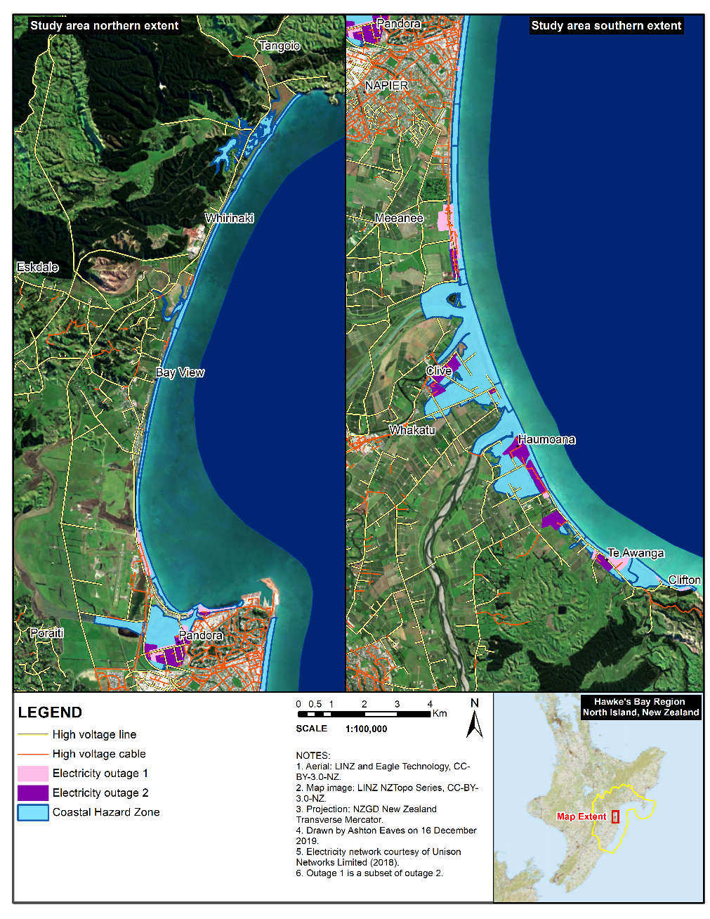

**Figure A4A** Electricity outage map.

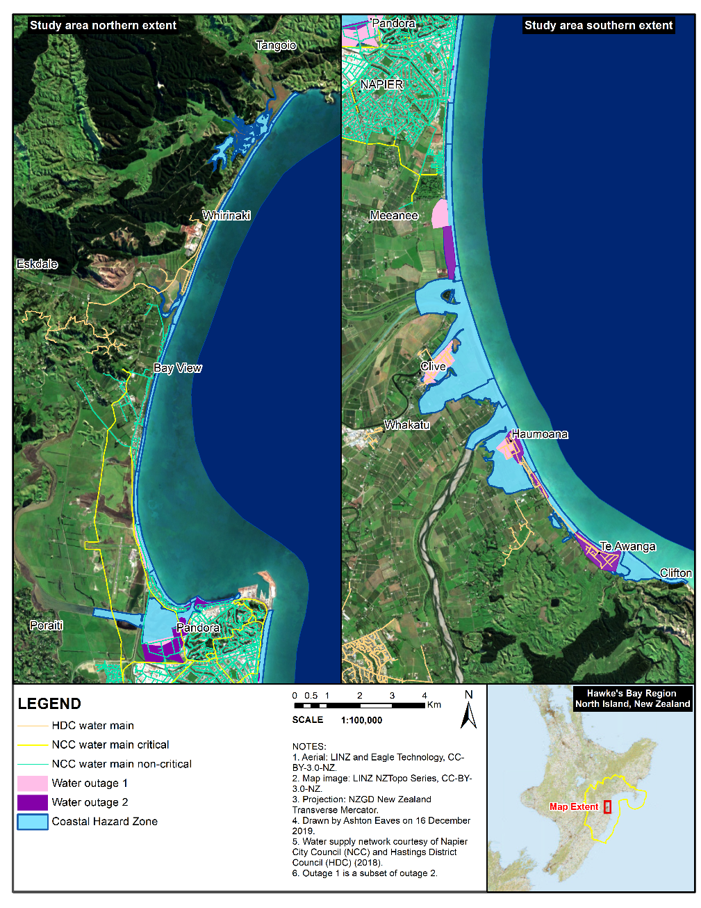

**Figure A4B** Water outage map.

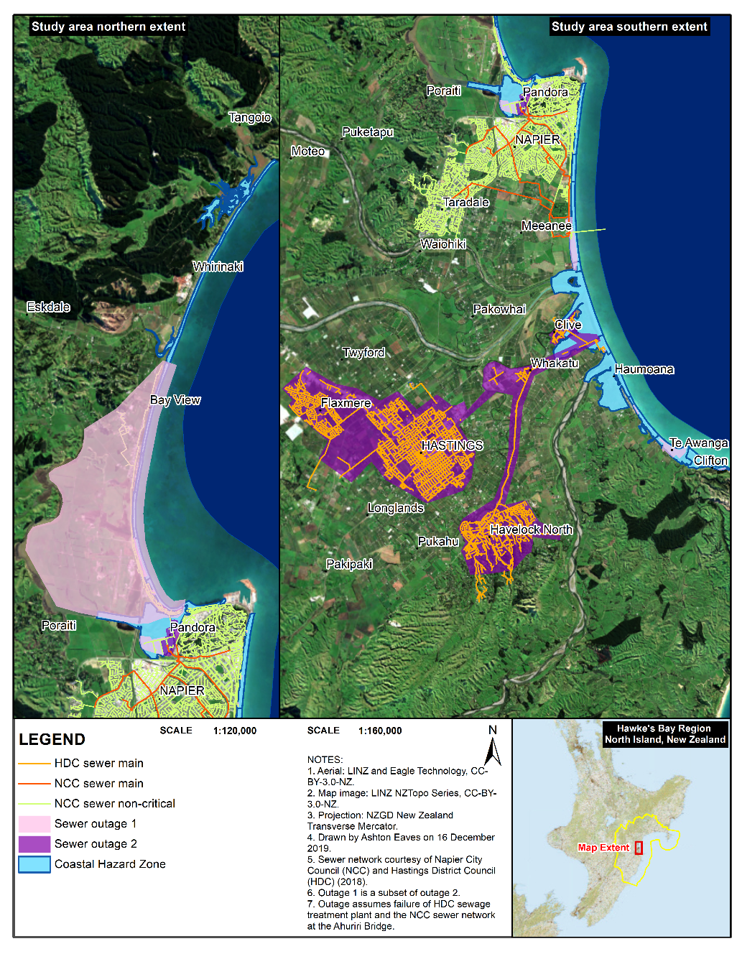

**Figure A4C** Sewer outage map.

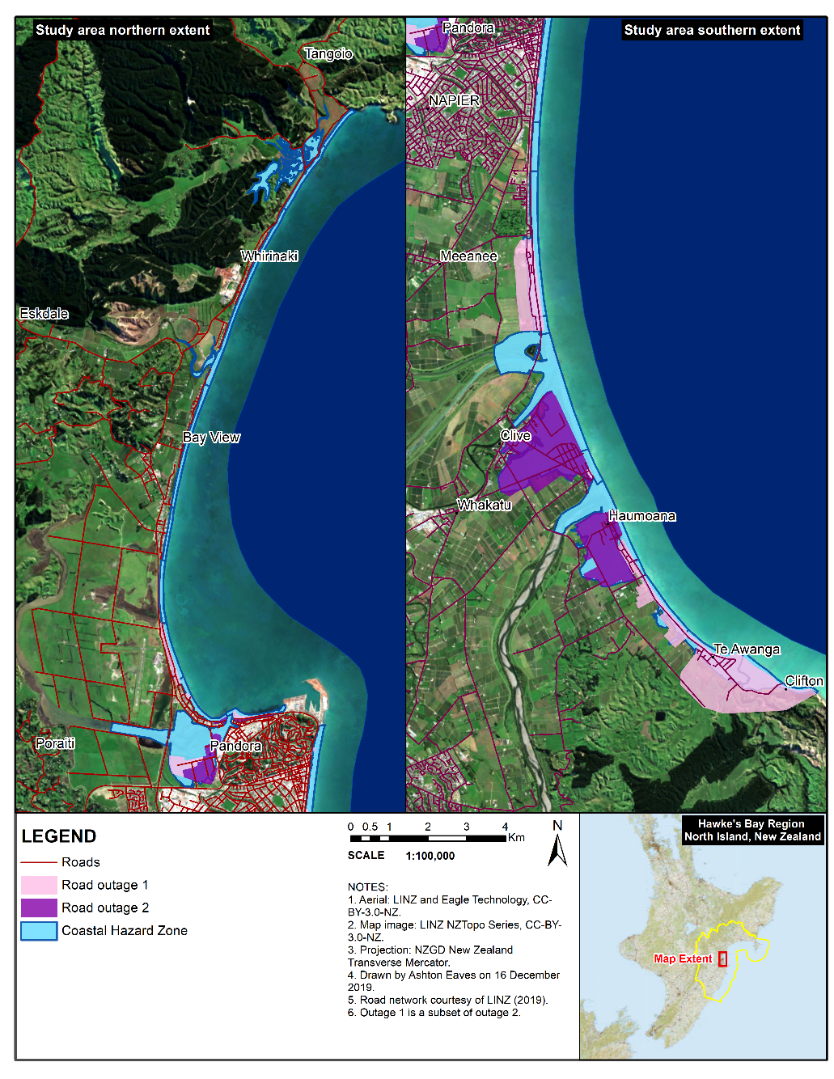

**Figure A4D** Roads outage map.

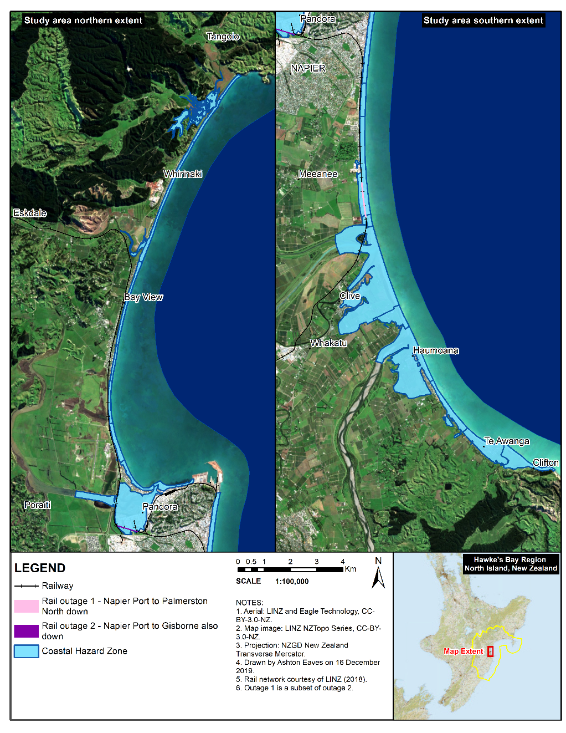

**Figure A4E** Rail outage map.

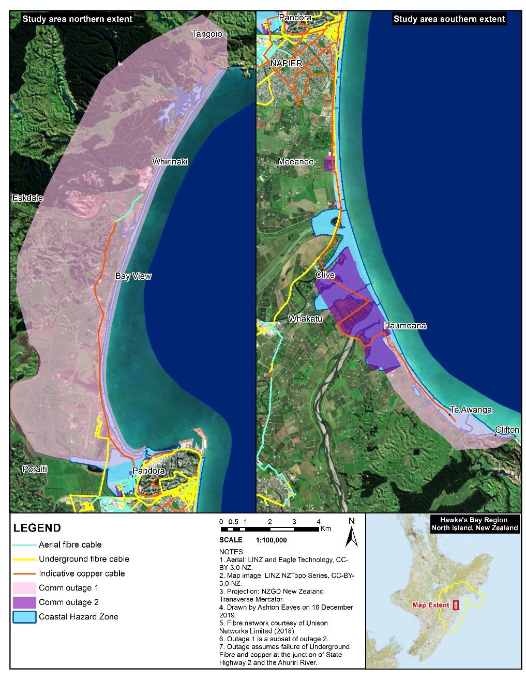

**Figure A4F** Communications outage map.

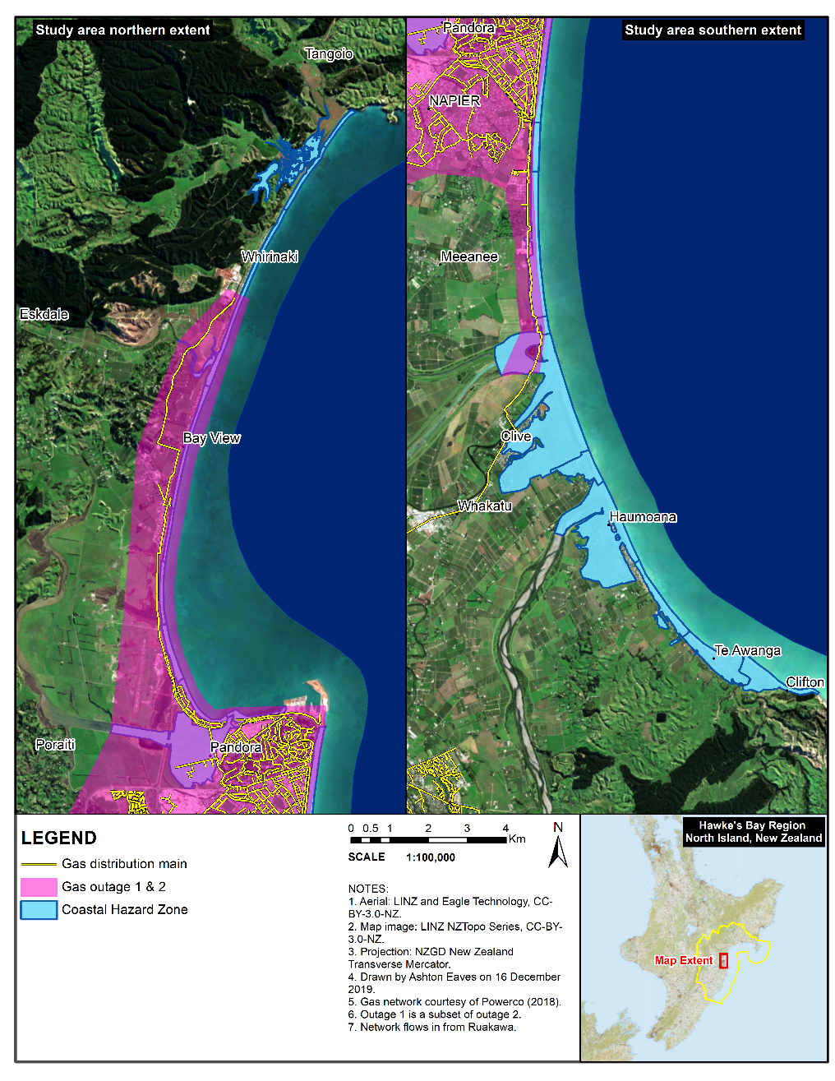

**Figure A4G** Gas outage map

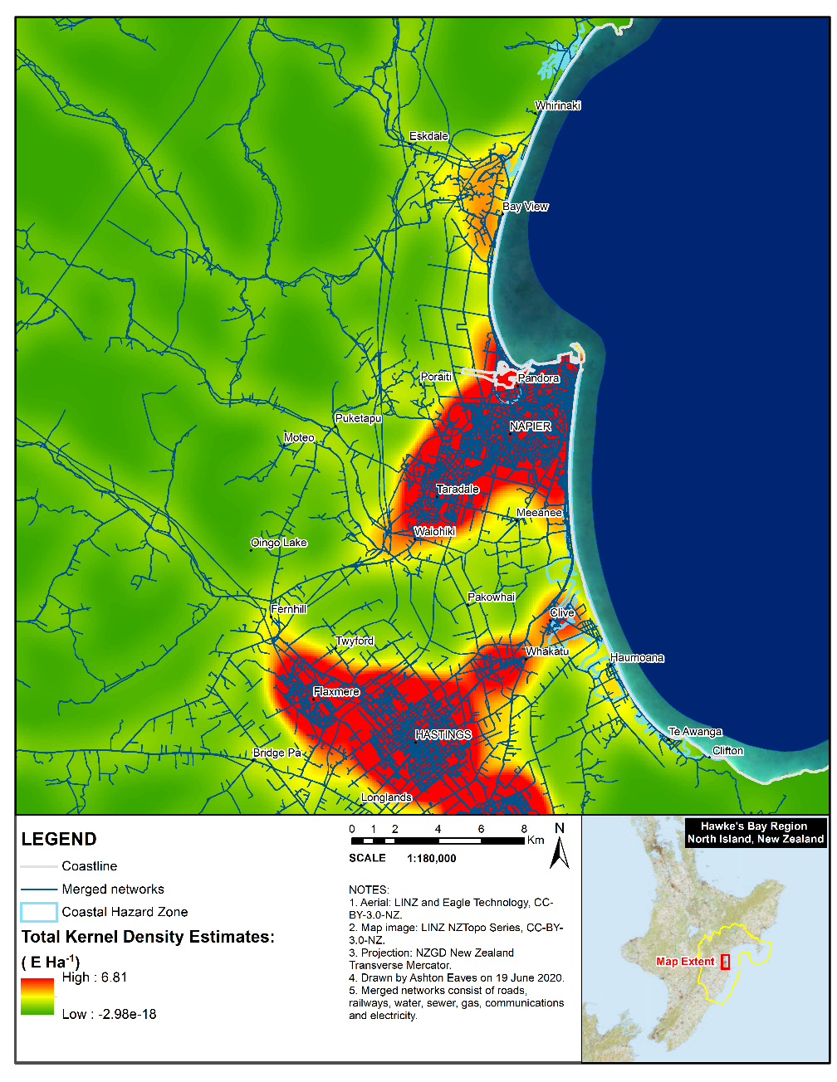

**Figure A4H** Network Total Kernel Density Estimates map.

## Appendix 3 Testing

### 3A Table of testing undertaken for C-ADAPT.

|  |  |
| --- | --- |
| Test type | Conditions |
| Empirical direct structure tests | * Model outputs reliant on the 2009 Riskscape database were validated against 2017 local government valuations. * Hydrologic inundation calibrated against Ahuriri hydrograph. Standard deviation adjusted to suit. * CoreLogic (2018) estimate a year on year increase of 7% in New Zealand. The Socio-Economic Module through the Insurance variable illustrates 10%. * Calculated Vulnerable Capital against the New Zealand house sales database from 1990 to 2018. Adjusted to suit the database from 2007 to 2018 of 2.6% growth for properties in the CHZ. * Clean up and remediation compared to 2020 flood event. * Household income and unemployment compared with actual data from 2007 through to 2018 from StatsNZ. * GDP tracked against TVA for 2007 through to 2018 using modelled data and data from StatsNZ. * Sectors tracked against industries for 2007 through to 2018 using modelled data and data from StatsNZ. * The New Zealand Land Resource Inventory (NZLRI), the national physical land resource information database, was used for land-use calibration. |
| Theoretical direct structure tests | * SLR aligns with IPCC scenarios (IPCC, 2014a). * Geodetic change conforms with the MfE projections (New Zealand Government, 2017). * Storm Surge, Wave Run-up, Catchment Hydrostaticity, Tide and TWL conform with measurements by Komar and the Hawke’s Bay Regional Council (2014). The 11m threshold is breached regularly before 2019. * At least four flood events were recorded for Hawke’s Bay by the Insurance Council of New Zealand (2019a). Claims range from NZD1.1M to NZD 6.4M (Insurance Council of New Zealand, 2019a). * Total asset replacement value was calibrated to align with the reported insurance claims from flooding of NZD 4.3M on the 3rd of June 2018 in Hawke’s Bay and Gisborne (Insurance Council of New Zealand, 2019a). * The initial premium is $NZ20071,000 and calibrates to $NZ20071,500 by 2018 to conform with Corelogic Inc (2018). During the 2016 financial year, New Zealand households, on average, spent 17.6% of their income on housing costs (mortgage or rent expenses, property rates and building-related insurance) (StatsNZ, 2016). Given that the mean regional individual income is $NZ200728,000 (StatsNZ, 2020), 5% represents a tolerable threshold percentage of capital wealth lost by households. * Property rates on households and firms rationalised to income expectations from MERIT. * The number of enterprises paying the general rate was compared to GDP growth from MERIT. * Bonds return on investment (compound interest) is rationalised to market rates pre-covid as described by Tapley (2016). * The rest of the world interest rate was rationalised with Market Economics. * Interdependencies were rationalised against the New Zealand Lifelines Council (2017), and Kernel Density Estimates from the geospatial infrastructure locations. * Coastal defence valuations were set out by HBRC (2019 & 2020) and compared against Infometric Consulting Limited’s ROA (2017). |
| Structure orientated behaviour tests (Note: only applied to Risk Assessment Module and Socio-Economic Module) | The following questions were asked of the model through Vensim® Reality Check:   1. Are premiums and the AEP reflected in the behavioural reframing? 2. Do the annual anticipated loss and insurance influence amenity value? 3. Does the hazard of high water levels influence premiums? 4. Does the integrated risk assessment reflect the changing asset and social vulnerability?   Results:   * 3 successes and 1 failure testing 4 Reality Check equations. * The Reality Check Index as run was 4.02879e-005. * Closeness score is 67.1% on 8 measurements. |
| Behaviour pattern tests | Behaviour pattern tests were carried out on:   |  |  |  |  |  |  |  |  | | --- | --- | --- | --- | --- | --- | --- | --- | | SLR | AEP | Insurance | WTP insurance | Return period |  |  |  | | Significant WL | Behavioural reframing | Wealth | WTAL | Market adjustment |  |  |  | | Geodetic change | Flooded area | Exposed capital | Income | AEL |  |  |  | | Excesses | Coastal amenity value | Premiums | Disruption | Total CHZ |  |  |  | | Total intensification | Total new zones | Trigger count | Land balance dynamic | Compound interest |  |  |  | | Climate bonds | Total regional bonds | Available funds | Total targeted rate | Total hhld rate |  |  |  | | Total general rate | Retreat rates funds | Total rates tax | Total defence cost |  |  |  |  | |

### 3A Reality Check testing for the Risk Assessment Module and the Socio-Economic Module.

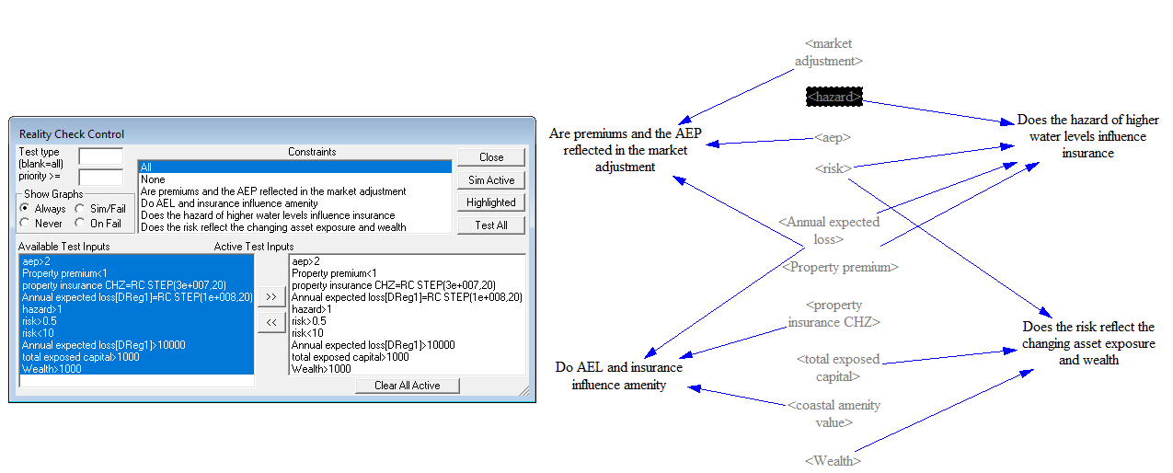

**Figure A3** Set up for the Reality Check.

## Appendix 4 Model assessment results from the SDM-doc Tool

Results for the Risk Assessment Module and the Socio-Economic Module.

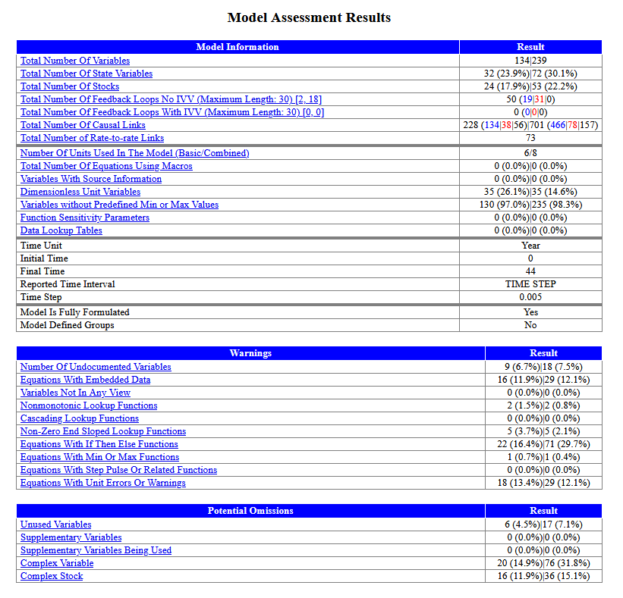

## Appendix 5 Sensitivity analysis

The sensitivity simulations involved 100 simulations using Latin hypercube sampling. The set-up for the Risk Assessment Module and the Socio-Economic Module is visible in Table A7, with the results of the sensitivity analysis for the key variables with their confidence intervals are also visible. Note that the black line represents the mean of all runs and the blue line the initial simulation. The sensitivity results in 7B illustrates some of the key relationships for the integration of the modules into MERIT to create C-ADAPT. Given the vast amount of results available, only a selection of RCP4.5 baseline scenario outputs and RCP8.5 scenario outputs for the rates and bonds scenarios are added.

### 5A Sensitivity results for the Risk Assessment Module and the Socio-Economic Module

**Table 5A Sensitivity analysis set up for constants in Vensim®. Sensitivity analysis used realistic distributions for the modules.**

|  |  |  |
| --- | --- | --- |
| Variable | Distribution | Range |
| NON MARKET VALUE | RANDOM UNIFORM | 0.9, 1.3 |
| INI PREMIUM | RANDOM UNIFORM | 500, 2500 |
| ROI | RANDOM UNIFORM | 0.9, 1.15 |
| ATTRITION RATE | RANDOM UNIFORM | 0.5, 1.5 |
| WTP THRESHOLD | RANDOM UNIFORM | 0.01, 0.1 |
| INITIAL EXCESS | RANDOM UNIFORM | 500, 10000 |
| FREQUENCY | RANDOM UNIFORM | 0.055, 0.068 |
| SCALE | RANDOM NORMAL | 200, 10000 |
| ICE MELT | RANDOM NORMAL | 0, 0.0011 |
| WATER DEPTH | RANDOM NORMAL | 0, 0.008 |
| INSURE THRESHOLD | RANDOM UNIFORM | 1, 7 |

1. **Sea level rise:**

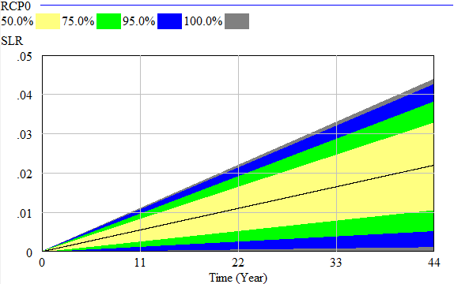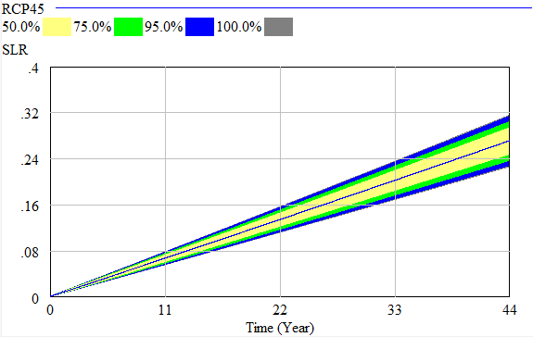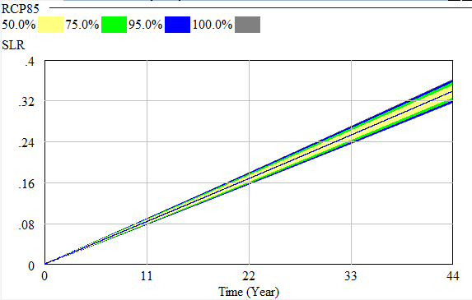

1. **Annual Exceedance Probability:**

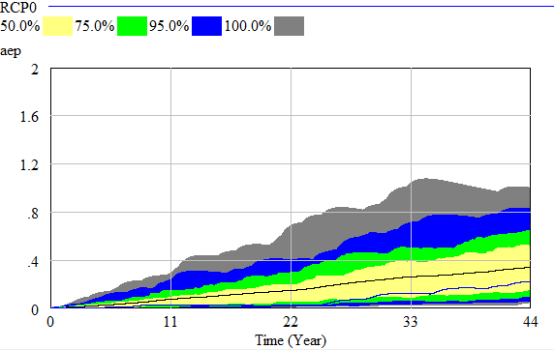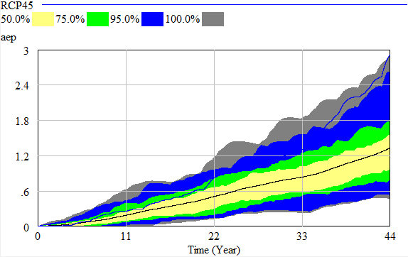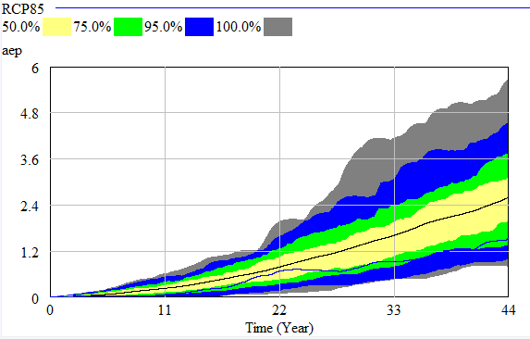

1. **Annual Expected Loss:**

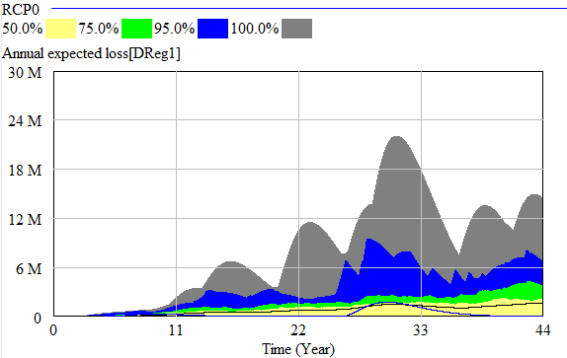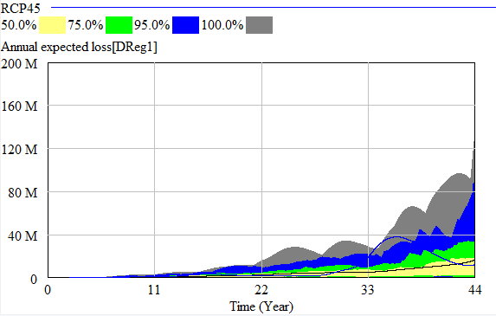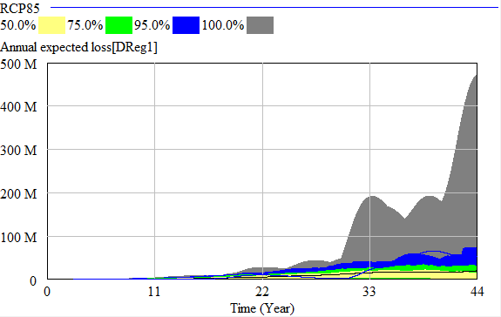

1. **Total Exposed Capital:**

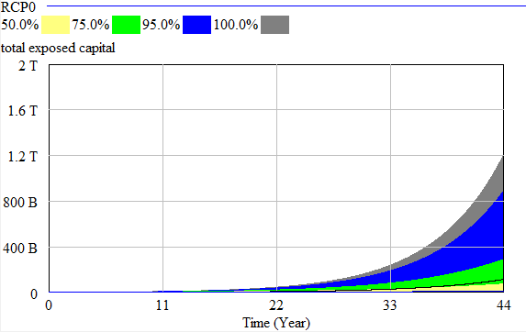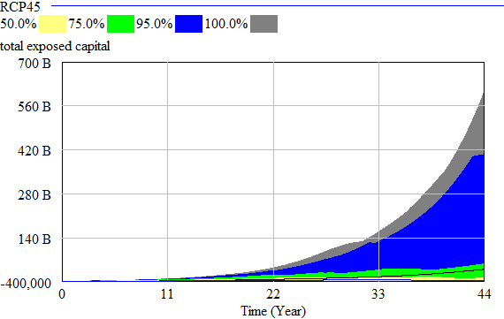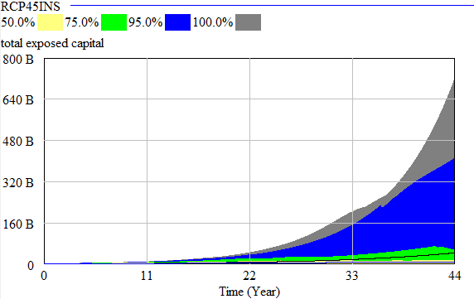

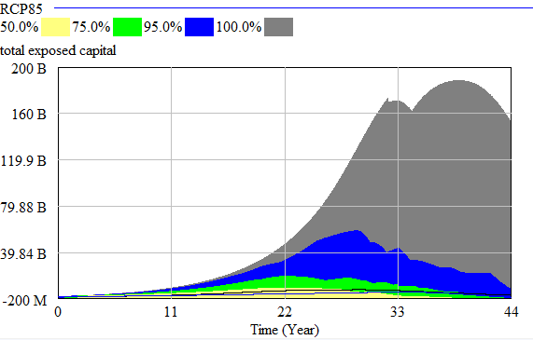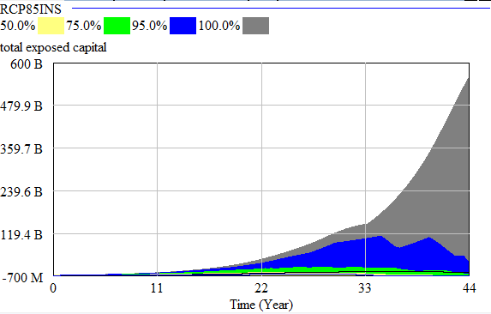

1. **Market Adjustment (Return on Investment):**

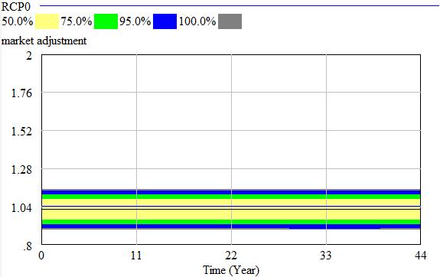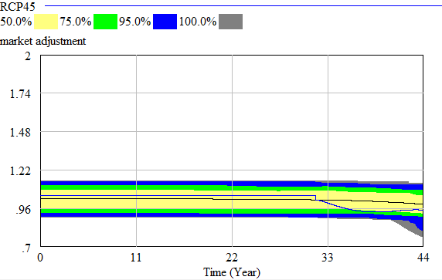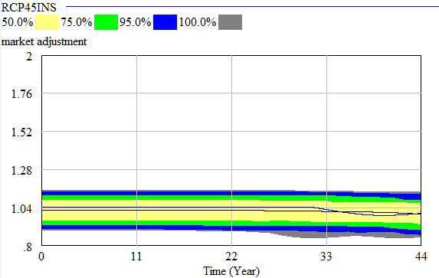

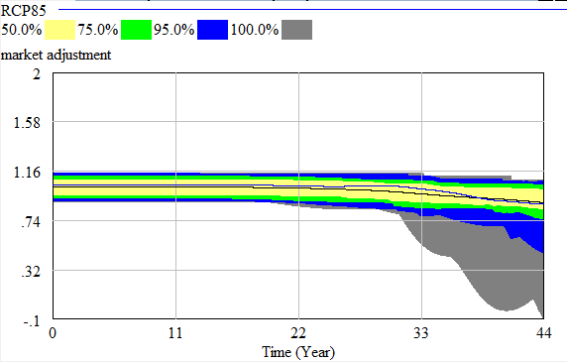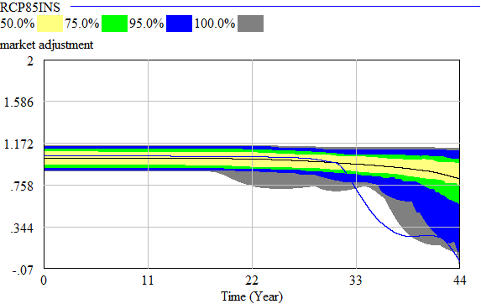

1. **Coastal Amenity Value:**

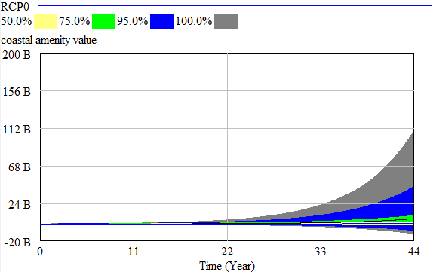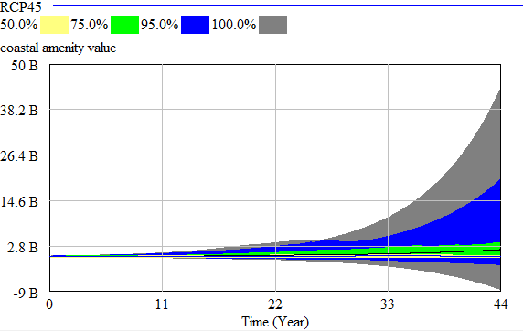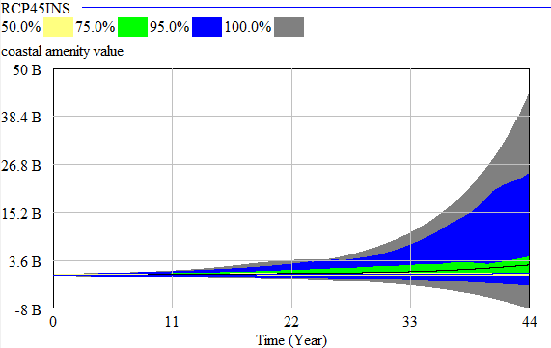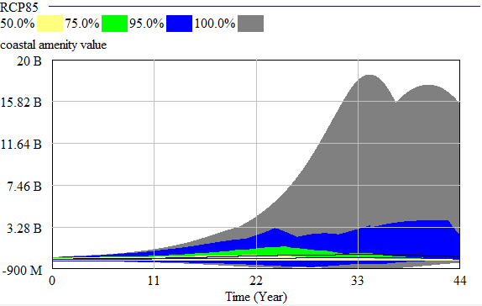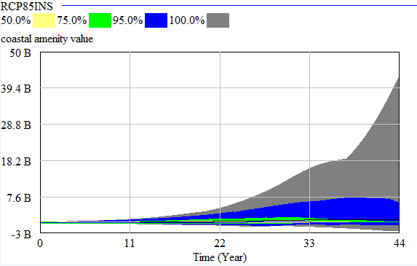

1. **Property Premium:**

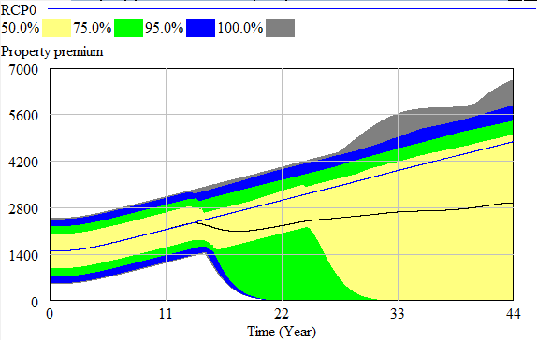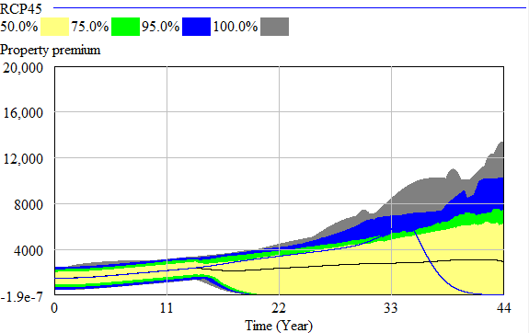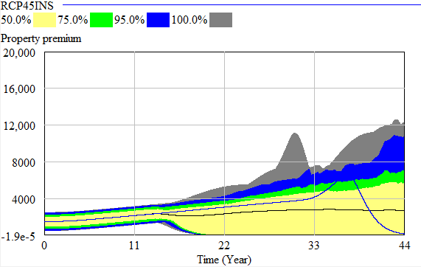

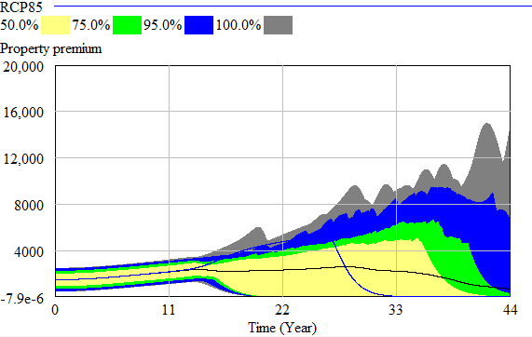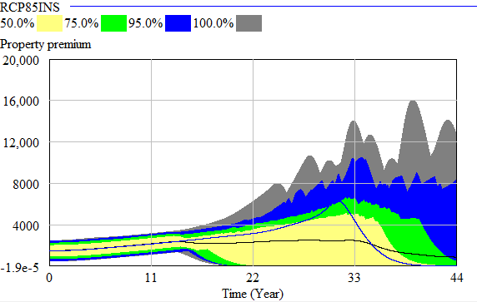

1. **Property Excess:**

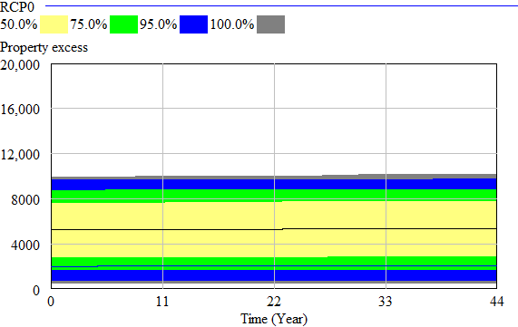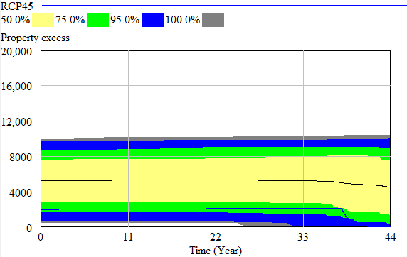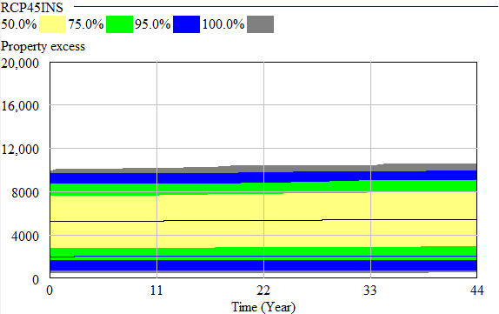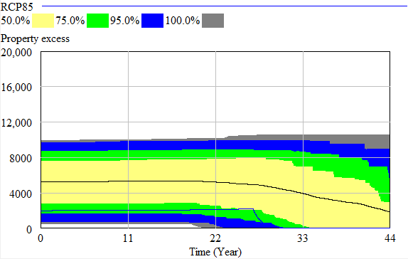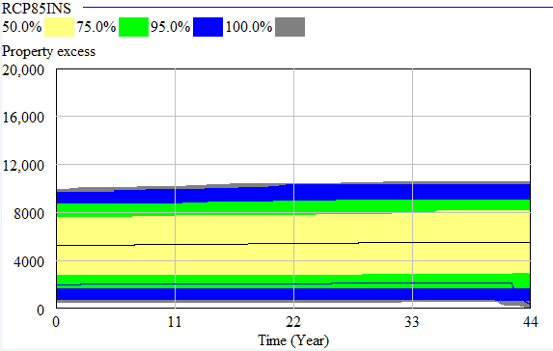

### 5B Sensitivity results for MERIT integration

**RCP4.5**

|  |  |  |
| --- | --- | --- |
| Variable | Distribution | Range |
| FREQUENCY | RANDOM UNIFORM | 0.065, 0.067 |
| SCALE | RANDOM NORMAL | 900, 1100 |
| WATER DEPTH | RANDOM NORMAL | 0.0055, 0.0065 |

**RCP8.5**

|  |  |  |
| --- | --- | --- |
| Variable | Distribution | Range |
| FREQUENCY | RANDOM UNIFORM | 0.066, 0.068 |
| SCALE | RANDOM NORMAL | 200, 300 |
| WATER DEPTH | RANDOM NORMAL | 0.007, 0.008 |

1. **The effect of infrastructure disruption on actual production (RCP4.5):**



1. **The effect of CHZ land lost on natural capital (RCP4.5):**



1. **The effect of damages on investment (RCP4.5):**



1. **The effect of increasing insurance premiums on industry income (RCP4.5):**

** **

1. **The effect of increasing insurance premiums on industry expenditure (RCP4.5):**

** **

1. **The effect of the local government development tax on total government consumption (RCP4.5):**

** **

1. **The effect of the cumulative loss of capital stock on built capital (RCP4.5):**

** **

1. **The effect of the local government managed retreat rating tax on direct tax income (RCP8.5):**



1. **The effect of the local government managed retreat rating tax on industry expenditure (RCP8.5):**



1. **The effect of local government investment through rates in new capital on aggregate investment (RCP8.5):**



1. **The effect of local government investment through rates in new capital on total government consumption (RCP8.5):**



1. **The effect of the central government bond release on total savings (RCP8.5):**

** **

1. **The effect of the central government bond release on the rest of world income (RCP8.5):**



1. **The effect of offshore capital generation on central government savings (RCP8.5):**

** **

1. **The effect of central government purchasing properties on aggregate investment (RCP8.5):**

 

1. **The effect of central government paying bonds back with interest to investors (RCP8.5):**

** **

## Appendix 6 PYRDM output

|  |  |  |  |  |  |  |  |  |  |  |  |
| --- | --- | --- | --- | --- | --- | --- | --- | --- | --- | --- | --- |
|  | RCP0 | RCP4.5 | RCP8.5 | RCP4.5 Defence | RCP8.5 Defence | RCP4.5 Bonds | RCP4.5 Rates | RCP8.5 Bonds | RCP8.5 Rates | sum | rank |
| 2020 | 0 | 0 | 0 | 0 | 0 | 0 | 0 | 0 | 0 | 0 | 0 |
| 2020.25 | 0 | 0 | 0 | 0 | 0 | 0 | 0 | 0 | 0 | 0 | 10 |
| 2020.5 | 0 | 0 | 0 | 0 | 0 | 0 | 0 | 0 | 0 | 0 | 9 |
| 2020.75 | 0 | 0 | 0 | 0 | 0 | 0 | 0 | 0 | 0 | 0 | 8 |
| 2021 | 0 | 0 | 0 | 0 | 0 | 0 | 0 | 1 | 0 | 1 | 17 |
| 2021.25 | 0 | 0 | 0 | 0 | 0 | 0 | 0 | 1 | 0 | 1 | 16 |
| 2021.5 | 0 | 1 | 1 | 0 | 1 | 1 | 0 | 1 | 1 | 6 | 27 |
| 2021.75 | 0 | 0 | 1 | 0 | 1 | 0 | 0 | 1 | 1 | 4 | 24 |
| 2022 | 0 | 1 | 1 | 1 | 1 | 1 | 1 | 1 | 1 | 8 | 42 |
| 2022.25 | 0 | 0 | 0 | 0 | 0 | 0 | 0 | 0 | 0 | 0 | 7 |
| 2022.5 | 0 | 0 | 0 | 0 | 0 | 0 | 0 | 0 | 0 | 0 | 6 |
| 2022.75 | 0 | 0 | 0 | 0 | 0 | 0 | 0 | 0 | 0 | 0 | 5 |
| 2023 | 0 | 0 | 0 | 0 | 0 | 0 | 0 | 0 | 0 | 0 | 4 |
| 2023.25 | 0 | 0 | 0 | 0 | 0 | 0 | 0 | 0 | 0 | 0 | 3 |
| 2023.5 | 0 | 0 | 0 | 0 | 0 | 0 | 0 | 0 | 0 | 0 | 2 |
| 2023.75 | 0 | 0 | 0 | 0 | 0 | 1 | 1 | 1 | 1 | 4 | 23 |
| 2024 | 1 | 1 | 1 | 1 | 1 | 0 | 1 | 1 | 1 | 8 | 41 |
| 2024.25 | 0 | 0 | 0 | 0 | 0 | 0 | 0 | 1 | 0 | 1 | 19 |
| 2024.5 | 1 | 0 | 0 | 0 | 0 | 0 | 0 | 1 | 0 | 2 | 20 |
| 2024.75 | 2 | 2 | 2 | 2 | 2 | 2 | 2 | 0 | 2 | 16 | 56 |
| 2025 | 1 | 1 | 1 | 1 | 1 | 1 | 1 | 0 | 1 | 8 | 40 |
| 2025.25 | 0 | 0 | 0 | 0 | 0 | 0 | 0 | 0 | 0 | 0 | 12 |
| 2025.5 | 0 | 0 | 0 | 0 | 0 | 0 | 0 | 0 | 0 | 0 | 1 |
| 2025.75 | 0 | 0 | 0 | 0 | 0 | 0 | 0 | 1 | 0 | 1 | 18 |
| 2026 | 0 | 0 | 0 | 0 | 0 | 0 | 0 | 1 | 0 | 1 | 13 |
| 2026.25 | 0 | 1 | 1 | 1 | 1 | 1 | 1 | 2 | 1 | 9 | 44 |
| 2026.5 | 1 | 1 | 2 | 1 | 2 | 0 | 1 | 3 | 2 | 13 | 50 |
| 2026.75 | 1 | 1 | 0 | 1 | 0 | 0 | 1 | 1 | 2 | 7 | 30 |
| 2027 | 1 | 1 | 1 | 1 | 1 | 1 | 1 | 1 | 0 | 8 | 39 |
| 2027.25 | 0 | 0 | 0 | 0 | 0 | 0 | 0 | 0 | 0 | 0 | 11 |
| 2027.5 | 1 | 1 | 1 | 1 | 1 | 1 | 1 | 0 | 1 | 8 | 37 |
| 2027.75 | 1 | 1 | 1 | 1 | 1 | 1 | 1 | 0 | 1 | 8 | 38 |
| 2028 | 1 | 1 | 2 | 2 | 2 | 1 | 2 | 0 | 3 | 14 | 52 |
| 2028.25 | 1 | 1 | 1 | 1 | 1 | 1 | 1 | 0 | 2 | 9 | 45 |
| 2028.5 | 0 | 0 | 0 | 0 | 0 | 0 | 0 | 0 | 1 | 1 | 15 |
| 2028.75 | 0 | 0 | 0 | 0 | 0 | 0 | 0 | 0 | 1 | 1 | 14 |
| 2029 | 1 | 0 | 0 | 0 | 0 | 0 | 0 | 0 | 1 | 2 | 21 |
| 2029.25 | 1 | 0 | 0 | 0 | 0 | 0 | 1 | 0 | 1 | 3 | 22 |
| 2029.5 | 2 | 2 | 0 | 1 | 1 | 0 | 1 | 0 | 1 | 8 | 36 |
| 2029.75 | 2 | 2 | 1 | 2 | 1 | 0 | 2 | 0 | 1 | 11 | 46 |
| 2030 | 1 | 1 | 1 | 1 | 1 | 0 | 1 | 0 | 0 | 6 | 26 |
| 2030.25 | 1 | 1 | 0 | 1 | 1 | 1 | 1 | 0 | 0 | 6 | 25 |
| 2030.5 | 1 | 0 | 0 | 0 | 1 | 1 | 1 | 0 | 3 | 7 | 31 |
| 2030.75 | 0 | 0 | 0 | 1 | 1 | 1 | 1 | 0 | 3 | 7 | 29 |
| 2031 | 3 | 0 | 0 | 0 | 0 | 4 | 1 | 3 | 0 | 11 | 47 |
| 2031.25 | 0 | 1 | 1 | 1 | 3 | 2 | 2 | 1 | 1 | 12 | 49 |
| 2031.5 | 0 | 0 | 1 | 0 | 3 | 1 | 1 | 1 | 2 | 9 | 43 |
| 2031.75 | 0 | 0 | 1 | 0 | 3 | 1 | 0 | 0 | 2 | 7 | 28 |
| 2032 | 0 | 0 | 0 | 0 | 3 | 1 | 0 | 2 | 1 | 7 | 32 |
| 2032.25 | 0 | 0 | 0 | 0 | 3 | 2 | 1 | 2 | 0 | 8 | 33 |
| 2032.5 | 0 | 0 | 0 | 0 | 3 | 2 | 1 | 2 | 0 | 8 | 34 |
| 2032.75 | 0 | 0 | 0 | 0 | 3 | 2 | 1 | 2 | 0 | 8 | 35 |
| 2033 | 0 | 3 | 3 | 3 | 6 | 5 | 4 | 5 | 3 | 32 | 72 |
| 2033.25 | 0 | 3 | 3 | 4 | 6 | 5 | 4 | 5 | 3 | 33 | 74 |
| 2033.5 | 0 | 4 | 3 | 1 | 6 | 5 | 4 | 5 | 3 | 31 | 70 |
| 2033.75 | 0 | 1 | 5 | 1 | 3 | 5 | 4 | 5 | 3 | 27 | 63 |
| 2034 | 0 | 3 | 7 | 0 | 5 | 7 | 6 | 7 | 5 | 40 | 82 |
| 2034.25 | 0 | 3 | 8 | 0 | 5 | 7 | 3 | 7 | 5 | 38 | 79 |
| 2034.5 | 0 | 3 | 10 | 0 | 7 | 7 | 2 | 9 | 7 | 45 | 94 |
| 2034.75 | 0 | 0 | 10 | 0 | 7 | 6 | 0 | 8 | 5 | 36 | 75 |
| 2035 | 0 | 0 | 5 | 0 | 5 | 6 | 0 | 6 | 5 | 27 | 62 |
| 2035.25 | 0 | 0 | 5 | 0 | 2 | 3 | 0 | 3 | 5 | 18 | 58 |
| 2035.5 | 0 | 0 | 2 | 0 | 2 | 3 | 0 | 3 | 2 | 12 | 48 |
| 2035.75 | 0 | 0 | 2 | 0 | 2 | 4 | 0 | 4 | 2 | 14 | 54 |
| 2036 | 0 | 0 | 2 | 0 | 2 | 4 | 0 | 4 | 2 | 14 | 51 |
| 2036.25 | 0 | 0 | 2 | 0 | 2 | 4 | 0 | 4 | 2 | 14 | 53 |
| 2036.5 | 0 | 0 | 2 | 0 | 2 | 4 | 0 | 6 | 2 | 16 | 55 |
| 2036.75 | 0 | 0 | 3 | 0 | 3 | 4 | 0 | 6 | 2 | 18 | 57 |
| 2037 | 0 | 0 | 3 | 2 | 3 | 5 | 0 | 6 | 3 | 22 | 59 |
| 2037.25 | 0 | 1 | 4 | 3 | 4 | 7 | 1 | 7 | 4 | 31 | 71 |
| 2037.5 | 0 | 2 | 4 | 4 | 4 | 7 | 2 | 7 | 6 | 36 | 77 |
| 2037.75 | 0 | 3 | 4 | 3 | 4 | 6 | 2 | 8 | 6 | 36 | 76 |
| 2038 | 0 | 3 | 4 | 3 | 6 | 7 | 1 | 8 | 5 | 37 | 78 |
| 2038.25 | 0 | 2 | 3 | 2 | 5 | 6 | 0 | 6 | 4 | 28 | 67 |
| 2038.5 | 0 | 2 | 4 | 2 | 4 | 6 | 0 | 7 | 4 | 29 | 69 |
| 2038.75 | 0 | 2 | 4 | 2 | 4 | 6 | 0 | 7 | 4 | 29 | 68 |
| 2039 | 0 | 2 | 4 | 2 | 4 | 6 | 3 | 7 | 4 | 32 | 73 |
| 2039.25 | 0 | 2 | 4 | 2 | 4 | 5 | 2 | 5 | 4 | 28 | 66 |
| 2039.5 | 0 | 2 | 4 | 2 | 4 | 5 | 2 | 5 | 4 | 28 | 65 |
| 2039.75 | 0 | 2 | 4 | 2 | 4 | 5 | 2 | 5 | 4 | 28 | 64 |
| 2040 | 0 | 2 | 3 | 2 | 4 | 5 | 2 | 5 | 4 | 27 | 60 |
| 2040.25 | 0 | 2 | 3 | 2 | 4 | 5 | 2 | 5 | 4 | 27 | 61 |
| 2040.5 | 0 | 4 | 5 | 4 | 6 | 7 | 4 | 7 | 6 | 43 | 89 |
| 2040.75 | 0 | 4 | 8 | 4 | 6 | 7 | 4 | 7 | 6 | 46 | 96 |
| 2041 | 0 | 4 | 8 | 4 | 6 | 7 | 4 | 7 | 4 | 44 | 91 |
| 2041.25 | 0 | 2 | 8 | 4 | 6 | 7 | 2 | 7 | 4 | 40 | 83 |
| 2041.5 | 0 | 2 | 11 | 2 | 9 | 5 | 2 | 7 | 4 | 42 | 87 |
| 2041.75 | 0 | 2 | 11 | 2 | 9 | 5 | 2 | 7 | 4 | 42 | 88 |
| 2042 | 0 | 2 | 11 | 2 | 9 | 5 | 2 | 5 | 5 | 41 | 86 |
| 2042.25 | 0 | 2 | 11 | 2 | 9 | 5 | 2 | 5 | 5 | 41 | 85 |
| 2042.5 | 0 | 2 | 11 | 2 | 7 | 5 | 2 | 5 | 5 | 39 | 81 |
| 2042.75 | 0 | 3 | 10 | 3 | 10 | 6 | 3 | 6 | 6 | 47 | 98 |
| 2043 | 0 | 3 | 10 | 3 | 10 | 6 | 3 | 5 | 5 | 45 | 93 |
| 2043.25 | 0 | 3 | 9 | 3 | 10 | 6 | 2 | 5 | 5 | 43 | 90 |
| 2043.5 | 0 | 3 | 9 | 3 | 10 | 4 | 2 | 5 | 2 | 38 | 80 |
| 2043.75 | 0 | 2 | 12 | 2 | 10 | 6 | 2 | 5 | 2 | 41 | 84 |
| 2044 | 0 | 4 | 12 | 2 | 10 | 6 | 2 | 7 | 1 | 44 | 92 |
| 2044.25 | 0 | 4 | 12 | 2 | 11 | 6 | 2 | 7 | 1 | 45 | 95 |
| 2044.5 | 0 | 4 | 12 | 2 | 11 | 7 | 2 | 7 | 1 | 46 | 97 |
| 2044.75 | 0 | 7 | 12 | 5 | 11 | 7 | 2 | 7 | 4 | 55 | 100 |
| 2045 | 0 | 7 | 11 | 5 | 10 | 7 | 2 | 7 | 4 | 53 | 99 |
| 2045.25 | 0 | 8 | 11 | 6 | 10 | 8 | 2 | 7 | 4 | 56 | 102 |
| 2045.5 | 0 | 8 | 11 | 6 | 12 | 8 | 4 | 7 | 4 | 60 | 106 |
| 2045.75 | 0 | 8 | 11 | 6 | 14 | 8 | 4 | 7 | 4 | 62 | 111 |
| 2046 | 0 | 8 | 11 | 6 | 14 | 8 | 4 | 8 | 4 | 63 | 113 |
| 2046.25 | 0 | 10 | 12 | 8 | 16 | 10 | 6 | 9 | 6 | 77 | 120 |
| 2046.5 | 0 | 9 | 12 | 7 | 15 | 9 | 5 | 8 | 3 | 68 | 119 |
| 2046.75 | 1 | 9 | 13 | 7 | 15 | 9 | 0 | 8 | 3 | 65 | 115 |
| 2047 | 1 | 9 | 12 | 7 | 15 | 9 | 0 | 7 | 4 | 64 | 114 |
| 2047.25 | 1 | 9 | 13 | 7 | 15 | 9 | 0 | 7 | 4 | 65 | 117 |
| 2047.5 | 1 | 8 | 14 | 8 | 16 | 10 | 1 | 8 | 0 | 66 | 118 |
| 2047.75 | 1 | 9 | 13 | 8 | 16 | 9 | 1 | 8 | 0 | 65 | 116 |
| 2048 | 1 | 9 | 13 | 8 | 16 | 9 | 1 | 6 | 0 | 63 | 112 |
| 2048.25 | 1 | 9 | 13 | 8 | 16 | 8 | 1 | 6 | 0 | 62 | 107 |
| 2048.5 | 1 | 8 | 13 | 9 | 16 | 8 | 1 | 6 | 0 | 62 | 108 |
| 2048.75 | 1 | 8 | 13 | 8 | 17 | 8 | 2 | 5 | 0 | 62 | 109 |
| 2049 | 1 | 8 | 13 | 8 | 17 | 8 | 2 | 5 | 0 | 62 | 110 |
| 2049.25 | 0 | 7 | 12 | 7 | 16 | 7 | 1 | 4 | 3 | 57 | 103 |
| 2049.5 | 0 | 7 | 13 | 4 | 16 | 7 | 1 | 4 | 3 | 55 | 101 |
| 2049.75 | 0 | 9 | 13 | 4 | 16 | 8 | 1 | 8 | 1 | 60 | 105 |
| 2050 | 0 | 6 | 12 | 4 | 17 | 8 | 1 | 8 | 1 | 57 | 104 |
| sum | 34 | 298 | 586 | 255 | 641 | 472 | 160 | 460 | 272 |  |  |
| rank | 0 | 4 | 7 | 2 | 8 | 6 | 1 | 5 | 3 |  |  |

# **References**

Allison, A. (2020). *Developing a methodology for transdisciplinary modelling of complex human-environment systems* (PhD), University of Auckland, Auckland, NZ.

Auckland Council. (2017). *Water Quality Targeted Rate*. Retrieved from Auckland. <https://ourauckland.aucklandcouncil.govt.nz/media/19292/attachment-b-water-quality-targeted-rate.pdf>.

Barlas, Y. (1996). Formal aspects of model validity and validation in system dynamics. *System Dynamics Review, 12*(3), 183-210.

Baron, H., Ruggiero, P., et al. (2015). Incorporating climate change and morphological uncertainty into coastal change hazard assessments. *Natural Hazards, 75*(3), 2081-2102.

Beavan, R., & Litchfield, N. (2012). *Vertical land movement around the New Zealand coastline: Implications for sea-level rise*. Retrieved from Lower Hutt. <www.gns.cri.nz/static/pubs/2012/SR%202012-029.pdf>.

Bin, O., Crawford, T., et al. (2008). Viewscapes and Flood Hazard: Coastal Housing Market Response to Amenities and Risk. *Land Economics, 84*(3), 434-448.

Bisaro, A., & Hinkel, J. (2018). Mobilizing private finance for coastal adaptation: A literature review. *Wiley Interdisciplinary Reviews: Climate Change, 9*(3), 514.

Bosello, F. (2014). The Role of Economic Modelling for Climate Change Mitigation and Adaptation Strategies. In *Routledge Handbook of the Economics of Climate Change Adaptation*: Routledge.

Boston, J. (2017). *Safeguarding the future : governing in an uncertain world*: Wellington, New Zealand : Bridget Williams Books Limited.

Bragen, M., & Martinez-Moyano, I. (2014). System Dynamics Model Documentation Tool (Version Java): Argonne National Laboratory. Retrieved from <https://vensim.com/new-sdm-doc-version/>.

Bram, J., Haughwout, A., et al. (2002). Has September 11 affected New York city's growth potential? In Y. Okuyama & S. Chang (Eds.), *Modelling Spatial and Economic Impacts of Disasters*. Berlin.: Springer.

Brouwer, R., & Schaafsma, M. (2013). Modelling risk adaptation and mitigation behaviour under different climate change scenarios. *Climatic Change, 117*(1), 11-29.

Brown, C., Seville, E., et al. (2015). *Developing the business behaviours module within MERIT*. Retrieved from The Economics of Resilient Infrastructure Programme: Lower Hutt, NZ.

Callaway, J. (2014). The role of technology in adaptation. In A. Markandya, I. Galarraga, & E. Sainz de Murieta (Eds.), *Routledge Handbook of the Economics of Climate Change Adaptation*: Routledge.

Cash, D. W., & Moser, S. C. (2000). Linking global and local scales: Designing dynamic assessment and management processes. *Global Environmental Change, 10*(2), 109-120.

Climate Bonds Initiative. (2019). Climate Bonds Initiative is an international organisation working solely to mobilise the largest capital market of all, the $100 trillion bond market, for climate change solutions. Retrieved 8 February 2019. Retrieved from <https://www.climatebonds.net/resources/overview/climate-bonds-for-beginners>.

CoreLogic Inc. (2018). Insurance Premiums In 2018: Up, Up And Away. Retrieved 19 February 2019. Retrieved from <https://www.corelogic.co.nz/news/insurance-premiums-2018-and-away#.XGuX17hS9hE>.

Daniel, V., Florax, R., et al. (2009). Flooding risk and housing values: An economic assessment of environmental hazard. *Ecological Economics, 69*(2), 355-365.

Earthquake Commission NZ. (2019). *Householders' guide to EQCover*. Retrieved from Wellington, NZ.

Eaves, A., & Doscher, C. (2015). Coastal modelling of sea level rise for the Christchurch coastal environment. *Lincoln Planning Review, 7*(1), 3-15.

Ebersberger, B., & Pyka, A. (2009). The use of genetic programming in evolutionary economics. In J. Foster & W. Hölzl (Eds.), *Applied evolutionary economics and complex systems*. Cheltenham: Edward Elgar.

Filippova, O. (2009). The influence of submarkets on water view house price premiums in New Zealand. *International Journal of Housing Markets and Analysis, 2*(1), 91-105.

Filippova, O., Nguyen, C., et al. (2020). Who Cares? Future Sea Level Rise and House Prices. *Land Economics, 96*(2), 207-224.

Finance.co.nz. (2019). Savings. Retrieved 4 April 2019. Retrieved from <https://www.finance.co.nz/savings>.

Fleming, D., Noy, I., et al. (2018a). *Public insurance and climate change (part one): Past trends in weather-related insurance in New Zealand.* Retrieved from Motu Economic and Public Policy Research: Wellington.

Fleming, D., Noy, I., et al. (2018b). *Public insurance and climate change (part one): Past trends in weather-related insurance in New Zealand.* Retrieved from Motu Economic and Public Policy Research: Wellington.

Ford, A. (2010). *Modeling the environment.* (2nd ed.. ed.). Washington, D.C.: Island Press.

Foudi, S., & Nuria, O. (2014). Flood risk management: Assessment for prevention with hydro-economic approaches. In A. Markandya, I. Galarraga, & E. Sainz de Murieta (Eds.), *Routledge handbook of the economics of climate change adaptation.* New York: Routledge.

Frame, B., & Reisinger, A. (2016). *Exploring Options for New Zealand under Different Global Climates. Synthesis Report RA5. Climate Changes, Impacts and Implications (CCII) for New Zealand to 2100.* Retrieved from <http://ccii.org.nz/wp-content/uploads/2017/02/RA5-Synthesis-report.pdf>.

Frame, B., Taylor, R., et al. (2005). *Work in Progress: Four futures for New Zealand*. Retrieved from Lincoln, NZ.

Geis, D. (2000). By design: The disaster resistant and quality of life community. *Natural Hazards Review, 1*(3), 151-160.

Goel, A. L. (1985). Software Reliability Models: Assumptions, Limitations, and Applicability. *Software Engineering, IEEE Transactions on, 11*(12), 1411-1423.

Grace, E., France-Hudson, B., et al. (2018). *Managing existing uses in areas at high risk from natural hazards: an issues paper.* Retrieved from Lower Hutt, NZ.

Greenberger, M., Crenson, M., et al. (1976). *Models in the policy process: public decision making in the computer era*. The University of California: Russel Sage Foundation.

Haasnoot, M., van Deursen, W. P. A., et al. (2014). Fit for purpose? Building and evaluating a fast, integrated model for exploring water policy pathways. *Environmental Modelling & Software, 60*, 99-120.

Hall, D., & Lindsay, S. (2017). *Climate Finance Landscape for Aotearoa New Zealand: A preliminary survey.* Retrieved from Auckland.

Hamarat, C., Kwakkel, J., et al. (2013). Adaptive Robust Design under deep uncertainty. *Technological Forecasting and Social Change, 80*(3), 408-418.

Hamarat, C., Kwakkel, J., et al. (2014). An exploratory approach for adaptive policymaking by using multi-objective robust optimzation. *Simulation Modelling Practice and Theory.*

Hastings District Council. (2020). Business Investment; Whakangao Pakihi. Retrieved 14 February 2020. Retrieved from <https://www.hastingsdc.govt.nz/services/business/business-investment/>.

HBcoast. (2017). Coastal Hazard Strategy 2120. Retrieved 16 November 2017. Retrieved from <https://www.hbcoast.co.nz/>.

HBRC. (2016). *MATARIKI: Hawke’s Bay Regional Economic Development Strategy and Action Plan 2016.* Retrieved from Hawke's Bay Regional Council: Napier, NZ.

HBRC. (2017). *Hawke's Bay Civil Defence and Emergency Management Group online mapping site.* Retrieved from: <https://hbviewer.intramaps.co.nz/IntraMaps80/?default.html&configId=356ffec6-603c-480b-be35-564fe341f71d&project=Natural%20Hazards&module=Coastal%20Hazards>.

HBRC. (2018). *Ahuriri Lagoon Hydrograph at Causeway*

HBRC. (2019). *Design of Groynes and Nourishment - Clifton to Tangoio 2120 Strategy-Stage 4 Wave, Shoreline Evolution and Gravel Barrier Response Modelling. Groynes Design and Cost estimates.* Retrieved from Napier.

HBRC. (2020). *Short-term concept design and costing for Pandora Unit Clifton to Tangoio 2120 Coastal Strategy - Design Work stream*. Retrieved from Napier.

HBRC, HDC, et al. (2017). *Heretaunga Plains Urban Development Strategy 2017.* Retrieved from Hawke's Bay Regional Council: Napier, NZ.

Herd, E. (2018). Investors welcome the New Zealand Green Investment Finance fund. [Press release].

Infometrics Consulting Limited. (2017). *Real options analysis of strategies to manage coastal hazard risks.* Retrieved from Wellington.

Infometrics Consulting Limited. (2020). Hawke's Bay Region economic profile. Retrieved 20 November 2020. Retrieved from <https://ecoprofile.infometrics.co.nz/Hawke%27s%20Bay%20Region/StandardOfLiving/Household_Income>.

Insurance Council of New Zealand. (2019a). The cost of natural disasters in New Zealand. Retrieved 19 February 2019. Retrieved from <https://www.icnz.org.nz/media-resources/natural-disasters/?L=0>.

Insurance Council of New Zealand. (2019b). The real cost of natural disasters. Retrieved 19 February 2019. Retrieved from <https://www.icnz.org.nz/media-resources/natural-disasters/?L=0>.

IPCC. (2012). *Managing the Risks of Extreme Events and Disasters to Advance Climate Change Adaptation.* Retrieved from Cambridge, UK. <https://www.ipcc.ch/site/assets/uploads/2018/03/SREX_Full_Report-1.pdf>.

IPCC. (2014a). *Climate change 2014: Synthesis report. Contribution of Working Groups I, II and III to the Fifth Assessment Report of the Intergovernmental Panel on Climate Change.* Retrieved from Geneva. <http://ar5-syr.ipcc.ch/>.

IPCC. (2014b). Technical Summary. In C. B. Field, V. R. Barros, D. J. Dokken, K. J. Mach, M. D. Mastrandrea, T. E. Bilir, M. Chatterjee, K. L. Ebi, Y. O. Estrada, R. C. Genova, B. Girma, E. S. Kissel, A. N. Levy, S. MacCracken, P. R. Mastrandrea, & L. L. White (Eds.), *Climate Change 2014: Impacts, Adaptation, and Vulnerability. Part A: Global and Sectoral Aspects. Contribution of Working Group II to the Fifth Assessment Report of the Intergovernmental Panel on Climate Change* (pp. 35-94.). Cambridge, United Kingdom and New York, NY, USA.: Cambridge University Press.

IPCC. (2019a). *Special Report on the Ocean and Cryosphere in a Changing Climate*. Retrieved from Geneva. <https://www.ipcc.ch/srocc/>.

IPCC. (2019b). *Special Report on the Ocean and Cryosphere in a Changing Climate.* Retrieved from Geneva.

Johnson, D., Fischbach, J., et al. (2013). Estimating Surge-Based Flood Risk with the Coastal Louisiana Risk Assessment Model. *Journal of Coastal Research, 67*(sp1), 109-126.

Kapmeier, F., & Gonçalves, P. (2018). Wasted paradise? Policies for Small Island States to manage tourism-driven growth while controlling waste generation: the case of the Maldives. *System Dynamics Review, 34*(1-2), 172-221.

Kench, P., Ryan, E., et al. (2018). Co-creating Resilience Solutions to Coastal Hazards Through an Interdisciplinary Research Project in New Zealand. *Journal of Coastal Research., 85*(SP1), 1496-1500.

King, A., & Bell, R. (2005). *Riskscape New Zealand - A Multihazard Loss Modelling Tool* (Vol. 5).

Knopman, D., & Lempert, R. (2016). *Urban Responses to Climate Change: Framework for Decisionmaking and Supporting Indicators.* Retrieved from Santa Monica, CA. <https://www.rand.org/pubs/research_reports/RR1144.html>.

Komar, P., & Harris, E. (2014). *Hawke's Bay, New Zealand: Global climate change and barrier beach responses.* Retrieved from Hawke's Bay Regional Council: Napier, NZ.

Kourgialas, N., & Karatzas, G. (2011). Flood management and a GIS modelling method to assess flood-hazard areas—a case study. *Hydrological Sciences Journal, 56*(2), 212-225.

Kwakkel, J., Haasnoot, M., et al. (2015). Developing dynamic adaptive policy pathways: a computer-assisted approach for developing adaptive strategies for a deeply uncertain world. *Climatic Change, 132*(3), 373-386.

Kwakkel, J., Haasnoot, M., et al. (2012). Computer assisted dynamic adaptive policy design for sustainable water management in river deltas in a changing environment. In.

Landcare Research New Zealand Ltd. (2016). *LUCAS NZ Land Use Map 1990 2008 2012 2016 v006*. Retrieved from: <https://data.mfe.govt.nz/layer/52375-lucas-nz-land-use-map-1990-2008-2012-2016-v006/>.

Lempert, R., Kalra, N., et al. (2013). *Ensuring Robust Flood Risk Management in Ho Chi Minh City.*

LINZ. (2012). Tide level information for surveyors. Retrieved 12/9/2012. Retrieved from <http://www.linz.govt.nz/geodetic/datums-projections-heights/vertical-datums/tidal-level-information-for-surveyors>.

Local Government New Zealand. (2019). *Vulnerable: the quantum of local government infrastructure exposed to sea level rise*. Retrieved from Wellington.

Longworth, E. (2017). Alarm bells sounded over gaps in disaster resilience. In K. Ryan (Ed.), *Nine to noon.*: Radio New Zealand.

Macharis, C. (2000). Hybrid modeling: System dynamics combined with multi-criteria analysis. *System Dynamics Society*.

Macmillan, A. (2012). *Intervening in the trip to work: A system dynamics approach to commuting and public health.* (Doctor of Philosophy in Community Health.), University of Auckland, Auckland. Retrieved from <https://researchspace.auckland.ac.nz/bitstream/handle/2292/19500/whole.pdf>

Mahanga E Tu Inc v Hawkes Bay Regional Council, No. [2014] NZEnvC 83 (Environment Court 2014).

Maoate-Cox, D. (2020). How the Government borrows money. *The House.* Retrieved 14 June 2020. Retrieved from <https://www.rnz.co.nz/national/programmes/the-house/audio/2018750436/how-the-government-borrows-money>.

Market Economics. (2017). *Future demand for construction workers: Projections from the National Construction Occupations Model*. Retrieved from Wellington.

Market Economics Limited. (2017). *Economic impact of the 2016 Kaikoura earthquake: A report prepared for the Ministry of Transport.* (17022017). Retrieved from Market Economics: Auckland, NZ.

Matrix Software. (2014). Agile development methodology. Retrieved 6 October 2017. Retrieved from <http://matrix-soft.org/agile-development-methodology/>.

Maven Consulting Ltd. (2017). *Cape coast area coastal hazards social impact analysis and valuation.* Retrieved from Wellington. <www.consultmaven.co.nz>.

McDonald, G., Buxton, R., et al. (5 November 2014). *Modelling infrastructure interdependencies.* Paper presented at the National Lifelines Forum, Wellington.

McDonald, G., & McDonald, N. (2018). *Economy-wide Impacts of Proposed Policy Options for the TANK Catchments. Prepared for Hawke’s Bay Regional Council*. Retrieved from Auckland, NZ.

Ministry for Business Innovation and Employment. (2018). Market rent. Retrieved 10 October 2018. Retrieved from <https://www.tenancy.govt.nz/rent-bond-and-bills/market-rent/?location=Central+Hawkes+Bay+-+Entire+District&period=105&action_doSearchValues=Find+Rent>.

Ministry for the Environment. (2017). *Coastal hazards and climate change: Guidance for local government.* Retrieved from New Zealand Government: Wellington, NZ.

Moss, R., Edmonds, J., et al. (2010). The next generation of scenarios for climate change research and assessment. *Nature, 463*(7282), 747-756.

Mullin, M., Smith, M., et al. (2019). Paying to save the beach: effects of local finance decisions on coastal management. *Climatic Change, 152*(2), 275-289.

Napier City Council. (2020). Economic Development. Retrieved 14 February 2020. Retrieved from <https://www.napier.govt.nz/napier/business/economic-development/>.

New Zealand Government. (2017). *Coastal hazards and climate change: Guidance for local government.* Retrieved from Ministry for the Environment: Wellington, NZ.

NIWA. (2017a). *Managing and adapting to coastal erosion at Carters Beach: Prepared for West Coast Regional Council.* Retrieved from Hamilton, NZ.

NIWA. (2017b). *Riskscape Spatial Vulnerability Assessment Hawke's Bay Database*.

NIWA. (2017c). Riskscape. Retrieved 9 May 2017. Retrieved from <https://www.riskscape.org.nz/>.

Ojea, E. (2014). Ecosystem-Based Adaptation. In *Routledge Handbook of the Economics of Climate Change Adaptation*: Routledge.

Pandas Development Team. (2014). pandas.DataFrame.loc. Retrieved 12 March 2019. Retrieved from <https://pandas.pydata.org/pandas-docs/stable/reference/api/pandas.DataFrame.loc.html>.

Peck, A., Neuwirth, C., et al. (2014). *Coupling System Dynamics with Geographic Information Systems: CCaR Project Report.* Retrieved from.

Port of Napier Limited. (2018). *Annual Report*. Retrieved from Napier.

Python Software Foundation. (2017). Python documentation (Version 3.6.10). Retrieved from <https://docs.python.org/3/>.

Radio New Zealand. (2020). Hawke's Bay landowners fighting urban development. Retrieved 13 July 2020. Retrieved from <https://www.rnz.co.nz/national/programmes/morningreport/audio/2018754658/hawke-s-bay-landowners-fighting-urban-development>.

Ramachandra, T., Geekiyanage, D., et al. (02 July 2017). *Study on the Application of Economies of Scale in the Construction Industry: The Sri Lankan Perspective.* Paper presented at the The 6th World Construction Symposium 2017: What's New and What's Next in the Built Environment Sustainability Agenda?, Colombo, Sri Lanka.

Raybaut, P. (2009). Spyder: The Scientific Python Development Environment (Version 3.3.6). Retrieved from <https://www.spyder-ide.org/>.

RBNZ. (2018). Inflation calculator. Retrieved 7 October 2018. Retrieved from <https://rbnz.govt.nz/monetary-policy/inflation-calculator>.

Reese, S., & Ramsay, D. (2010). *Riskscape: Flood fragility methodology.* Retrieved from NIWA: Wellington, NZ.

Ruth, M., & Hannon, B. (1997). *Modelling dynamic economic systems.* New York.: Springer-Verlag.

Secretariat of the Convention on Biological Diversity. (2009). *Connecting biodiversity and climate change mitigation and adaptation: Report of the second ad hoc technical expert group on biodiversity and climate change.* Retrieved from Montreal.

Sharpe, M. (2019). Plan to make Napier and Hastings ratepayers pay $30 a year for defences against coastal erosion. *Stuff*. Retrieved from <https://www.stuff.co.nz/environment/climate-news/113059841/plan-to-make-napier-and-hastings-ratepayers-pay-30-a-year-for-defences-against-coastal-erosion?fbclid=IwAR1Q6q-gAWrQMrSNVh3oHwEpA0DkfoE8vMsFHIKAuFVY7Da1EeQPdVgeXeY>.

Silverman, B. W. (1986). *Density estimation for statistics and data analysis*. London

New York: Chapman and Hall.

Smith, N., Kim, J., et al. (2016). *Auckland water outage scenario: Modelling the economic consequences of interruptions in infrastructure service using MERIT.* Retrieved from Economics of Resilient Infrastructure Programme: Auckland, NZ.

Smith, N., & McDonald, G. (2016a). *MERIT: A short overview document. Prepared for New Zealand Transport Agency.* Retrieved from Market Economics: Auckland, NZ.

Smith, N., & McDonald, G. (2016b). *MERIT: short overview document. Prepared for New Zealand Transport Agency.* Retrieved from Auckland.

Smith, N., McDonald, G., et al. (2016). *Dynamic Economic Model: A technical report prepared under the Economics of Resilient Infrastructure Programme.* Retrieved from Market Economics: Auckland, NZ.

Smith, N., Orchiston, C., et al. (2016). *Scoping tourism dynamics post-quake: A module for MERIT prepared for QuakeCORE and NZ Transport Agency.* Retrieved from Market Economics: Auckland, NZ.

StatsNZ. (2013a). 2013 Census QuickStats about families and households. Retrieved 23 July 2020. Retrieved from <https://www.stats.govt.nz/reports/2013-census-quickstats-about-families-and-households>.

StatsNZ. (2013b). *Hawke's Bay Region Business Directory Data: Multi-regional input-output tables.* Retrieved from: <http://archive.stats.govt.nz>.

StatsNZ. (2013c). *National Accounts Input-Output Tables: Year ended March 2013.* Retrieved from: <http://archive.stats.govt.nz/browse_for_stats/economic_indicators/NationalAccounts/input-output%20tables-2013.aspx>.

StatsNZ. (2015). *Goods exports from Hawke's Bay*. Retrieved from Wellington. <http://archive.stats.govt.nz/browse_for_stats/industry_sectors/imports_and_exports/hawkes-bay-snapshot/hb-exports-infographic.aspx>.

StatsNZ. (2016). *Household Expenditure Statistics: Year ended June 2016.* Retrieved from: <http://archive.stats.govt.nz/browse_for_stats/people_and_communities/Households/HouseholdExpenditureStatistics_HOTPYeJun16/Commentary.aspx>.

StatsNZ. (2019a). Subnational population estimates. Retrieved 28 May 2019. Retrieved from <http://nzdotstat.stats.govt.nz/wbos/Index.aspx?DataSetCode=TABLECODE7501&_ga=2.193915631.35004856.1559012559-695083271.1509656097>.

StatsNZ. (2019b). *Which industries contributed to New Zealand’s GDP?* Retrieved from: <https://www.stats.govt.nz/experimental/which-industries-contributed-to-new-zealands-gdp>.

StatsNZ. (2020). *Infoshare.* Retrieved from: <http://archive.stats.govt.nz/infoshare/>.

Stepanova, K. (2018). Government payout to uninsured homeowners: vital, or reckless? *Insurance Business.* Retrieved <https://www.insurancebusinessmag.com/nz/news/breaking-news/government-payout-to-uninsured-homeowners-vital-or-reckless-109356.aspx>.

Tapley, K. (2016). *GBCNZ: Green Bond market overview*. Sustainable Finance Solutions. ANZ. Sydney.

Taylor-Hochberg, A. (2017). Creative financing for managed retreat. Retrieved 20 April 2019. Retrieved from <http://www.climigration.org/blog/2017/11/30/how-novel-financing-strategies-can-help-make-sense-of-managed-retreat>.

Tombs, B., & France-Hudson, B. (2018). Climate Change Compensation; an unavoidable discussion. *Policy Quarterly, 14*(4), 50-58.

Tonkin & Taylor. (2019). Hawke’s Bay Coastal Hazard Risk Strategy: A Case Study. Retrieved 16 November 2019. Retrieved from <https://www.tonkintaylor.co.nz/projects/all-projects/case-study-hawke-s-bay-coastal-hazard-risk-strategy/>.

Tonkin and Taylor Ltd. (2016). *Hawke's Bay Coastal Strategy: Coastal Risk Assessment*. Retrieved from Hawke's Bay Regional Council.

Trucano, T., Swiler, L., et al. (2006). Calibration, validation, and sensitivity analysis: What's what. *Reliability Engineering & System Safety, 91*(10), 1331-1357.

Turner, R. K. (2000). Integrating natural and socio-economic science in coastal management. *Journal of Marine Systems, 25*(3), 447-460.

Ventana System Inc. (2015). Vensim. Industrial strength simulation software for improving the performance of real systems. Retrieved from <https://vensim.com/>.

Waikato Regional Council. (2018). Targeted rates. Retrieved 30 February 2019. Retrieved from <https://www.waikatoregion.govt.nz/council/rates/targeted-rates/>.

Zorn, C. (2017). *The Interdependence and Recovery of Critical Infrastructure Networks Following Major Disruptions.* (Doctor of Philosophy in Civil Engineering), The University of Auckland, Auckland, NZ.

1. Note: dollars are nominal NZ$2007. NZ$2007 1.00 = NZ$2020 1.26 and NZ$2007 1.00= US$2020 0.81.